**AMERICAN NATIONAL STANDARD**

**ANSI/ISA-95.00.04-ed2 CVD01**

**Enterprise-Control System Integration**

**− Part 4: Object Model Attributes for Manufacturing   
Operations Management Integration**

ANSI/ ISA-95.00.04-ed2 CVD01 (ISA 95.00.04 ed2Mod)

Enterprise-Control System Integration − Part 4: Object Model Attributes for Manufacturing

Operations Management Integration

Copyright © 2017 by the International Society of Automation (ISA). All rights reserved. Not for resale. Printed in the United States of America. No part of this publication may be reproduced, stored in a retrieval system, or transmitted in any form or by any means (electronic mechanical, photocopying, recording, or otherwise), without the prior written permission of the Publisher.

ISA  
67 Alexander Drive  
P.O. Box 12277  
Research Triangle Park, North Carolina 27709

CONTENTS

INTRODUCTION 11

1 Scope 13

2 Normative references 13

3 Terms, definitions, abbreviations and conventions 13

3.1 Terms and definitions 13

3.2 Symbols and abbreviations 15

3.3 Conventions 15

4 Information exchange between manufacturing operations 15

4.1 MOM Activity information exchange network 15

4.2 MOM Information exchange models 16

4.2.1 Overview 16

4.2.2 Process segments and work masters 16

4.2.3 Common resource definitions 16

4.2.4 Work models 17

4.3 Cross model relationships for MOM activity context in exchanges 17

5 General information model characteristics 19

5.1 Minimum object attribute sets 19

5.2 Object attribute extensibility 19

5.3 Information object model structure 19

5.3.1 UML notation in information object models 19

5.3.2 Conventions used in tables of object relationships and roles 21

5.3.3 Conventions used in object attribute tables 23

5.3.4 Association relationships between object models and supporting resource models 24

5.3.5 Object relationships between abstract information models and implementation models 30

6 Resource relationship network information 32

6.1 Resource relationship network model 32

6.2 Resource relationship network 34

6.3 Resource relationship network property 35

6.4 Resource network connection 36

6.5 Resource network connection property 37

6.6 From resource reference 37

6.7 From resource reference property 38

6.8 To resource reference 39

6.9 To resource reference property 40

6.10 Resource network connection type 41

6.11 Resource network connection type property 41

7 Work definition information 42

7.1 Work definition model 42

7.2 Work master 45

7.3 Work directive 45

7.4 Work definition 46

7.5 Work master relationship roles and attributes 48

7.6 Work directive relationship roles and attributes 49

7.7 Parameter specification 49

7.8 Personnel specification 49

7.9 Personnel specification property 49

7.10 Equipment specification 50

7.11 Equipment specification property 50

7.12 Physical asset specification 50

7.13 Physical asset specification property 50

7.14 Material specification 50

7.15 Material specification property 50

7.16 Workflow specification information 50

7.16.1 Workflow specification model 50

7.16.2 Workflow specification 54

7.16.3 Workflow specification property 55

7.16.4 Workflow specification node 56

7.16.5 Workflow specification node property 57

7.16.6 Workflow specification connection 58

7.16.7 Workflow specification connection property 58

7.16.8 Workflow specification node type 59

7.16.9 Workflow specification node type property 59

7.16.10 Workflow specification connection type 60

7.16.11 Workflow specification connection type property 61

8 Work schedule information 62

8.1 Work schedule model 62

8.2 Work schedule 66

8.3 Work request 67

8.4 Job list definition 69

8.5 Job list 69

8.6 Job order 70

8.7 Job order parameter 72

8.8 Personnel requirement 73

8.9 Personnel requirement property 73

8.10 Equipment requirement 73

8.11 Equipment requirement property 73

8.12 Physical asset requirement 73

8.13 Physical asset requirement property 73

8.14 Material requirement 73

8.15 Material requirement property 73

8.16 Job order to work master relationship 73

9 Work performance information 74

9.1 Work performance model 74

9.2 Work performance 77

9.3 Work response 78

9.4 Job response list 79

9.5 Job response 80

9.6 Job response data 82

9.7 Personnel actual 82

9.8 Personnel actual property 82

9.9 Equipment actual 82

9.10 Equipment actual property 82

9.11 Physical asset actual 82

9.12 Physical asset actual property 82

9.13 Material actual 82

9.14 Material actual property 83

10 Work capability information 83

10.1 Work capability model 83

10.2 Work capability 85

10.3 Personnel capability 86

10.4 Personnel capability property 86

10.5 Equipment capability 86

10.6 Equipment capability property 86

10.7 Physical asset capability 86

10.8 Physical asset capability property 86

10.9 Material capability 86

10.10 Material capability property 87

11 Work master capability information 87

11.1 Work master capability model 87

11.2 Work master capability 89

11.3 Personnel capability 91

11.4 Personnel capability property 91

11.5 Equipment capability 91

11.6 Equipment capability property 91

11.7 Physical asset capability 91

11.8 Physical asset capability property 91

11.9 Material capability 92

11.10 Material capability property 92

12 Work KPI information 92

13 Work alert information 92

13.1 Work alert model 92

13.2 Work alert definition 93

13.3 Work alert definition property 93

13.4 Work alert 94

13.5 Work alert property 95

14 Work calendar information 96

14.1 Work calendar model 96

14.2 Work calendar definition 97

14.3 Work calendar definition property 98

14.4 Work calendar definition entry 99

14.5 Work calendar definition entry property 100

14.6 Work calendar 100

14.7 Work calendar property 101

14.8 Work calendar entry 101

14.9 Work calendar entry property 102

15 Work documents 102

16 Work Record information 103

16.1 Operations record model (abstract) 103

16.2 Work record information, an operations record specialization 104

16.3 Work record model 105

16.4 Work record specification 106

16.5 Work record 107

16.6 Work record entry 109

17 Object lists and relationships 110

18 Compliance 114

Annex A (informative) Questions and answers about object use 115

A.1 How are dependencies in the work schedule and work response handled? 115

A.2 Use of hierarchy scope in workflow specification model 115

A.3 What are examples of resource relationships? 115

Annex B (informative) Related standards 118

Annex C (informative) Representing a workflow specification in BPMN 120

Annex D (informative) Representing a workflow specification in flowchart notation 124

Annex E (informative) Example of work calendars 126

E.1 Four-day 24-hour shift pattern 126

E.2 Example of ISO 8601 format strings 127

E.3 Bank holiday work calendar 128

Annex F (informative) Examples of work record implementation 129

F.1 Representation of ISA-88 production record 129

F.2 Extension of ISA-88 production record to included ISA-95 objects 130

F.3 Representation of IEC WG5 work record 130

F.4 Work record model as presented in IEC WG5 130

F.4.1 Work record definition 130

F.4.2 Work record 131

F.4.3 Work record extensions 131

F.4.4 Work record model example 133

F.4.5 Work record entry 134

F.4.6 Work record container objects 136

F.5 Event types and subtypes 136

Bibliography 138

FIGURES

Figure 1 – Information exchange models for manufacturing operations management 16

Figure 2 – Cross-model MOM relationships between operations & work models 18

Figure 3 – Example: UML Diagram for an information model, Personnel model 22

Figure 4 – Cross-model relationships to resource models 25

Figure 5 – Resource relationship network model 33

Figure 6 – Work definition model 43

Figure 7 – Relationship of work master to work directive 46

Figure 8 – Workflow specification model 51

Figure 9 – Example of a workflow specification in BPMN format 53

Figure 10 – Example of a workflow specification in flowchart format 54

Figure 11 – Work schedule model 62

Figure 12 – Operations schedule for a site 64

Figure 13 – Work schedule for an area 65

Figure 14 – Work request, job order, job list 65

Figure 15 – Work request example for continuous processing 66

Figure 16 – Example of job orders and work master relationships 74

Figure 17 – Work performance model 75

Figure 18 – Work capability model 83

Figure 19 – Work master capability model 88

Figure 20 – Work alert model 92

Figure 21 – Work calendar model 97

Figure 22 – Operations record model (abstract) 103

Figure 23 – Work record environment 105

Figure 24 – Work record model 105

Figure 25 – Relationship between models 112

Figure A.1 – Equipment resources 116

Figure A.2 – Routing relationship network 116

Figure A.3 – Gas main relationship network 117

Figure A.4 – “Usable in” relationship network 117

Figure B.1 – Relationship to ISA-95.00.02 and IEC 61512 standards 119

Figure C.1 – Example of a workflow specification in BPMN notation 122

Figure C.2 – Example workflow process in the workflow specification model 123

Figure D.1 – Example of a workflow specification in flowchart notation 124

Figure D.2 – Example workflow process in the workflow specification model 125

Figure F.1 – Work record environment 131

Figure F.2 – Work record container example 132

Figure F.3 – Work record element reference example 133

Figure F.4 – Work record model 134

TABLES

Table 1 – Cross-model MOM relationship description 18

Table 2 – UML notation used 19

Table 3 – Example: Relationship table for an information model, Personnel model relationships 22

Table 4 – Example: Relationship role table, Personnel class relationship roles 23

Table 5 – Example: Object attribute table 24

Table 6 – Detailed UML model relationships in Figure 4 25

Table 7 – Four possible cross-model relationships for a resource task instance 26

Table 8 – List of ISA-95 models and their permitted resource object instances in cross-model relationships to resource models 26

Table 9 – Resource task cross-model relationship roles 27

Table 10 – Resource task property cross-model relationship roles 28

Table 11 – Resource group cross-model relationship roles 28

Table 12 – Resource group property cross-model relationship roles 29

Table 13 – Resource cross-model relationship roles 29

Table 14 – Resource property cross-model relationship roles 30

Table 15 – Resource relationship network model relationships 34

Table 16 – Resource relationship network relationships roles 35

Table 17 – Resource relationship network attributes 35

Table 18 – Resource relationship network property relationship roles 35

Table 19 – Resource relationship network property attributes 36

Table 20 – Resource network connection relationship roles 36

Table 21 – Resource network connection attributes 37

Table 22 – Resource network connection property relationship roles 37

Table 23 – Resource network connection property attributes 37

Table 24 – From resource reference relationship roles 38

Table 25 – From resource reference attributes 38

Table 26 – From resource reference property relationships roles 39

Table 27 – From resource reference property attributes 39

Table 28 – To resource reference relationships roles 39

Table 29 – To resource reference attributes 40

Table 30 – To resource reference property relationships roles 40

Table 31 – To resource reference property attributes 41

Table 32 – Resource network connection type relationship roles 41

Table 33 – Resource network connection type attributes 41

Table 34 – Resource network connection type property relationship roles 42

Table 35 – Resource network connection type property attributes 42

Table 36 – Work definition model relationships 43

Table 37 – Additional material specification attributes 46

Table 38 – Work definition relationship roles 47

Table 39 – Work definition attributes (common in work master and work directive) 47

Table 40 – Work master relationship roles 48

Table 41 – Work master attributes 48

Table 42 – Work directive relationship roles 49

Table 43 – Workflow specification model relationships 51

Table 44 – Workflow specification relationship roles 54

Table 45 – Workflow specification attributes 55

Table 46– Workflow specification property relationship roles 55

Table 47 – Workflow specification property attributes 56

Table 48 – Workflow specification node relationship roles 56

Table 49 – Workflow specification node attributes 57

Table 50 – Workflow specification node property relationship roles 57

Table 51 – Workflow specification node property attributes 57

Table 52 – Workflow specification connection relationship roles 58

Table 53 – Workflow specification connection attributes 58

Table 54 – Workflow specification connection property relationship roles 58

Table 55 – Workflow specification connection property attributes 59

Table 56 – Workflow specification node type relationship roles 59

Table 57 – Workflow specification node type attributes 59

Table 58 – Workflow specification node type property relationship roles 60

Table 59 – Workflow specification node type property attributes 60

Table 60 – Workflow specification connection type relationship roles 60

Table 61 – Workflow specification connection type attributes 61

Table 62 – Workflow specification connection type property relationship roles 61

Table 63 – Workflow specification connection type property attributes 61

Table 64 – Work schedule model relationships 63

Table 65 – Work schedule relationship roles 66

Table 66 – Work schedule attributes 66

Table 67 – Work request relationship roles 68

Table 68 – Work request attributes 68

Table 69 – Job list relationship roles 69

Table 70 – Job list attributes 70

Table 71 – Job order relationship roles 70

Table 72 – Job order attributes 71

Table 73 – Job order parameter relationship roles 73

Table 74 – Work performance model relationships 75

Table 75 – Work performance relationship roles 77

Table 76 – Work performance attributes 77

Table 77 – Work response relationship roles 78

Table 78 – Work response attributes 79

Table 79 – Job response list relationship roles 79

Table 80 – Job response list attributes 80

Table 81 – Job response relationship roles 80

Table 82 – Job response attributes 81

Table 83 – Job response data relationship roles 82

Table 84 – Work capability model relationships 84

Table 85 – Work capability relationship roles 85

Table 86 – Work capability attributes 85

Table 87 – Work master capability model relationships 88

Table 88 – Work master capability relationship roles 90

Table 89 – Work master capability attributes 90

Table 90 – Work alert model relationships 93

Table 91 – Work alert definition relationship roles 93

Table 92 – Work alert definition attributes 93

Table 93 – Work alert definition property relationship roles 94

Table 94 – Work alert definition property attributes 94

Table 95 – Examples of work alert properties 94

Table 96 – Work alert relationship roles 94

Table 97 – Work alert attributes 95

Table 98 – Work alert property relationship roles 95

Table 99 – Work alert property attributes 96

Table 100 – Work calendar model relationships 97

Table 101 – Work calendar definition relationship roles 98

Table 102 – Work calendar definition attributes 98

Table 103 – Work calendar definition property relationship roles 98

Table 104 – Work calendar definition property attributes 98

Table 105– Work calendar definition entry relationship roles 99

Table 106 – Work calendar definition entry attributes 99

Table 107 – Work calendar definition entry property relationship roles 100

Table 108 – Work calendar definition entry property attributes 100

Table 109 – Work calendar relationship roles 100

Table 110 – Work calendar attributes 100

Table 111 – Work calendar property relationship roles 101

Table 112 – Work calendar property attributes 101

Table 113 – Work calendar entry relationship roles 101

Table 114 – Work calendar entry attributes 101

Table 115 – Work calendar entry property relationship roles 102

Table 116 – Work calendar entry property attributes 102

Table 117 – Operations record model relationships 104

Table 118 – Work record model 106

Table 119 – Work record specification relationship roles 106

Table 120 - Work record specification attributes 106

Table 121 - Work record relationship roles 108

Table 122 - Work record attributes 108

Table 123 – Work record entry relationships 109

Table 124 – Work record entry attributes 110

Table 125 – Objects and models 113

Table E.1 – Four-day 24-hour shift pattern example 126

Table E.2 – Work calendar definition for 4-day 24–hour shift entry examples 126

Table E.3 – Work calendar definition entry for 4-day 24–hour shift example 126

Table E.4 – Work calendar entries for 2014 shift calendar 127

Table E.5 – Work calendar definition for 2014 England bank holidays 128

Table E.6 – Work calendar definition entries for 2014 England bank holidays 128

Table F.1 – ISA-88 objects as presented in the work record specification 129

Table F.2 – ISA-88 model representation of the allowed content of the work record 130

Table F.3 – Work record entry relationship 135

Table F.4 – Work record entry attributes 135

Table F.5 – Additional event types and subtypes 136

INTRODUCTION

The primary updates in Part 4 CD01 are listed below. They have been incorporated through WD01-WD04 over 2 years of comments and discussion during quarterly committee meetings.

1. 4 new models:
   1. Operations Record Model aligns Operations Event Record & Work Record
   2. Test Model aligns with OAGIS BOD & Example Appendix
   3. Operational Location Model
2. Planning-Job Order State Model w/ Request/Response Definitions & Ex. Annex
3. Alignment of Updated Operations/Work Capability Definitions & Models
4. Explicit UML Relationship and Role Tables & Annex Examples
5. Hierarchy Scope attribute on Resource objects for context of Plans & Actuals
6. Alignment of Schedules, Actuals & Operations/Work Definitions & Models
   1. Operations Segment to Work Master
   2. Segment Requirement to Job Order
   3. Work Master to Work Request
   4. Work Master to Job Response
   5. Job Order to Work Directive
   6. Workflow Specification to Job Response
7. Updated Cross-Model Relationship Method for Resource Models
8. Updated Confidence Factor attribute aligns w/ OAGIS & Best Practice

9. Updated Capability type attribute and defined values.

10. New Definition Type attribute for Operations & Work Definitions

This part of ANSI/ISA-95 defines the interfaces between enterprise activities and control activities and is to be used in conjunction with ANSI/ISA-95.00.03.

The scope of this part of ANSI/ISA-95 is limited to defining the details of the information content of interfaces within manufacturing operations management. The scope is limited to the definition of object models and attributes for the information defined in ANSI/ISA-95.00.03. The goal is to reduce the effort, cost, and errors associated with implementing these interfaces.

The standard may be used to reduce the effort associated with implementing new product offerings. The goal is to have enterprise systems and control systems that interoperate and easily integrate.

This part of ANSI/ISA-95 further defines the object models and attributes involved in data exchange between activities of manufacturing operations management defined in ANSI/ISA-95.00.03. The models and terminology defined in ANSI/ISA-95.00.03 and this part of ANSI/ISA-95.

* emphasize good manufacturing operations management integration practices during the entire life cycle of the systems;
* can be used to improve existing integration capability of manufacturing operations management systems; and
* can be applied regardless of the degree of automation.

Specifically, ANSI/ISA-95.00.03 and this part of ANSI/ISA-95 provide a standard terminology and a consistent set of concepts and models for integrating manufacturing operations management systems that will improve communications between all parties involved. Benefits produced will reduce the user’s time to reach full production levels for new products;

1. enable vendors to supply appropriate tools for implementing integration of manufacturing operations management systems;
2. enable users to better identify their needs;
3. reduce the cost of automating manufacturing processes;
4. optimize supply chains; and
5. reduce life-cycle engineering efforts.

ANSI/ISA-95.00.03 and this part of ANSI/ISA-95 may be used to reduce the effort associated with implementing new product offerings. The goal is to have manufacturing operations management systems that interoperate and easily integrate.

It is not the intent of the standards to

1. suggest that there is only one way of implementing integration of manufacturing operations management systems;
2. force users to abandon their current way of handling integration; or
3. restrict development in the area of integration of manufacturing operations management systems.

ENTERPRISE-CONTROL SYSTEM INTEGRATION –

Part 4: Object model attributes for manufacturing   
operations management integration

# Scope

This part defines object models and attributes exchanged between Level 3 manufacturing operations management activities defined in part 3 of this standard.

# Normative references

The following documents, in whole or in part, are normatively referenced in this document and are indispensable for its application. For dated references, only the edition cited applies. For undated references, the latest edition of the referenced document (including any amendments) applies.

ANSI/ISA 95.00.01-2010, Enterprise-control system integration – Part 1: Models and terminology

ANSI/ISA 95.00.02-2010, Enterprise-control system integration – Part 2: Object models and attributes

ANSI/ISA 95.00.03, Enterprise-control system integration – Part 3: Activity models of manufacturing operations management

IEC 61512-1, Batch control – Part 1: Models and terminology

IEC 61512-4:2009, Batch control – Part 4: Batch production records

ISO/IEC 19501, Information technology – Open Distributed Processing – Unified Modeling Language (UML) Version 1.4.2

ISO/IEC 19505-1, Information technology – Object Management Group Unified Modeling Language (OMG UML) – Part 1: Infrastructure

ISO/IEC 19505-2, Information technology – Object Management Group Unified Modeling Language (OMG UML) – Part 2: Superstructure

ISO 8601, Data elements and interchange formats – Information interchange – Representation of dates and times

ISO 22400-1, Automation systems and integration – Key performance indicators (KPIs) for manufacturing operations management – Part 1: Overview, concepts and terminology

ISO 22400-2, Automation systems and integration – Key performance indicators (KPIs) for manufacturing operations management – Part 2: Definitions and descriptions

IEC 62682, Management of Alarm Systems for the Process Industries

# Terms, definitions, abbreviations and conventions

## Terms and definitions

For the purposes of this document the terms and definitions given in IEC 62264-1 as well as the following apply.

batch production record

BPR

subset of the execution and business information that is retained based upon business requirements identified by the batch production record specification

NOTE1 to entry This note applies to the French language only.

[SOURCE: IEC 61512-4:2009, 3.2]

job list

collection of job orders for one or more work centers and/or resources for a specific time frame

job order

unit of scheduled work that is dispatched for execution [SOURCE: ANSI/ISA 95.00.03]

job response

information on the result of execution of a job order

job response list

collection of job responses for one or more work centers and/or resources for a specific time frame

resource relationship network

one or more expressions of a relationship between two or more resources

work alert

notification of a Level 3 event that does not require acknowledgement

work calendar

collection of work calendar entries

work calendar entry

information about a specific time period

work capability

collection of information about the resources for work for selected future and past times

work definition

collection of information about resources and workflow specification associated with job orders

work directive

type of work definition derived from a work master and used to perform a specific job order

work KPI

key performance indicator related to Level 3 activities

work master

type of work definition that is a template for work to be performed for a job order

work performance

collection of work responses

work master capability

collection of information about the resources for selected future and past times for a specific work master

work record

subset of the execution and business information that is retained based upon business requirements

work request

collection of job orders

work response

collection of job responses

work schedule

detailed schedule of MOM activities as a collection of work requests

workflow specification

information representing work as a pattern of activities used to orchestrate the execution of procedures

EXAMPLE A repeatable sequence of procedures, enabled by an organization of resources with defined roles corresponding to flows of mass, energy or information.

## Symbols and abbreviations

BPMN Business Process Model and Notation

BPR Batch production record

ERP Enterprise resource planning

ID Identifier

KPI Key performance indicator

MES Manufacturing execution system

MOM Manufacturing operations management

SOP Standard operating procedures

UML Unified Modeling Language

UTC Coordinated Universal Time

## Conventions

Italics are used, beyond the use defined in ISO/IEC Directives Part 2, to emphasize the 62264-specific meaning of terminology. They are used for the following cases:

* Names of objects used in exchanged data

# Information exchange between manufacturing operations

## MOM Activity information exchange network

A set of models are used to represent the information exchanged between activities defined in ANSI/ISA 95.00.03. This is illustrated in Figure 1 with each information model represented as black rounded rectangles. This part of ANSI/ISA 95 defines models of information which can be exchanged between Level 3 activities (represented as ellipses in the figure) within an operational category or across operational categories. ISA-95.00.02 defines models of information that may be exchanged between Level 4 activities and Level 3 activities and are represented as yellow rounded rectangles. Other information (represented as hashed elements) shown in Figure 1 is defined in other standards, such as IEC 61512 and IEC 62541.

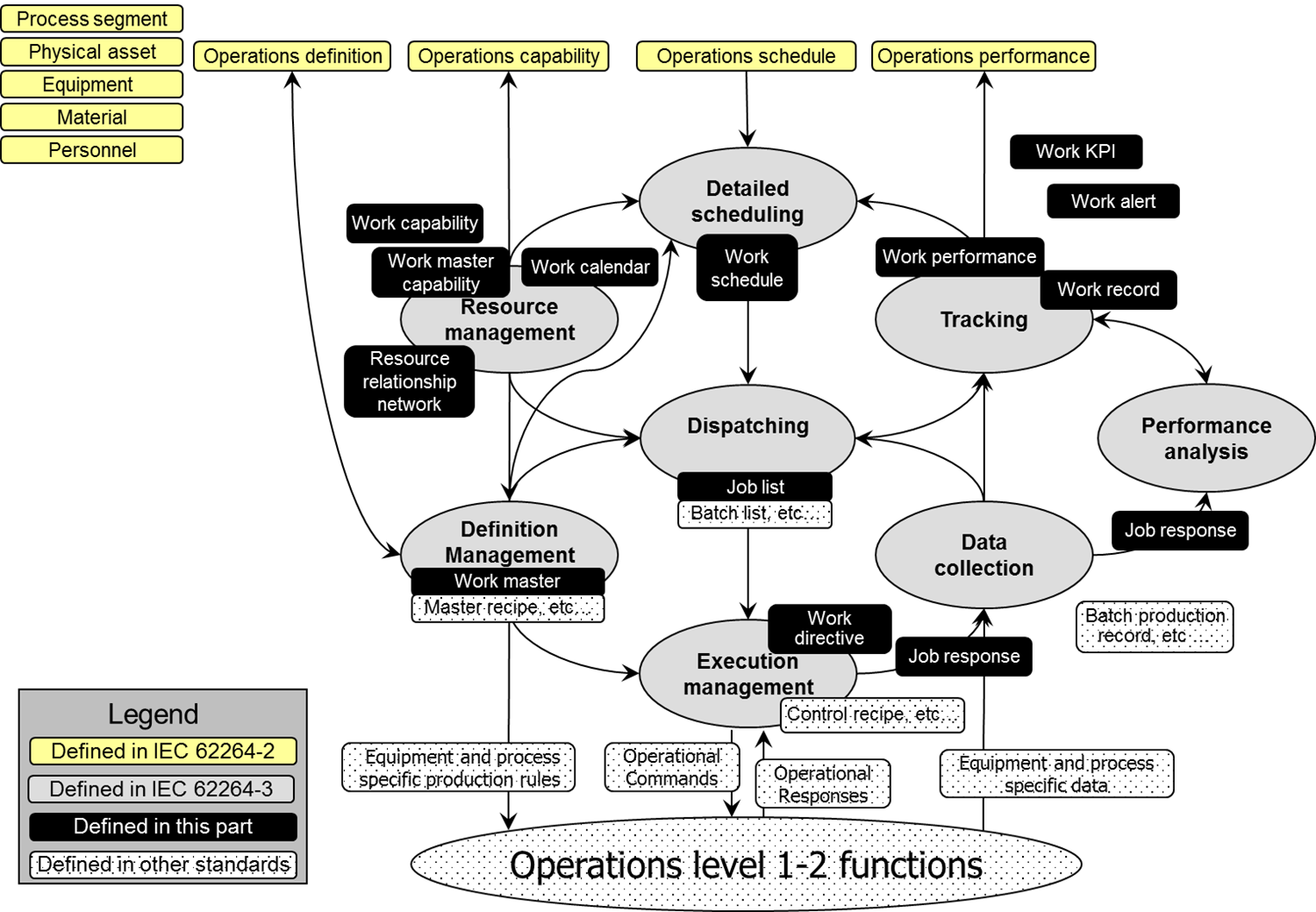

Figure 1 – Information exchange models   
for manufacturing operations management

NOTE IEC 61512 defines object models that relate to the lower elements of the Level 3 activities and defines the information used to create and manage master recipes, control recipes, batch lists, and batch production records. Equivalent structures, or IEC 61512 structures, could be used for other types of production. This standard does not redefine these objects.

## MOM Information exchange models

### Overview

The information exchange models define structures that can be used to define, manage, and execute work within Level 3 MOM. The models are similar in structure to those defined in part 2 of this standard but are defined for information exchange between Level 3 MOM activities.

### Process segments and work masters

Part 2 models of this standard define the view of manufacturing as seen by Level 4 business systems and based on a view of the manufacturing processes defined in *process segments*. The models of this part of ANSI/ISA-95 define the view of manufacturing as seen by Level 3 operations and are based on a view of the manufacturing processes defined in *work masters*.

*Work masters* define the resources and steps for *job orders* that are scheduled, displayed, executed, and tracked by Level 3 MOM activities.

NOTE Part 2 models of this standard are used to exchange information from the process segment (business) view for Level 4 planning. Models such as *operations definition* and *operations schedule* support the allocation of resources and scheduling activities to the plant. Models in this part of ANSI/ISA-95 are used to exchange information for Level 3 execution.  Models such as *work master* reference the *operations definition* exchanged with Level 4, but they have the details needed for actual execution of Level 3 activities. See Annex B for additional discussion of ISA-95.00.02, this part of ANSI/ISA-95, and IEC 61512 model relationships.

### Common resource definitions

The object models in this part of ANSI/ISA 95 use the personnel, equipment, physical asset, and material information defined in part 2 of this standard. When used with Level 3 work objects, the personnel, equipment, physical asset, and material information may include information required for Level 3 activities in addition to the information required to be shared with Level 4 activities.

EXAMPLE 1 The personnel information required for Level 3 activities can include detailed experience and qualification levels that are not shared with a Level 4 personnel or training management system.

EXAMPLE 2 The material information maintained for Level 3 activities can include sublot information which is not shared with Level 4 material management systems.

EXAMPLE 3 Delivery, usage and emission of energy units can be handled as material information.

### Work models

The following object models are defined in this part of ANSI/ISA-95

1. Resource relationship network – *Resource relationship networks* are created by tasks in resource management and definition management activities.
2. *Work definition* 
   1. *Work master* – *Work masters* are created by an engineering activity defined in part of this standard and to be managed by a task in definition management activities.
   2. *Work directive* – *Work directives* are created by a task in execution management activities.
3. *Work schedule* – *Work schedules* are created by a task in detailed scheduling activities.
4. *Job list* – *Job lists* are created by a task in dispatching activities.

NOTE 1 In this part of ANSI/ISA-95, the term job is sometimes used instead of *job order* when referring to an entry in a *job list*.

1. *Work performance* – *Work performances* are created by a task in tracking activities.
2. *Work capability* – *Work capabilities* are created by a task in resource management activities.
3. *Work master capability* – *Work master capabilities* are created by a task in resource management activities.
4. *Work alert* – *Work alerts* may be created by any activity in the activity model.
5. *Work calendar* – *Work calendars* may be created by a task in resource management activities.

NOTE 3 *Work calendars* can also be created by a task in a Level 4 activity.

1. *Work record* – *Work records* are created by a task in tracking activities.

## Cross model relationships for MOM activity context in exchanges

The part 2 operations information models and part 4 work information models are aligned through defined cross-model relationships to provide the context of MOM activity or workflow for schedules/requirements, definitions, and performance/response exchanges. These cross-model relationships provide a smart manufacturing integration framework for interactive manufacturing operations in the plant and between the plant and enterprise functions, Figure 2 and Table 1shows the supported relationships between MOM objects that provide data references for schedule/request/requirement; job order/definitions; and responses/actuals.

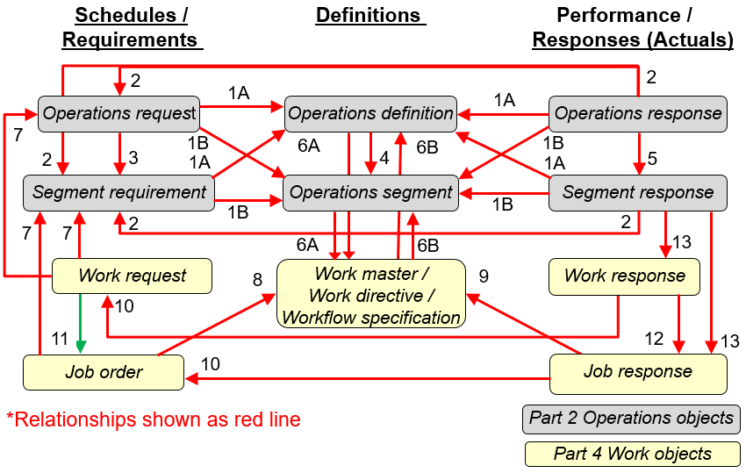

Figure 2 – Cross-model MOM relationships between operations & work models

Table 1 – Cross-model MOM relationship description

| Reference  No. | MOM context relationship description | |
| --- | --- | --- |
| From (*object*) | To *(object*) |
| 1A | Level 4 (L4) schedule (*operations request)*  L4 requirement *(segment requirement*)  L4 response (*operations response, segment response*) | L4 definition (*operations definition*) |
| 1B | L4 schedule (*operations request)*  *L4 requirement (segment requirement*)  L4 response (*operations response, segment response*) | L4 definition (*operations segment*) |
| 2 | L4 response (*operations response, segment response*) | L4 schedule (*operations request)*  L4 requirement *(segment requirement*). |
| 3 | L4 schedule (*operations request*) | L4 requirement (*segment requirement*) |
| 4 | L4 definition (*operations definition*) | L4 definition (*operation segment*) |
| 5 | L4 response (*operations response*) | L4 response (*segment response*) |
| 6A | L4 definition (*operations definition, operations segment)* | L3 definition (work master) |
| 6B | Level 3 (L3) definition (*work directive*) | L4 definition (*operations definition, operations segment*) |
| 7 | L3 schedule (*job order, work request*) | L4 requirement (*segment requirement*)  L4 schedule (*operations request*) |
| 8 | L3 schedule (*job order, work request*) | L3 definition (*work master*) |
| 9 | L3 response (*job response*) | L3 definition (*work masters, work directives*) |
| 10 | L3 response (*job response, work response*) | L3 schedule (*job order, work request*) |
| 11 | L3 schedule (*work request*) | L3 requirement (*job order*) |
| 12 | L3 response (*work response*) | L3 response (*job response*) |
| 13 | L4 response (*segment response*) | L3 response (work responses, job responses) |

# General information model characteristics

## Minimum object attribute sets

Clause 5 describes the methods used to define object models and attributes for information exchanged between Level 3 and Level 4 activities and associated functions. The attributes are part of the definition of object models for exchanged information and terms.

In this standard, the word “class” used as part of an object definition name is to be considered as a category, not as a “class” in the UML specification.

EXAMPLE “*Personnel class*” is to be considered a “personnel category”, in the sense of distinguishing between the kinds of *personnel* in the real world.

A minimum set of industry-independent information has been defined as attributes. However, values for all attributes may not be required depending on the actual usage of the models. If additional information, including industry- and application-specific information, is needed, it shall be presented as property objects. This mechanism is the extension capability referenced in the scope of this standard. This method increases the usability through the use of standard attributes and allows flexibility and extensibility through the use of properties. The use of properties is included to make the standard as widely applicable as practical.

NOTE This was written to make the standard as widely applicable as practical.

## Object attribute extensibility

For particular applications, the objects defined in the object models will be extended through the addition of attributes to object class definitions. Accordingly, this standard provides for attributes that are application or industry specific, to be modeled in terms of properties and represented in property classes in the model.

EXAMPLE The *personnel class property* may define application- or industry-specific attributes for *personnel classes*, and *person property* may contain values for the properties.

## Information object model structure

The information object models are depicted using a simplified application of the Unified Modeling Language (UML) notational methodology, as defined in ISO/IEC 19501, ISO/IEC 19505-1 and ISO/IEC 19505-2.

### UML notation in information object models

Table 2 defines the UML notations used in the simplified information object diagrams.

Table 2 – UML notation used

| Symbol | Definition |
| --- | --- |
|  | Defines a package, a collection of object models, state models, use cases, and other UML models. Packages are general-purpose grouping mechanisms used to organize semantically related model elements. In this document, a package is used to specify an external model, such as operations definition model, or a reference to another part of the model. |
|  | Represents a UML class of objects, each with the same types of attributes. Each object is uniquely identifiable or enumerable. No operations or methods are listed for the classes. |
|  | An association between elements of a class and elements of another or the same class. Each association is identified. Can have the expected number or range of members of the subclass, when ‘*\**’ indicates an indeterminate number. For example, 0..*\** means that zero or more members of the subclass can exist.  The semantics of the association are defined in the object relationship table of each object participating in the relationship. |
|  | Generalization (arrow points to the super class) shows that an element of the class is a specialized type of the super class. |
|  | Dependence is a weak association that shows that a modeling element depends on another modeling element. The item at the tail depends on the item at the head of the relationship.  The semantics of the association are defined in the object relationship table of each object participating in the relationship. |
|  | Aggregation shows an element of the class (whole element) is made up of elements of other classes (part elements).  EXAMPLE 1    The aggregation notation identifies that the lifetime of the part element is independent of the whole element. The part element is able to be a part of multiple parent elements. When a whole element is deleted, the part elements are not deleted.  The parts’ physical relationship is independent of its lifetime relationship. A part can be represented directly in the whole or referenced from the whole. |
|  | A composition relationship represents a whole–part relationship and is a type of aggregation. A composition relationship specifies that the lifetime of the part classifier is dependent on the lifetime of the whole classifier. Composition shows a strong form of aggregation, which requires 1) a part instance is included in only one composition at a time and 2) the composition object has sole responsibility for disposition of its parts.  EXAMPLE 2    The composition notation identifies that the lifetime of the part elements is dependent on the whole element. When a whole element is deleted, the part elements are deleted.  The parts’ physical relationship is independent of its lifetime relationship as a part represented directly in the whole or referenced from the whole. |
|  | Three or more elements are strongly associated. If three elements are associated, the term ‘ternary’ association may be used.  The association object (diamond shape) may be an object, which can support attributes relevant to the association.  There is no lifetime dependency between the associated objects. |
|  | The association of A and B are refined by the class C, which is referred to as the association class.  If A and B are the same class, A and B are part elements with no distinctions made between the A and B. A and B are referred to as source and target to allow distinction of parts. |

NOTE UML lifecycles are not applicable to individual information exchanges. The relationships in the UML diagram provides a view into object lifecycles at the time of an information exchange. The navigation shown in the UML diagram is the most commonly applied; however, some implementation methods and technologies may require a bidirectional relationship or need to specify the relationship roles for both ends of the relationship. The defined relationship in the ISA-95 UML diagrams in combination with the model relationship table and the object relationship tables for each object define the “minimum” compliance required for ISA-95. Additional relationship and roles required for an implementation shall be explicitly defined as non-compliant the implementation documentation...

### Conventions used in tables of object relationships and roles

This subclause explains the use and meaning of the relationship table for each information model and the role table for each object in an information model.

Each information model’s UML diagram is explicitly defined by the simplified UML model in combination with a relationship table the UML model that lists each predominate relationship and with a role table for each object in UML model that lists its role in each of the object’s relationships.

The object relationship table uses the following UML object relationship types to identify the relationship between objects. In the object relationship table, the object relationship is defined specifically from each object’s perspective. The generic specification may be further qualified within the relationship table entry to clarify the relationship context.

1. Association The association type represents a general relationship between two objects. The relationship table identifies the details of whether the relationship attribute is required or optional in the object. A dashed line indicates a weak association between objects.

EXAMPLE A *material definition* defines 0..* *material lot* objects where, in contrast, a *material lot* is defined by 1..1 *material definition*. A *material lot* contains a relationship to its *material definition*, which is represented as a relationship attribute in the *material lot*. In an data exchange implementation, the *material lot* objects associated with a *material definition* is recorded in the *material definition* occurrence; but in another implementation, the *material lot* objects are recorded in separate systems using link table references.

1. Dependency The object has a semantic link to the object, which may be required to be satisfied before the object can be created.
2. Aggregation The view of the UML relationship is qualified by the target end of the relationship link; the terminology used is “aggregation part” for the sub object and “aggregation whole” for the parent object. An aggregation type may be refined with the following keywords:
3. Whole The object is the whole object in the aggregation.
4. Part The object is the part object in the aggregation.
5. Hierarchy The object may be both a whole and part object (e.g. equipment hierarchy). This infers that implementations may utilize parent and child prefixes or link tables if navigation of the hierarchy is required. In an aggregation hierarchy when a parent object is deleted, the relationships to other child objects are removed if specified in link tables but the child objects are not deleted.
6. Composition The relationship view is qualified by the target end of the relationship; the terminology used is ‘composition part’ for the sub object and ‘composition whole’ for the parent object. A composition type may be refined with the following keywords:
7. Whole The object is the whole object in the composition.
8. Part The object is the part object in the composition.
9. Composition hierarchy The objects may be both a whole and part object (e.g. material lot hierarchy). Implementations may utilize parent and child prefixes or link tables if navigation of the hierarchy is required. If the root parent object is deleted, all child objects and their child objects are deleted.

EXAMPLE The UML diagram of personnel model in Figure 3 below in combination with the associated relationship table in Table 3 shows the *personnel class* object’s relationships as an example of how the standard represents each object’s relationships in the context of the information model.

NOTE The “>” symbol on either end of the relationship name indicates the direction of the predominate relationship direction. Depending on the implementation technology applied, the role on both ends and the reverse relationship may be required and should be documented as non-compliant to ISA-95.



Figure 3 – Example: UML Diagram for an information model, Personnel model

Table 3 – Example: Relationship table for an information model, Personnel model relationships

| From | To | Type | Relationship Name |
| --- | --- | --- | --- |
| Personnel class | Personnel class property | Composition | Has properties of |
| Personnel class | Personnel class | Association | Is a specialization of |
| Person | Personnel class | Association | Defined by |
| Person | Person property | Composition | Has values of |
| Person property | Personnel class property | Dependency | Maps to |
| Person property | Person property | Composition hierarchy | Contains |
| Personnel class property | Personnel class property | Composition hierarchy | Contains |

To explicitly define object’s relationships in an information model’s UML diagram, each object’s definition uses a relationship role table to lists role of the related object in each predominate relationship.

NOTE The column headers for the object relationship table are

1. Related object For a given object, each row in the relationship role table defines a relationship of the object to another object in the information model.
2. Role The relationship role of the related object in relationship to the given object (what the given object may use to identify the related object).
3. Multiplicity The multiplicity in UML diagram that specifies cardinality - i.e. number of elements - of some collection of elements. Multiplicity element defines some collection of elements and includes both multiplicity as well as specification of order and uniqueness of the collection elements.
4. Description The description of the object’s relationship.

EXAMPLE The example for role table for the personnel class object in the example of the UML diagram of personnel model is shown in Table 4.

Table 4 – Example: Relationship role table, Personnel class relationship roles

| Related Object | Role | Multiplicity | Relationship Name | Description |
| --- | --- | --- | --- | --- |
| Personnel class | Pattern personnel class | 0..* | Is a specialization of | The pattern *personnel class(s)* of which this *personnel class* is a specialization*.* |
| Personnel class | Instance personnel class | 0..* | Is a specialization of | The instance *personnel class(s)* contained within this pattern *personnel class*. |
| Personnel class property | Personnel class property | 0..* | Has properties of | The *personnel class properties* of this *personnel class*. |
| Person | NA | 0..* | Defined by | The *person* supports this *personnel class.*  The *person* objects support the *personnel class property(s)* associated with this *personnel class.* |

### Conventions used in object attribute tables

#### Object attribute tables

This subclause gives the meaning of the object attribute tables. This includes a listing of the object identification, data types, presentation of the examples in the tables, references to resources, object relationships, related object naming convention, and object relationship implementations.

All attributes in the tables shall be considered optional, except where specified as required in the attribute description.

#### Object identification

Many objects in the information model require unique identifications (IDs). These IDs shall be unique within the scope of the exchanged information.

NOTE This may require translations:

* from the internal ID of the source system to the interface content ID,
* from the interface content ID to the internal ID of the target system.

EXAMPLE A unit can be identified as “X6777” in the interface content, as resource “R100011” in the business system, and as “East Side Reactor” in the control system.

A unique identification set shall be agreed for an information exchange.

The object IDs are used only to identify objects within related exchanged information sets. The object ID attributes may be global object IDs or database index attributes.

NOTE Generally, objects that are elements of composite aggregations or shared aggregation that are not referenced elsewhere in the model, do not require unique IDs.

#### Data types

The attributes presented are abstract representations, without any specific data type specified.

NOTE Specific implementations of this part should specify how the information is represented.

EXAMPLE 1 An attribute can be represented as a string in one implementation and as a numeric value in another implementation.

EXAMPLE 2 A date/time value can be represented in ISO standard format in one implementation and in Julian calendar format in another. Attributes for date or time can contain values for a date, a date and time or a time value, the standard does not enforce the value semantics. Each implementation will have to negotiate the value semantics.

EXAMPLE 3 An object or attribute relationship can be represented by key fields in data base tables, or by parent/child elements in an XML by nested hierarchy.

#### Presentation of examples

Examples are included with each attribute given. Examples are presented for each of the main operations categories defined in ISA 95.00.01. Table 5 shows how the attribute example rows and columns are used.

Table 5 – Example: Object attribute table

| Attribute name | Description | Production example | Maintenance example | Quality example | Inventory examples |
| --- | --- | --- | --- | --- | --- |
| Name of first attribute | Description of first attribute | Production example | Maintenance example | Quality example | Inventory example |
| Name of second attribute | Description of second attribute | Production example | Maintenance example | Quality example | Inventory example |
| Name of third attribute | Description of third attribute | Production example | Maintenance example | Quality example | Inventory example |

When an example value is a set of values, or a member of a set of values, the set of values is given within a set of braces, {}.

The examples are purely fictional. They are provided to further describe attributes in the model. No attempt was made to make the examples complete or representative of any manufacturing enterprise.

NOTE 1 Within a table the columns for production, maintenance, quality and inventory can be examples where the four operations management categories are coordinated or they can be separate examples. For example, when one system is coordinating multiple operations management categories the IDs used in each column can be the same. When different systems coordinate multiple operations management categories the IDs can be different. Example attributes are meant to be illustrative, and do not imply requirements.

NOTE 2 Time and date attributes can illustrate a general or specific time horizon. For example, a yearly or quarterly plan can use general dates with no specific time, while a detailed schedule can include a specific time stamp down to the minute.

Data resolution used in the examples are typical examples.

NOTE 1 Specific implementations of this part should specify the data resolution required for each attribute.

NOTE 2 . When <NA> (not applicable) is used as an example this is only illustrative that there is not a value for this attribute in this example. It does not imply there can never be a value. This is also true when all four columns contain <NA>.

### Association relationships between object models and supporting resource models

#### Object color convention for cross-model relationship

The object color convention used in the Part 2 and Part 4 UML diagrams for information models is

* A UML object with a white background belongs to the information model defined in the clause containing the UML diagram.
* A UML object with a gray background belongs to a defined information model in Part 2 that is not defined in the clause containing the UML diagram.
* A UML object with a yellow background belongs to a defined information model in Part 4 that is not defined in the clause containing the UML diagram.
* A UML object with a dark gray background belongs to an external information model not defined in the ISA-95 standard parts.
* A UML object with a blue background belongs to an abstract object defined in the clause.
* A UML object with a pink background belongs to an interface abstract object defined in the clause containing the UML diagram.

NOTE When a Part 2 (gray) or Part 4 (yellow) object has relationship to an object (white) defined in the clause containing the UML diagram, only the basic relationships between the objects not defined in the clause are shown for better context of the object (white) defined in the clause.

#### ISA-95 resource model referencing method

The simplified ISA-95 UML model uses the ISA-95 resource model referencing method in the Clause 6 operations management information models to simplify the UML representation of the four possible relationships between a specific object (specification, requirement, actual) in an information model and an associated object in the resource information model. The simplified ISA-95 UML model does not fully document the possible cross-model relationships; thereby, the resource model referencing method does not conform to the Unified Modeling Language (UML) notational methodology as defined in ISO/IEC 19501.

The simplified ISA-95 UML techniques are intended as a visualization method that must be used in combination the object attribute tables, object model relationship table, and object role tables for an explicit definition of the abstract ISA-95 information exchanges supported by compliant integration implementations.

Figure 4 illustrates resource model referencing method in the simplified ISA-95 UML model in the left column to compare the detailed relationships per the ISO/IEC 19501 compliant UML model in the right column.

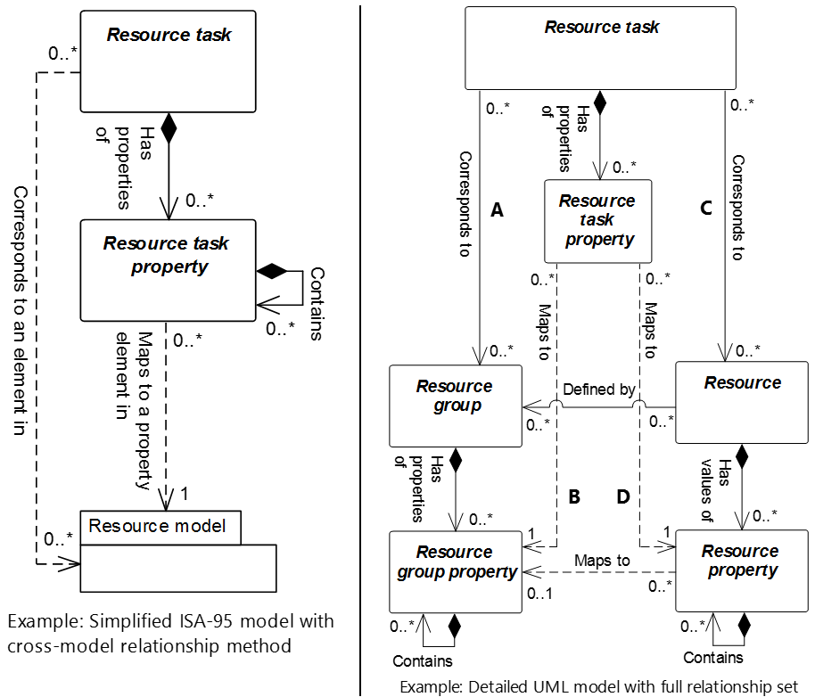

Figure 4 – Cross-model relationships to resource models

NOTE 1 The implemented association relationship for a *resource task* is defined through only one of four relationships

* 1. A
  2. A and B
  3. C
  4. C and D

NOTE 2 Reference terms for resource objects in Figure 4 are

1. *resource task* includes the resource task objects listed in Table 6,
2. *resource group* includes *personnel class, equipment class, physical asset class, material class, and material definition objects,*
3. *resource* includes *person, equipment, physical asset, material lot and material sublot objects.*

Table 6 lists the object relationships in the detailed UML model example in Figure 4.

Table 6 – Detailed UML model relationships in Figure 4

| From | To | Type | Relationship Name |
| --- | --- | --- | --- |
| Resource task | Resource group | Association (A) | Corresponds to |
| Resource task | Resource | Association (C) | Corresponds to |
| Resource task property | Resource group property | Dependency (B) | Maps to |
| Resource task property | Resource property | Dependency (D) | Maps to |
| Resource task | Resource task property | Composition | Has properties of |
| Resource | Resource group | Association | Defined by` |
| Resource | Resource property | Composition | Has values of |
| Resource group | Resource group property | Composition | Has properties of |
| Resource property | Resource group property | Dependency | Maps to |
| Resource property | Resource property | Composition hierarchy | Contains |
| Resource group property | Resource group property | Composition hierarchy | Contains |

Table 7 provides the reference labels for each of the four-possible cross-model relationships for referencing resource objects shown in Figure 4 for an implemented *resource task* instance such as Mixer 101 as an *equipment* object*.*

1. Only one of the four possible relationships are permitted for a given *resource task* instance.
2. The paired relationships, Label A with B and Label C with D, shows that a *resource task* cannot be represented by a single dependency relationship to either a *resource class property* (B) or to a *resource property* (D) since the properties are in a composition relationship;
3. Consequently, the *resource task* only references a resource model property if the property's parent object has an association relationship (A or D) with the *resource task*.

Table 7 – Four possible cross-model relationships for a *resource task* instance

|  |  |
| --- | --- |
| Figure 3 relationship label | Possible cross-model relationships for a *resource task* instance |
| A | An association between the *resource task* and *resource group* |
| A with B | An association between the *resource task* and *resource group* and  A dependency between the *resource task property* and *resource group property* |
| C | An association between the *resource task* and resource |
| C with D | An association between the *resource task* and resource and  A dependency between the *resource task property* and *resource property* |

Table 8 lists the ISA-95 models applying the simplified ISA-95 resource model referencing method and defines the set of possible resource relationships for objects within each model.

Table 8 – List of ISA-95 models and their permitted resource object instances in cross-model relationships to resource models

| ISA-95 Model | Resource task | Associated resource model | Associated resource group | Associated *resource* |
| --- | --- | --- | --- | --- |
| Process segment | Personnel segment specification | Personnel | Personnel class | Person |
| Equipment segment specification | Equipment | Equipment class | Equipment |
| Physical asset segment specification | Physical asset | Physical asset class | Physical asset |
| Material segment specification | Material | Material class, material definition | Material lot, material sublot |
| Operations definition | Personnel specification | Personnel | Personnel class | Person |
| Equipment specification | Equipment | Equipment class | Equipment |
| Physical asset specification | Physical asset | Physical asset class | Physical asset |
| Material specification | Material | Material class, material definition | Material lot, material sublot |
| Operations schedule | Personnel requirement | Personnel | Personnel class | Person |
| Equipment requirement | Equipment | Equipment class | Equipment |
| Physical asset requirement | Physical asset | Physical asset class | Physical asset |
| Material requirement | Material | Material class, material definition | Material lot, material sublot |
| Operations performance | Personnel actual | Personnel | Personnel class | Person |
| Equipment actual | Equipment | Equipment class | Equipment |
| Physical asset actual | Physical asset | Physical asset class | Physical asset |
| Material actual | Material | Material class, material definition | Material lot, material sublot |
| Operations capability | Personnel capability | Personnel | Personnel class | Person |
| Equipment capability | Equipment | Equipment class | Equipment |
| Physical asset capability | Physical asset | Physical asset class | Physical asset |
| Material capability | Material | Material class, material definition | Material lot, material sublot |
| Process segment capability | Personnel capability | Personnel | Personnel class | Person |
| Equipment capability | Equipment | Equipment class | Equipment |
| Physical asset capability | Physical asset | Physical asset class | Physical asset |
| Material capability | Material | Material class, material definition | Material lot, material sublot |

Table 9 to Table 14 provide the role table for the following reference objects contained in the detailed UML model in Figure 4: *Resource task, resource task property, resource group, resource group property, resource,* and *resource property*.

Table 9 – Resource task cross-model relationship roles

| Related Object | Role | Multiplicity | Relationship Name | Description |
| --- | --- | --- | --- | --- |
| Resource group (A) | Resource group | 0..* | Corresponds to | The *resource group(s)* support this resource task.  The *resource group(s)* support the *resource task property(s)* associated with this *resource task*. |
| Resource (C) | Resource | 0..* | Corresponds to | The *resource(s)* support this *resource task*.  The *resource(s)* support the *resource task property(s)* associated with this *resource task.* |
| Resource task property | Resource task property | 0..* | Has properties of | The *resource task property(s)* defining in part this *resource task.* |
| **EXAMPLE *Personnel segment specification* cross-model relationships to personnel model** | | | | |
| Personnel class (A) | Personnel class | 0..* | Corresponds to | The *personnel class(s)* support this *personnel segment specification.*  The *personnel class(s)* support the *personnel segment specification property(s)* associated with this *personnel segment specification*. |
| Person (C) | Person | 0..* | Corresponds to | The *personnel class(s)* support this *person.*  The *personnel class(s)* support the *person property(s)* associated with this *person.* |

Table 10 – Resource task property cross-model relationship roles

|  |  |  |  |  |
| --- | --- | --- | --- | --- |
| **Related Object** | **Role** | **Multiplicity** | **Relationship Name** | **Description** |
| Resource group property (B) | Resource group property | 1 | Maps to | This *resource task property* defined by the *resource group property*. |
| Resource property (D) | Resource property | 1 | Maps to | This *resource task property* defined by the *resource property*. |
| Resource task | NA | 1 | Composition | This *resource task property(s)* of the *resource task.* |
| **EXAMPLE *Personnel segment specification* cross-model relationships to *personnel model property(s)*** | | | | |
| Personnel class property (B) | Personnel class property | 1 | Maps to | The *personnel class(s)* support this *personnel segment specification*.  The *personnel class property(s)* support the *personnel segment specification* *property(s)* associated with this *personnel segment specification*. |
| Person property (D) | Person property | 1 | Maps to | The *person(s)* support this *personnel segment specification.* The *person property(s)* support the *personnel segment specification property(s)* associated with this *personnel segment specification.* |

Table 11 – Resource group cross-model relationship roles

|  |  |  |  |  |
| --- | --- | --- | --- | --- |
| **Related Object** | **Role** | **Multiplicity** | **Relationship Name** | **Description** |
| Resource task (A) | NA | 0..* | Corresponds to | The *resource task* related to this *resource group*. |
| Resource | NA | 0..* | Defined by | The *resource* defined by this *resource group.* |
| Resource group property | Resource group property | 0..* | Has properties of | The *resource group property(s)* of this *resource group property.* |
| **EXAMPLE *Personnel segment specification* cross-model relationships with *personnel class*** | | | | |
| Personnel segment specification (A) | NA | 0..* | Corresponds to | The *personnel class(s)* support this *personnel segment specification*.  The *personnel class property(s)* support the *personnel segment specification* *property(s)* associated with this *personnel segment specification*. |
| Personnel class property | Personnel class property | 0..* | Has properties of | The *personnel class(s)* support this *personnel segment specification.*  The *personnel class property(s)* support *the personnel segment specification property(s)* associated with this *personnel segment specification*. |

Table 12 – Resource group property cross-model relationship roles

|  |  |  |  |  |
| --- | --- | --- | --- | --- |
| **Related Object** | **Role** | **Multiplicity** | **Relationship Name** | **Description** |
| Resource task property (B) | NA | 0..* | Maps to | The *resource task property* related to this *resource group property*. |
| Resource group | NA | 1 | Has properties of | The *resource group* defined in part by this *resource property*. |
| Resource property | NA | 0..* | Maps to | The *resource property* defined by this *resource group property.* |
| Resource group property | Resource group property | 0..* | Contains | The *resource group property(s)* of this *resource group property.* |
| **EXAMPLE *Personnel class property* cross-model relationships with a *personnel segment specification property*** | | | | |
| Personnel segment specification property (B) | NA | 1 | Maps to | The *personnel class(s)* support the *personnel segment specification*.  This *personnel class property(s)* support the *personnel segment specification* *property(s)* associated with the *personnel segment specification*. |
| Personnel class property | Personnel class property | 0..* | Contains | The *personnel class(s)* support this *personnel segment specification.*  The *personnel class property(s)* support *the personnel segment specification property(s)* associated with this *personnel segment specification*. |

Table 13 – Resource cross-model relationship roles

|  |  |  |  |  |
| --- | --- | --- | --- | --- |
| **Related Object** | **Role** | **Multiplicity** | **Relationship Name** | **Description** |
| Resource task (C) | NA | 0..* | Corresponds to | This *resource* related to the *resource task*. |
| Resource group | Resource group | 0..* | Defined by | This *resource* defined by the resource group |
| Resource property | Resource property | 0..* | Has values of | The *resource property(s)* containing the values of this *resource.* |
| **EXAMPLE  *Personnel segment specification* cross-model relationships with a person** | | | | |
| Personnel segment specification (C) | NA | 0..* | Corresponds to | This *person(s)* support the *personnel segment specification*.  This *person property(s)* support the *personnel segment specification* *property(s)* associated with the *personnel segment specification*. |
| Person property | Person property | 0..* | Has values of | This *person(s)* support the *personnel segment specification.*  This *person property(s)* support *the personnel segment specification property(s)* associated with this *personnel segment specification*. |

Table 14 – Resource property cross-model relationship roles

| **Related Object** | **Role** | **Multiplicity** | **Relationship Name** | **Description** |
| --- | --- | --- | --- | --- |
| Resource task property (D) | NA | 0..* | Maps to | The *resource task property* related to this *resource group property*. |
| Resource | NA | 1 | Has values of | The *resource* contains the values of this *resource property(s)*. |
| Resource group property | Resource group property | 0..1 | Maps to | This *resource property* defined by the *resource group*. |
| Resource property | Resource property | 0..* | Contains | The *resource property(s)* of this *resource property.* |
| **EXAMPLE  *Person property* cross-model relationships with a *personnel segment specification property*** | | | | |
| Personnel segment specification property (D) | NA | 0..* | Maps to | This *person(s)* support the *personnel segment specification*.  This *person property(s)* support the *personnel segment specification* *property(s)* associated with the *personnel segment specification*. |
| Personnel class property | Personnel class property | 0..1 | Maps to | This *person(s)*support the *personnel segment specification.*  This *person property(s)* support *the personnel segment specification property(s)* associated with this *personnel segment specification*. This *person property* is defined in part by the *personnel class property*. |

### Object relationships between abstract information models and implementation models

ISA-95 information models represent exchanged data in an abstract UML model using

1. Objects
2. Attributes of objects
3. Relationships and roles between objects

NOTE 1 Abstract model, a conceptual abstract overview of the structure of data. An abstract model does not provide information related to how the structure is to be implemented or the means (rules, technologies) that are needed to implement the structure shown.

NOTE 2 ISA-95 abstract information models can be represented as a logical model schema for the specific purpose to formally documents the contents of the abstract models.

NOTE 3 UML lifecycles are not applicable to individual information exchanges. The relationships in the UML model provides a view into object lifecycles at the time of an information exchange

ISA-95 abstract information models differ from the logical models typically used by IT groups in application development. Logical models in application development focus on a specific target. ISA-95 abstract models are generic models so they can be applied across many industries and applications. As such the ISA-95 abstract models are focused on being abstract and generic with limited constraints on the representation. Constraints are applied during the transformation from abstract to implementation model.

NOTE Implementation model, an interpretation / instance of the abstract model relevant as specific implementation scope. An implementation model applies rules and requirements to the abstract model to develop a model implemented with a specific exchange technology.

The data shown in the abstract ISA-95 UML models may be implemented as a subset, specialization or extension of those models. The relationship between the abstract ISA-95 UML and implementation models is expressed through a transformation process which may be a combination of text and transformation / constraint rules. The data shown in an implementation model may include the following as well as additional entries depending on the requirements of the implementation:

* 1. Cardinality
  2. Navigability
  3. Definitions
  4. Key attributes (primary keys, secondary keys)
  5. Intermediate objects / link objects (e.g. Many to many tables)

NOTE 1 Implementation models may be generic models that support a broad implementation scope in a specific exchange technology which can further refined by other implementation models that have a tighter scope.

NOTE 2 Different implementation models of the ISA-95 abstract objects and UML models apply various technical methods to represent the object relationships presented in the ISA-95 abstract model.

EXAMPLE 1 ISA-95 object relationships can be represented as additional attributes in a database implementation; The same object relationships can also be represented as in a containment in an XML document implementation.

EXAMPLE 2 An ISA-95 implementation model is the business-to-manufacturing-markup-language (B2MML) from MESA International.

The abstract to implementation model transformation process from ISA-95 abstract models or a more generic implementation model is achieved by the application of rules and processing steps over the objects, relationships, and attributes of the source model to produce the implementation model.

Implementation models may constrain ISA-95 logical model object relationships by applying additional constraints to the abstract ISA-95 logical models. The abstract ISA-95 models and associated relationship and role tables present information which may not be relevant to specific implementation models. The object lifetime and navigation information is typically required in a persistent store but is not required for a specific information exchange interpretation. Navigation constraints are defined and applied for ISA-95 undefined navigations. Even though individual message payloads have no navigation and lifetime semantics applied, the ISA-95 information models can be used to represent a canonical information model that references all endpoints. In this case, the object relationships influence the message representation. The implementation of the abstract ISA-95 relationships vary depending on the implementation technology applied and implementation requirements. The related object naming conventions and relationship types in ISA-95 object relationship tables allow implementation models to be constructed from the abstract models in the standard in a common manner.

The implementation model can be visualized using the same UML, attribute table and relationship table formats as used in ISA-95. The implementation model is documented in a standard message profile which describes the compliant and specialized custom objects. The user of the implementation model shall be able to understand the difference between the source of abstract model to the end result in the implementation model.

Annex A in part 2 of this standard shows a typical related object naming convention for the mapping for the ISA-95 abstract model to an implementation model. Annex G in part 2 shows typical implementation model examples. Annex H in part 2 shows descriptions of typical implementation technologies.

NOTE 1 In the message payloads, the object relationship is either as contained objects or external references using reference ID values. The reference ID values may be directly reference the ID of an external object or an intermediate associative ID to link tables that connect the objects and add attributes to the link.

NOTE 2 If the transaction processing logic within the sender and receiver applications require navigation persistence, the message payload may require relationship attributes for the object relationships to aid in message processing.

ISA-95 abstract UML models are independent of the implementation models. Implementation models are classified by two categories representing application of ISA-95 models. Further specializations on these categories can be developed depending on implementation requirements.

1. Information model persistence Information is retained in a persistent store closely aligned with the ISA-95 models, which can be part of messaging infrastructure or at application level in systems. This category of system receives and generate ISA-95 transactions with minimal additional translation between the message and the store’s meta data. ISA-95 objects are created, updated and deleted with ISA-95-based transactions. The persistence technology uses a storage model to implement the relationship rules.

EXAMPLE 1 Storage models relational, associative, object, semantic, graph, triple store.

In a message or information exchange, object lifetimes and navigation are defined by the model relationship and role tables represented in ISA-95. The details of processing of the relationship are managed by the implementation method.

1. Message structure definition Messages between applications construct data objects from each application’s information models by serializing their content into a message payload in a form validated against the ISA-95 models. As message payloads are constructed and interpreted as a whole, there are no navigation and lifetime semantics applied to the content in message payloads. Each message is a partial snapshot of the sender’s information model at the time of the data exchange.

EXAMPLE 2

* Hierarchical (Nested XML)
* Flat (Flat buffers, flat XML, csv)
* Object (OMG - IDL), JSON

# Resource relationship network information

## Resource relationship network model

*Resource relationship networks* shall be used to describe relationships between two or more resources in order to represent information that may be required for detailed scheduling activities, dispatching activities, execution activities, or other Level 3 activities.

Each *resource relationship network* is a collection of *resource network connections*, as shown in Figure 5. Table 15 lists the relationships of the objects in the *resource relationship network* model.

Each *resource network connection* shall be represented as a directed connection between a *to resource reference* and a *from resource reference*.

NOTE 1 Relationships are represented as directed multi-graphs in graph theory. Each relationship represents an “edge” with the resource references represented as vertices.

NOTE 2 The properties of the resource relationship elements are used to represent constraints in the network, such as constraints in flow, direction, set or ordering.

EXAMPLE 1 A “route” *resource network connection* between *equipment* can include properties that include the material transport time between the *equipment* and the material transfer rate between the *equipment.*

EXAMPLE 2 An “approved for use” *resource network connection* between *equipment* and *material definitions* can define which specific *equipment* has been approved for use with specific *materials.* A property of the *resource network connection* can be the date at which the approval for use is expired or revoked.

EXAMPLE 3 A “material substitution” *resource network connection* can define a primary *material* and the list of possible alternate *materials*.

Each *resource network connection* is defined by a *resource network connection type*. The *resource network connection type* may include *resource network connection type properties*, which define the allowable *resource network connection properties*.

NOTE 3 The *resource relationship network* model is conceptually similar to the MIMOSA CCOM network model. See bibliography.

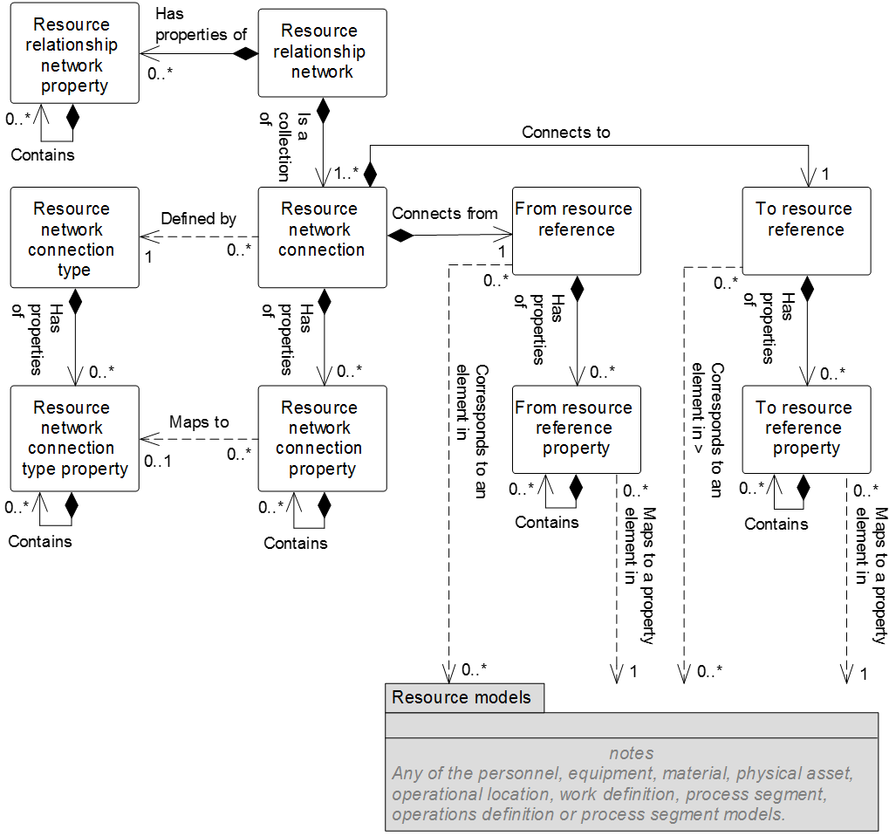

Figure 5 – Resource relationship network model

NOTE 1 The object color convention used in the Part 2 and Part 4 UML diagrams for information models is

* A UML object with a white background belongs to the information model defined in the clause containing the UML diagram.
* A UML object with a gray background belongs to a defined information model in Part 2 that is not defined in the clause containing the UML diagram.
* A UML object with a yellow background belongs to a defined information model in Part 4 that is not defined in the clause containing the UML diagram.

NOTE 1 When a Part 2 (gray) or Part 4 (yellow) object has relationship to an object (white) defined in the clause containing the UML diagram, only the basic relationships between the objects not defined in the clause are shown for better context of the object (white) defined in the clause.

Table 15 – Resource relationship network model relationships

| From | To | Type | Relationship Name |
| --- | --- | --- | --- |
| Resource relationship network | Resource relationship network property | Composition whole | Has properties of |
| Resource relationship network | Resource network connection | Composition whole | Is a collection of |
| Resource relationship network property | Resource relationship network property | Composition hierarchy | Contains |
| Resource network connection | Resource network connection type | Dependency | Defined by |
| Resource network connection | From resource reference | Composition whole | Connects from |
| Resource network connection | To resource reference | Composition whole | Connects to |
| Resource network connection | Resource network connection property | Composition whole | Has properties of |
| Resource network connection type | Resource network connection type property | Composition whole | Has properties of |
| From resource reference | From resource reference property | Composition whole | Has properties of |
| To resource reference | To resource reference property | Composition whole | Has properties of |
| Resource network connection property | Resource network connection property | Composition hierarchy | Contains |
| Resource network connection type property | Resource network connection type property | Composition hierarchy | Contains |
| From resource reference property | From resource reference property | Composition hierarchy | Contains |
| To resource reference property | To resource reference property | Composition hierarchy | Contains |
| From resource reference | *[Resource] class | Association (A) | Corresponds to |
| From resource reference | * [Resource] | Association (C) | Corresponds to |
| From resource reference property | *[Resource] class property | Dependency (B) | Maps to |
| From resource reference property | *[Resource] property | Dependency (D) | Maps to |
| To resource reference | *[Resource] class | Association (A) | Corresponds to |
| To resource reference | * [Resource] | Association (C) | Corresponds to |
| To resource reference property | *[Resource] class property | Dependency (B) | Maps to |
| To resource reference property | *[Resource] property | Dependency (D) | Maps to |

NOTE 1 *[Resource] shall apply to the similar object in the following models: *Personnel, equipment, material, physical asset, operational location, work definition, process segment, operations definition* or *process segment*.

NOTE 2 *[Resource] class shall apply to objects that identify classes of resources or similar resource grouping objects, if applicable (e.g. *material definition*).

## Resource relationship network

A resource relationship network shall be a composition of one or more resource network connections.

Table 16 defines the relationships roles for the *resource relationship network*. Table 17 defines the attributes for the *resource relationship network*.

Table 16 – Resource relationship network relationships roles

| Related Object | Role | Multiplicity | Relationship Name | Description |
| --- | --- | --- | --- | --- |
| Resource network connection | Resource network connection | 1..* | Is a collection of | The *resource network connections* related to this *resource relationship network* as a whole. |
| Resource relationship network property | Resource relationship network property | 0..* | Has properties of | The *resource relationship network property(s)* of this *resource relationship network*. |

Table 17 – Resource relationship network attributes

| Attribute name | Description | Production examples | Maintenance examples | Quality examples | Inventory examples |
| --- | --- | --- | --- | --- | --- |
| ID | A unique identification of a *resource relationship network.* | BN5FP | B5EN | B5RS | BFFTR |
| Description | A description of the *resource relationship network*. | Building 5 flow path | Building 5 electrical network | Building 5 receive signoff | Building 5 fork truck route |
| Relationship type | Optional: Defines the type of the relationship. The defined types are:  Physical – The elements of the relationship are physically connected or in the same area.  Logical – The elements of the relationship are not necessarily physically connected or in the same area. | Physical | Physical | Logical | Logical |
| Relationship form | Optional: Defines the form of the relationships. The defined types are:  Permanent – The relationship is not intended to be split or changed during operations processes.  Transient – The relationship may be spilt or changed during operations processes. | Permanent | Permanent | Permanent | Transient |

## Resource relationship network property

A property of a *resource relationship network* shall be defined as a *resource relationship network property*.

A *resource relationship network property* may contain nested *resource relationship network property(s)*.

Table 18 defines the relationship roles for *resource relationship network property* objects. Table 19 defines the attributes for *resource relationship network property* objects.

Table 18 – Resource relationship network property relationship roles

| Related Object | Role | Multiplicity | Relationship Name | Description |
| --- | --- | --- | --- | --- |
| Resource relationship network | NA | 1 | Has properties of | The *resource relationship network* to which this *resource relationship network property* belongs. |
| Resource relationship network property | Resource relationship network property child | 0..* | Contains | The nested *resource relationship network properties* of this *resource relationship network property*. |

Table 19 – Resource relationship network property attributes

| Attribute name | Description | Production examples | Maintenance examples | Quality examples | Inventory examples |
| --- | --- | --- | --- | --- | --- |
| ID | A unique identification of a *resource relationship network property.* | P&ID document reference | Resource relationship network type | Last updated date | Approver |
| Description | Additional information about the *resource relationship network property*. | Reference to the P&ID document for this resource relationship network. | The type of resource relationship network | The date of the last update to the resource relationship network. | The approver of the resource relationship network. |
| Value | The value, set of values, or range of the property. | http://… | Dependency model | 3 March 2015 | J. Smith. |
| Value unit of measure | The unit of measure of the associated property value, if applicable. | N/A | N/A | N/A | N/A |

## Resource network connection

The directed relationship between two resources in a *resource relationship network* shall be defined as a *resource network connection*.

A *resource network connection* shall be composed of the following

1. a *from resource reference* relationship defining one resource reference (as the starting point of a directed connection or the tail of an arrow that graphically represents the relationship);
2. a *to resource reference* relationship defining one resource reference (as the ending point of a directed connection or the head of an arrow that graphically represents the relationship);
3. zero or more resource network connection properties;
4. an associated resource network connection type.

Table 20 defines the relationship roles for the resource network connection. Table 21 defines the attributes for the *resource network connection*.

Table 20 – Resource network connection relationship roles

| Related Object | Role | Multiplicity | Relationship Name | Description |
| --- | --- | --- | --- | --- |
| Resource relationship network | NA | 1 | Is a collection of | The *resource relationship networ*k defined in part by this *resource network connection*. |
| Resource network connection type | Resource network connection type | 1 | Defined by | The *resource network connection type* defining this *resource network connection*. |
| To resource reference | To resource reference | 1 | Connects to | The *to resource reference* to which this *resource network connection* connects*.* |
| From resource reference | From resource reference | 1 | Connects from | The *from resource reference* from which this *resource network connection* connects. |
| Resource network connection property | Resource network connection property | 0..* | Has properties of | The *resource network connection property(s)* related to this *resource network connection.* |

Table 21 – Resource network connection attributes

| Attribute name | Description | Production examples | Maintenance examples | Quality examples | Inventory examples |
| --- | --- | --- | --- | --- | --- |
| ID | A unique identification of a *resource network connection.* | 7685 | 6383290 | Hyuwq9 | TT28623 |
| Description | A description of a *resource network connection*. | Piping | Wiring | Next signer | Next stop |

## Resource network connection property

A property of a *resource network connection* shall be defined as a *resource network connection property*.

*Resource network connection properties* are used to contain property values that are associated with the specific connection.

A *Resource network connection property* may contain nested *resource network connection property(s)*.

Table 22 defines the relationship roles of the *resource network connection property*. Table 23 defines the attributes of *resource network connection property*.

Table 22 – Resource network connection property relationship roles

| Related Object | Role | Multiplicity | Relationship Name | Description |
| --- | --- | --- | --- | --- |
| Resource network connection | NA | 1 | Has properties of | The *resource network connection* defined in part by this *resource network connection property.* |
| Resource network connection type property | Resource network connection type property | 0..1 | Maps to | The *resource network connection type property*(s) of the *resource network connection* *type* defines this *resource network connection property(s)* when derived from a specific *resource network connection type*. |
| Resource network connection property | Resource network connection property child | 0..* | Contains | The nested *resource network connection properties* of this *resource network connection property*. |

Table 23 – Resource network connection property attributes

| Attribute name | Description | Production examples | Maintenance examples | Quality examples | Inventory examples |
| --- | --- | --- | --- | --- | --- |
| ID | A unique identification of a *resource network connection property.* | Pipe type | Gauge | N/A | Inside |
| Description | Additional information about the *resource network connection property*. | Type of piping | Wire type | N/A | Location |
| Value | The value, set of values, or range of the property. | 53 | 20 | N/A | TRUE |
| Value unit of measure | The unit of measure of the associated property value, if applicable. | Steel grade | AWG | N/A | Boolean |

## From resource reference

A “from” reference to a resource shall be defined as a *from resource reference*.

A *from resource reference* may be composed of zero or more *from resource reference properties*.

A property of a *from resource reference* shall be defined as a *from resource reference property*. A *from resource reference property* may contain nested *from resource reference property(s)*.

Table 24 defines the relationship roles for the *from resource reference*. Table 25 defines the attributes for the *from resource reference*.

Table 24 – From resource reference relationship roles

| Related Object | Role | Multiplicity | Relationship Name | Description |
| --- | --- | --- | --- | --- |
| Resource network connection | NA | 1 | Connects from | The *resource network connection* defined in part by this *from resource reference*. |
| From resource reference property | From resource reference property | 0..* | Has properties of | The *from resource reference property*(s) defines in part this *from resource reference property*. |
| [Resource]** class | [Resource] class | 0..* | Corresponds to | A cross-model association to element in the [resource] model as explained in clause 5.3.5. |
| [Resource]** | [Resource] | 0..* | Corresponds to | A cross-model association to element in the [resource] model as explained in clause 5.3.4. |

NOTE **[Resource] shall apply to the similar object in the following models: *personnel, equipment, material, physical asset, operational location, work definition, process segment, operations definition* or *process segment.*

Table 25 – From resource reference attributes

| Attribute Name | Description | Production Examples | Maintenance Examples | Quality Examples | Inventory Examples |
| --- | --- | --- | --- | --- | --- |
| ID | A unique identification of a *from resource reference.* | 12345 | 12346 | A123 | S7728 |
| Resource type | The type of the resource. The defined types are:  *Personnel class*  *Person*  *Equipment class*  *Equipment*  *Physical asset class*  *Physical asset*  *Material class*  *Material definition*  *Material lot*  *Material sublot*  *Work master*  *Process segment*  *Operation definition*  *Operational location*  *Operations segment*  *Test specification*  *Test result* | Equipment | Physical asset | Personnel class | Equipment |

## From resource reference property

A property of a from resource reference shall be defined as a from resource reference property.

NOTE A *from resource reference* with one or more *from resource reference properties* defines the subset of the *resource* that has the defined *resource property* values.

Table 26 defines the relationships for the *from resource reference property*. Table 27 defines the attributes for the *from resource reference property*.

Table 26 – From resource reference property relationships roles

| Related Object | Role | Multiplicity | Relationship Name | Description |
| --- | --- | --- | --- | --- |
| From resource reference | NA | 1 | Has properties of | The *from resource reference* defined in part by this *from resource reference property*. |
| From resource reference property | From resource reference property child | 0..* | Contains | The nested *from resource reference properties* of this *from resource reference property*. |
| [Resource]** class property | [Resource] class property | 0..* | Maps to | A cross-model dependency to element in the [Resource] model as explained in clause 4.6.4. |
| [Resource]** property | [Resource] property | 0..* | Maps to | A cross-model dependency to element in the [Resource] model as explained in clause 4.6.4. |

NOTE **[Resource] shall apply to the similar object in the following models: *personnel, equipment, material, physical asset, operational location, work definition, process segment, operations definition* or *process segment.*

Table 27 – From resource reference property attributes

| Attribute name | Description | Production examples | Maintenance examples | Quality examples | Inventory examples |
| --- | --- | --- | --- | --- | --- |
| ID | A unique identification of a *from* *resource reference property.* | A7872 | CB101 | Hhjw78 | Tye8 |
| Value | A value of a property that is used to identify the subset of the resources that are referenced. | 200 | 40 | First | 42 |
| Value unit of measure | The unit of measure of the associated property value, if applicable. | L/min | A | N/A | N/A |

## To resource reference

A “to” reference to a resource shall be defined as a *to resource reference*.

A *to resource reference* may be composed of zero or more *to resource reference roperties*.

Table 28 defines the relationship roles for the *to resource reference*. Table 29 defines the attributes for the *to resource reference*.

Table 28 – To resource reference relationships roles

| Related Object | Role | Multiplicity | Relationship Name | Description |
| --- | --- | --- | --- | --- |
| Resource network connection | NA | 1 | Connects to | The *resource network connection* defined in part by this *to resource reference*. |
| To resource reference property | To resource reference property | 0..* | Has properties of | The *to resource reference property*(s) defines in part this *to resource reference property*. |
| [Resource]** class | [Resource] class | 0..* | Corresponds to | A cross-model association to element in the [resource] model as explained in clause 5.3.5. |
| [Resource]** | [Resource] | 0..* | Corresponds to | A cross-model association to element in the [resource] model as explained in clause 5.3.4. |

NOTE **[Resource] shall apply to the similar object in the following models: *personnel, equipment, material, physical asset, operational location, work definition, process segment, operations definition* or *process segment.*

Table 29 – To resource reference attributes

| Attribute name | Description | Production examples | Maintenance examples | Quality examples | Inventory examples |
| --- | --- | --- | --- | --- | --- |
| ID | A unique identification of a *to resource reference.* | 12345 | 12346 | A123 | S7728 |
| Resource ID | The ID of a resource. | B5Tank08 | B5V480Box | Supervisor | Line3EndOfLine |
| Resource type | The type of the resource. The defined types are:  *Personnel class*  *Person*  *Equipment class*  *Equipment*  *Physical asset class*  *Physical asset*  *Material class*  *Material definition*  *Material lot*  *Material sublot*  *Work master*  *Process segment*  *Operation definition*  *Operational location*  *Operations segment*  *Test specification*  *Test result* | Equipment | Physical asset | Personnel class | Equipment |

## To resource reference property

A property of a to resource reference shall be defined as a to resource reference property.

NOTE A *to resource reference* with one or more *to resource reference properties* defines the subset of the *resource* that has the defined *resource property* values.

A *to resource reference property* may contain nested to *resource reference property(s)*.

Table 30 defines the relationship roles for the *to resource reference property*. Table 31 defines the attributes for the *to resource reference property*.

Table 30 – To resource reference property relationships roles

| Related Object | Role | Multiplicity | Relationship Name | Description |
| --- | --- | --- | --- | --- |
| To resource reference | NA | 1 | Has properties of | The *to resource reference* defined in part by this *to resource reference property*. |
| To resource reference property | To resource reference property child | 0..* | Contains | The nested *from resource reference properties* of this *from resource reference property*. |
| [Resource]** class property | [Resource] class property | 0..* | Maps to | A cross-model dependency to element in the [Resource] model as explained in clause 4.6.4. |
| [Resource]** property | [Resource] property | 0..* | Maps to | A cross-model dependency to element in the [Resource] model as explained in clause 4.6.4. |

NOTE **[Resource] shall apply to the similar object in the following models: *personnel, equipment, material, physical asset, operational location, work definition, process segment, operations definition* or *process segment*.

Table 31 – To resource reference property attributes

| Attribute name | Description | Production examples | Maintenance examples | Quality examples | Inventory examples |
| --- | --- | --- | --- | --- | --- |
| ID | A unique identification of a *to* *resource reference property.* | A7872 | CB101 | Hhjw78 | N/A |
| Value | A value of a property that is used to identify the subset of the resources that are referenced. | 200 | 40 | First | N/A |
| Value unit of measure | The unit of measure of the associated property value, if applicable. | L/min | A | N/A | Boolean |

## Resource network connection type

A definition of a type of a *resource network connection* shall be defined as a *resource network connection type*.

A resource network connection type may be composed of zero or more resource network connection type properties.

Table 32 defines the relationship roles of the *resource network connection type*. Table 33 defines the attributes of the *resource network connection type*.

Table 32 – Resource network connection type relationship roles

| Related Object | Role | Multiplicity | Relationship Name | Description |
| --- | --- | --- | --- | --- |
| Resource network connection | NA | 0..* | Defined by | The *resource network connection(s)* derived from this *resource network connection type*. Only applied, if navigation is required. |
| Resource network connection type property | Resource network connection type property | 0..* | Has properties of | The *resource network connection type property(s)* related to this *resource network connection type.* |

Table 33 – Resource network connection type attributes

| Attribute name | Description | Production examples | Maintenance examples | Quality examples | Inventory examples |
| --- | --- | --- | --- | --- | --- |
| ID | A unique identification of a *resource network connection type.* | PC01 | ME1 | QE1 | IE1 |
| Description | A description of a *resource network connection type*. | Distribution piping | 40 A breakers | N/A | WIP replenishment stops |
| Type | The connection type. | Piping connection | Electrical connection | N/A | WIP-STOPS |

## Resource network connection type property

A property of a *resource network connection type* shall be defined as a *resource* *network connection type property*.

*Resource network connection type properties* may be used to specify the defined properties that can be associated with the specific *resource network connection type*.

A *resource network connection type property* may contain nested *resource network connection type property(s)*.Table 34 defines the relationship roles of the *resource network connection type property*. Table 35 defines the attributes of the *resource network connection type property*.

Table 34 – Resource network connection type property relationship roles

| Related Object | Role | Multiplicity | Relationship Name | Description |
| --- | --- | --- | --- | --- |
| Resource network connection type | NA | 1 | Has properties of | The *resource network connection type* defined in part by this *resource network connection type property*. |
| Resource network connection property | NA | 0..* | Maps to | The *resource network connection property(s)* derived from this *resource network connection type property* supporting its parent object. Only applied, if navigation is required. |
| Resource network connection type property | Resource network connection type property child | 0..* | Contains | The nested *resource network connection type properties* of this *network connection type property*. |

Table 35 – Resource network connection type property attributes

| Attribute name | Description | Production examples | Maintenance examples | Quality examples | Inventory examples |
| --- | --- | --- | --- | --- | --- |
| ID | A unique identification of a *resource network connection type property.* | Pipe type | LowArc | N/A | Inside |
| Description | Additional information about the *resource network connection type property*. | Type of piping | Breaker low arc | N/A | Location |
| Value | The default value, set of values, or range of the property. | 53 | 1 | N/A | TRUE |
| Value unit of measure | The unit of measure of the associated property value, if applicable. | Steel grade | Type | N/A | Boolean |

# Work definition information

## Work definition model

An identification of the resources and workflow required to perform a specified unit of work shall be defined as a *work definition*. The *work definition* may apply to production, maintenance, quality test, and inventory operations activities.

Figure 6 below is the common work definition model; objects shown as gray boxes are defined in part 2 of this standard. Table 36 lists the relationships of the objects in the work definition model.

*Work definitions* are modeled as an abstract class. There are two types of *work definitions* that are modeled as non-abstract classes: *work master* and *work directives*.

*Work masters* are template information not associated with any specific *job order*. *Work directives* start as copies of *work masters* and are augmented with information for a specific *job order*.

A *work master* may have a reference to one or more *operations definitions or operations segments*. In this situation, the *work master* defines the detailed steps needed to accomplish all or part of the operation.

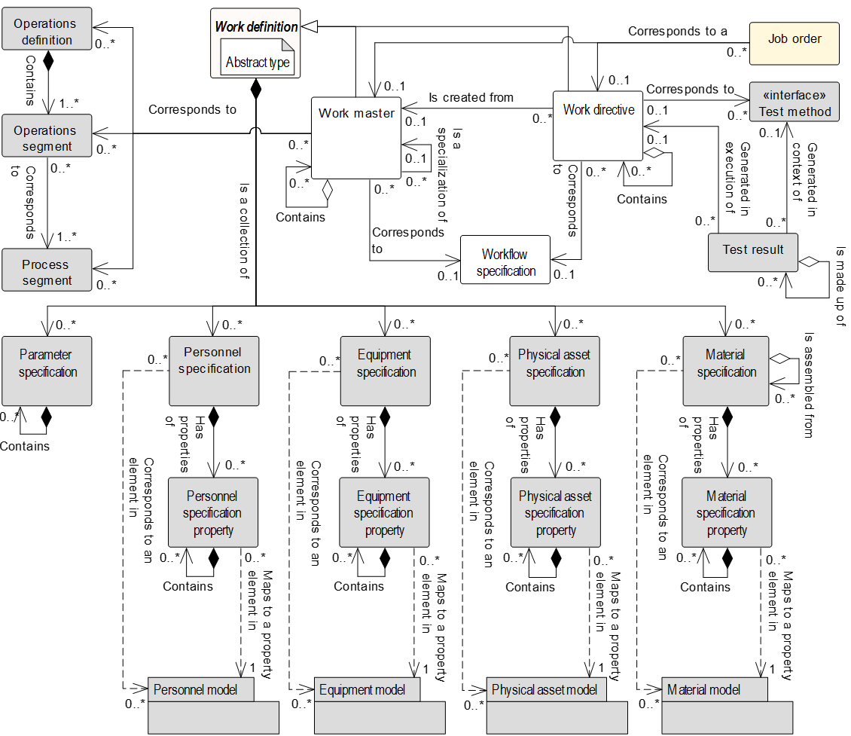

Figure 6 – Work definition model

NOTE 1 The object color convention used in the Part 2 and Part 4 UML diagrams for information models is

* A UML object with a white background belongs to the information model defined in the clause containing the UML diagram.
* A UML object with a gray background belongs to a defined information model in Part 2 that is not defined in the clause containing the UML diagram.
* A UML object with a yellow background belongs to a defined information model in Part 4 that is not defined in the clause containing the UML diagram.

NOTE 2 When a Part 2 (gray) or Part 4 (yellow) object has relationship to an object (white) defined in the clause containing the UML diagram, only the basic relationships between the objects not defined in the clause are shown for better context of the object (white) defined in the clause.

Table 36 – Work definition model relationships

| From | To | Type | Relationship Name |
| --- | --- | --- | --- |
| Work master | Work definition |  |  |
| Work directive | Work definition |  |  |
| Work definition | Parameter specification | Composition whole | Is a collection of |
| Work definition | Personnel specification | Composition whole | Is a collection of |
| Work definition | Equipment specification | Composition whole | Is a collection of |
| Work definition | Physical asset specification | Composition whole | Is a collection of |
| Work definition | Material specification | Composition whole | Is a collection of |
| Work master | Operations definition | Association | Corresponds to |
| Work master | Operations segment | Association | Corresponds to |
| Work master | Process segment | Association | Corresponds to |
| Work master | Work master | Association | Is a specialization of |
| Work master | Work master | Composition hierarchy | Contains |
| Work master | Workflow specification | Association | Corresponds to |
| Work directive | Work master | Association | Is created from |
| Work directive | Work directive | Composition hierarchy | Contains |
| Work directive | Workflow specification | Association | Corresponds to a |
| Work directive | Test method (Part 2) | Association | Corresponds to |
| Job order | Work master | Association | Corresponds to a |
| Job order | Work directive | Association | Corresponds to a |
| Test result* (Part 2) | Work directive | Association | Generated in execution of |
| Parameter specification | Parameter specification | Composition hierarchy | Contains |
| Personnel specification | Personnel specification property | Composition whole | Has properties of |
| Personnel specification property | Personnel specification property | Composition hierarchy | Contains |
| Personnel specification | Personnel class | Association (A) | Corresponds to |
| Personnel specification | Person | Association (C) | Corresponds to |
| Personnel specification property | Personnel class property | Dependency (B) | Maps to |
| Personnel specification property | Person property | Dependency (D) | Maps to |
| Equipment specification | Equipment specification property | Composition whole | Has properties of |
| Equipment specification property | Equipment specification property | Composition hierarchy | Contains |
| Equipment specification | Equipment class | Association (A) | Corresponds to |
| Equipment specification | Equipment | Association (C) | Corresponds to |
| Equipment specification property | Equipment class property | Dependency (B) | Maps to |
| Equipment specification property | Equipment property | Dependency (D) | Maps to |
| Physical asset specification | Physical asset specification property | Composition whole | Has properties of |
| Physical asset specification property | Physical asset specification property | Composition hierarchy | Contains |
| Physical asset specification | Physical asset class | Association (A) | Corresponds to |
| Physical asset specification | Physical asset | Association (C) | Corresponds to |
| Physical asset specification property | Physical asset class property | Dependency (B) | Maps to |
| Physical asset specification property | Physical asset property | Dependency (D) | Maps to |
| Material specification | Material specification property | Composition whole | Has properties of |
| Material specification property | Material specification property | Composition hierarchy | Contains |
| Material specification | Material class | Association (A) | Corresponds to |
| Material specification | Material definition | Association (A) | Corresponds to |
| Material specification | Material lot | Association (C) | Corresponds to |
| Material specification | Material sublot | Association (C) | Corresponds to |
| Material specification property | Material class property | Dependency (B) | Maps to |
| Material specification property | Material definition property | Dependency (B) | Maps to |
| Material specification property | Material lot property | Dependency (D) | Maps to |
| Material specification | Material specification | Aggregation hierarchy | Is assembled from |

NOTE *Test result and test method are defined in the Test Model in Part 2 of this standard.

## Work master

The resources and instructions required to perform a unit of work without reference to a specific *job order* shall be defined as a *work master*. A *work master*:

* identifies *material classes* or *material definitions*;
* identifies nominal production run sizes (standard job order size);
* identifies *equipment classes* for work centers and work units;
* may identify other information required to execute the *work definition* for a *job order*.

EXAMPLE Instructions, automation procedures, SOPs, recipes, drawings, CNC programs, packaging specifications, label specifications, transition specification.

A *work master* may contain zero or more *work masters*, defining a hierarchy of *work masters* with the hierarchy defined through *workflow specification nodes* in the *workflow specification*.

A *work master* may be a specialization of another *work master*. A *work master* shall be defined as pattern or instance. An pattern *work master* defines a ‘template’, upon which other pattern or instance *work masters* may be based. Unlike instance *work masters,* pattern *work masters* shall not be directly scheduled or executed. Therefore, *job orders, job responses* and *work directives* shall not reference pattern *work masters*.

The *parameter, personnel, equipment, physical asset* and *material specifications* of a *work master* may map to those of any pattern *work master* upon which the *work master* is based.

EXAMPLE 1 An pattern *work master* may contain *material specifications* that reference *material classes*, while a instance *work master* based on this pattern *work master* may contain *material specifications* that reference *material definitions* belonging to those *material classes.*

EXAMPLE 2 A mining organization could define the following pattern and instance *work masters*.

1. Extraction (pattern)

2. Coal extraction (pattern), specialization of extraction (pattern)

3. Iron ore extraction (pattern), specialization of extraction (pattern)

4. Coal site S1 extraction (instance), specialization of coal extraction (pattern)

5. Iron ore site S2 extraction (instance), specialization of iron ore extraction (pattern)

NOTE Pattern *work masters* provide a basis for standardization and reuse of pattern *work masters* across many instance *work masters* across and between plants.

## Work directive

The resources and instructions required to perform a unit of work for a specific *job order* shall be defined as a *work directive*. A *work directive*:

* is created as a copy of a *work master*;
* is used to control one *job order* or part of a *job order*;
* defines exact batch sizes or production run sizes;
* may identify *material lots* or *material sublots* for the *job order*;
* may identify specific work centers and/or work units for the *job order*;
* may identify specific *personnel* for the *job order*;
* Contains the actual executed information after execution of the *job order*.

A *work directive* may contain zero or more *work directives*, defining a hierarchy of *work directives* with the hierarchy defined through *workflow specification nodes* in the *workflow specification*.

There is one *work directive* for each *job order*. It contains the specific information required to perform the *job order* and the *workflow specification* associated with the *job order*. Figure 7 illustrates the recursive nature of *work masters* and *work directives*.



Figure 7 – Relationship of work master to work directive

NOTE 1 The dashed vertical line in Figure 6 represents the tasks in o*perations execution management* that create a *work directive* from a *work master* based on the requirements of the *job list*.

NOTE 2 A common scenario is where ad hoc work is performed with no *work master* or *operations definition* associated such as a material spills or unplanned and undefined movements of *material* or use of *equipment*. This scenario requires a 0..1 relationships between a *work master* and *work directive* / *job order*. The process of ad hoc work may be recorded in a *work directive* to an ad hoc *job order.*

Table 37 defines two addition attributes for *material specification* objects to support the *material lot* and *material sublot* information used in *work directives*.

Table 37 – Additional material specification attributes

| Attribute name | Description |
| --- | --- |
| Material lot | Identifies the associated *material lot* or set of *material lots* of the specification for a *work directive.* |
| Material sublot | Identifies the associated *material sublot* or set of *material sublots* of the specification for a *work directive.* |

## Work definition

Table 38 defines the relationship roles for the work definition that are common to both *work master* and *work directive*. Table 39 defines the attributes for work definition.

The *work master* and *work directive* objects are specialized types of the super class of *work definition*, and the *work definition* attributes shall be included in the *work master* and *work directive* attributes.

The *work definition* is an abstract object that cannot be instantiated. Only the specialized objects (*work master and work directive*) can be instantiated and therefore is referenced within a relationship.

Table 38 – Work definition relationship roles

| Related Object | Role | Multiplicity | Relationship Names | Description |
| --- | --- | --- | --- | --- |
| Parameter specification | Parameter specification | 0..* | Is a collection of | The *parameter specifications* related to this *work definition.* |
| Personnel specification | Personnel specification | 0..* | Is a collection of | The *personnel specifications* related to this *work definition.* |
| Equipment specification | Equipment specification | 0..* | Is a collection of | The *equipment specifications* related to this *work definition.* |
| Physical asset specification | Physical asset specification | 0..* | Is a collection of | The *physical asset specifications* related to this *work definition.* |
| Material specification | Material specification | 0..* | Is a collection of | The *material specifications* related to this *work definition.* |

Table 39 – Work definition attributes (common in work master and work directive)

| Attribute name | Description | Production examples | Maintenance examples | Quality examples | Inventory examples |
| --- | --- | --- | --- | --- | --- |
| ID | A unique identification as the *work master* ID or *work directive ID* | Export quality widget | Medium size AC motor overhaul | Potency test procedure | Tank transfer procedure |
| Version | An identification of the version of the *work master version or work directive version*.  In cases where there are multiple versions of a *work definition*, then the version attribute shall contain the additional identification information to differentiate each version. | 1.0 | 1.4 | 1.1 | 1.1 |
| Description | Contains additional information and descriptions of the *work master or directive.* | “Information defining resources required for work of a single ‘export quality widget’” | For overhauls of motors less than 200 HP. | Test for potency of product | Movement of material from one tank to another |
| Hierarchy scope | Identifies where the exchanged information fits within the role based equipment hierarchy. | East Wing manufacturing line #2 | CNC Machine  Asset ID 13465 | Test cell 4  Receiving | Warehouse B |
| Work type | Describes the category of work.  Required attribute.  Defined values are  production, maintenance, quality, inventory, or mixed.  “Mixed” shall be used when the work definition contains resources and routing information required to perform several types of work. | Production | Maintenance | Quality | Inventory |
|  |  |  |  |  |  |
| Duration | Duration, if known. | 25 | 4 | 1 | 40 |
| Duration unit of measure | The units of measure of the duration, if defined. | Minutes | Hours | Day | Minutes |
| Published date | The date and time on which the *work master or work directive* was published or generated. | 12-30-1951 18:30 UTC | 10-17-2005  18:30 UTC | 10-17-2005  18:30 UTC | 10-17-2005  18:30 UTC |

NOTE A MIMOSA *solution package* is the equivalent of a work definition for maintenance.

## Work master relationship roles and attributes

Table 40 – Work master relationship roles, in combination with Table 38 – Work definition relationship roles, defines the complete set of relationship role for the *work master*.

Table 41 – Work master attributes, in combination with Table 39 – Work definition attributes (common in work master and work directive), defines the complete set of attributes for the *work master*.

A *work master* may contain *work masters*, defining a hierarchy of *work masters*. A *work master* may be defined as pattern or instance. An instance *work master* may be a specialization of an pattern *work master*.

Table 40 – Work master relationship roles

| Related Object | Role | Multiplicity | Relationship Name | Description |
| --- | --- | --- | --- | --- |
| Work master | Work master child | 0..* | Contains | The related object(s) makes up part of this *work master* as the whole. |
| Work directive | NA | 0..* | Is created from | The *work directive(s)* created from this *work master*.  if applicable. in cases where there are multiple *work directive versions* of a *work directive*, then the *work directive version* attribute shall contain the additional identification information to differentiate each version. The multiplicity of 0..1. |
| Work master | Pattern work master | 0..1 | Is a specialization of | The pattern *work master* upon which this instance *work master* is based as a specialization. |
| Work master | Instance work master | 0..* | Is a specialization of | The instance *work master(s)* contained within this pattern *work master* as a specialization*.* |
| Process segment | Process segment | 0..* | Corresponds to | The *process segment(s)* associated to this *work master*, if applicable. |
| Operations definition | Operations definition | 0..* | Corresponds to | The *operations definition(s)* associated to this *work master*, if applicable. |
| Operations segment | Operations segment | 0..* | Corresponds to | The *operations segment(s)* associated to this *work master*, if applicable.  If the *operations segment* reference is insufficient to identify the *operations segment*, then this *work master* should also identify the *operations definition* reference. |
| Workflow specification | Workflow specification | 0..1 | Corresponds to | This *work master* defined in part by the *workflow specification(s).*  The version attribute of the *work specification* may be specified. In cases where used in multiple *workflow master* versions, then the *version* attribute shall contain the additional identification information to differentiate each version. |

Table 41 – Work master attributes

|  |  |  |  |  |  |
| --- | --- | --- | --- | --- | --- |
| Attribute  Name | Description | Production  Examples | Maintenance  Examples | Quality  Examples | Inventory  Examples |
| Definition type | Defines the type of the *work master*. The defined types are:  Pattern – A *work master* that is used as a template for other *work masters*.  Instance – A *work master* that may be directly scheduled, dispatched and executed. | Pattern | Instance | Instance | Pattern |

## Work directive relationship roles and attributes

Table 42 – Work directive relationship roles, in combination with Table 38 – Work definition relationship roles, defines the complete set of relationship roles for a *work directive.*

Table 39 defines the attributes for the *work directive.* A *work directive* may contain *work directives*, defining a hierarchy of *work directives*.

Table 42 – Work directive relationship roles

| Related Object | Role | Multiplicity | Relationship Name | Description |
| --- | --- | --- | --- | --- |
| Work master | Work master | 0..1 | Is created from | The *work master* used to create this *work directive*.  if applicable. in cases where there are multiple *work master versions*, then the *work master version* attribute shall contain the additional identification information to differentiate each version |
| Work directive | Work directive child | 0..* | Contains | The related object(s), *work directive*, makes up part of this *work directive* as the whole. |
| Workflow specification | Workflow specification | 0..1 | Corresponds to | This *work directive* defined in part by the *workflow specification(s).*  The version of the *work directive* may be specified in the attribute of this object. |
| Job order | NA | 0.* | Corresponds to | A unique identification of the *job order* associated with this *work directive*.  The *ID* shall be used in other parts of the model when the *job order* needs to be identified. |
| Test result* (Part 2) | NA | 0..1 | Generated in execution of | A unique identification of the *test result* created by the execution of this *work directive*. |
| Test method* (Part 2) | Test method | 0..1 | Corresponds to | A unique identification of the *test method who execution is* recorded by this *work directive*. |

NOTE \**Test result* and *test method* are defined in the test model in Part 2 of this standard.

|  |  |  |  |  |  |
| --- | --- | --- | --- | --- | --- |
|  |  |  |  |  |  |
|  |  |  |  |  |  |
|  |  |  |  |  |  |

## Parameter specification

The definition of this object, the relationship roles, and the attributes for this object are defined in part 2 of this standard.

A *parameter specification* may be made up of zero or more nested *parameter specifications*.

## Personnel specification

The definition of this object, the relationship roles, and the attributes for this object are defined in part 2 of this standard.

## Personnel specification property

The definition of this object, the relationship roles, and the attributes for this object are defined in part of this standard.

## Equipment specification

The definition of this object, the relationship roles, and the attributes for this object are defined in part 2 of this standard.

## Equipment specification property

The definition of this object, the relationship roles, and the attributes for this object are defined in part 2 of this standard.

## Physical asset specification

The definition of this object and the attributes for this object, the relationship roles, are defined in part 2 of this standard.

## Physical asset specification property

The definition of this object, the relationship roles, and the attributes for this object are defined in part 2 of this standard.

## Material specification

The definition of this object, the relationship roles, and the attributes for this object are defined in part 2 of this standard.

A *material specification* may be an assembly of zero or more nested *material specifications*.

## Material specification property

The definition of this object, the relationship roles, and the attributes for this object are defined in part 2 of this standard.

## Workflow specification information

### Workflow specification model

A *workflow specification* is represented as a collection of nodes and connections. Each node is defined by a type definition, and each connection is defined by a type definition. A node may contain a reference to a *work definition*.

Different workflow representations are described as collections of node types and connection types. See Annex C and Annex D for examples of *workflow specifications* for different formats.

NOTE 1 Workflows are not unique to the manufacturing operations management domain. See the business process model and notation (BPMN[1]) at http://www.omg.org/spec/BPMN/ as a possible structure for a workflow format.

NOTE 2 The IEC 61512-1 recipe definitions are a workflow format. See the IEC 61512-2 definition for the recipe structure.

NOTE 3 Flowcharts are a workflow format.

NOTE 4 An IDEF (Integrated DEFinition) diagram is a workflow format.

The workflow specification model is shown in Figure 8. Table 43 lists the relationships of the objects in the work specification model. The model is a general model for exchanging workflows and is not unique to any specific workflow format. It represents the workflow as a collection of nodes and connections. The meaning of the nodes and connections is determined by the workflow format.

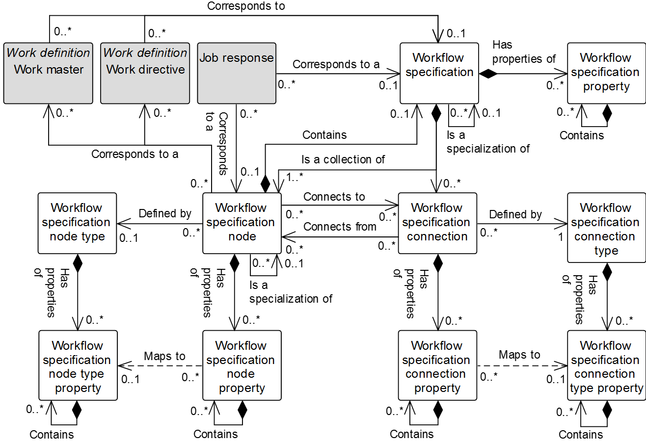

Figure 8 – Workflow specification model

NOTE 1 The object color convention used in the Part 2 and Part 4 UML diagrams for information models is

* A UML object with a white background belongs to the information model defined in the clause containing the UML diagram.
* A UML object with a gray background belongs to a defined information model in Part 2 that is not defined in the clause containing the UML diagram.
* A UML object with a yellow background belongs to a defined information model in Part 4 that is not defined in the clause containing the UML diagram.

NOTE 2 When a Part 2 (gray) or Part 4 (yellow) object has relationship to an object (white) defined in the clause containing the UML diagram, only the basic relationships between the objects not defined in the clause are shown for better context of the object (white) defined in the clause.

Table 43 – Workflow specification model relationships

| From | To | Type | Relationship Name |
| --- | --- | --- | --- |
| Workflow specification | Workflow specification property | Composition whole | Has properties of |
| Workflow specification | Workflow specification | Association | Is a specialization of |
| Workflow specification property | Workflow specification property | Composition hierarchy | Contains |
| Workflow specification | Workflow specification node | Composition whole | Is a collection of |
| Workflow specification | Workflow specification connection | Composition whole | Is a collection of |
| Workflow specification node | Workflow specification | Composition whole | Contains |
| Work master | Workflow specification | Association | Corresponds to a |
| Work directive | Workflow specification | Association | Corresponds to a |
| Job response | Workflow specification | Association | Corresponds to a |
| Job response | Workflow specification node | Association | Corresponds to a |
| Workflow specification node | Work master | Association | Corresponds to a |
| Workflow specification node | Work directive | Association | Corresponds to a |
| Workflow specification node | Workflow specification node property | Composition whole | Has properties of |
| Workflow specification node | Workflow specification node | Association | Is a specialization of |
| Workflow specification node property | Workflow specification node property | Composition hierarchy | Contains |
| Workflow specification node | Workflow specification node type | Association | Defined by |
| Workflow specification node type | Workflow specification node type property | Composition whole | Has properties of |
| Workflow specification node type property | Workflow specification node type property | Composition hierarchy | Contains |
| Workflow specification node property | Workflow specification node type property | Dependency | Maps to |
| Workflow specification connection | Workflow specification node | Association | Connects to |
| Workflow specification connection | Workflow specification node | Association | Connects from |
| Workflow specification connection | Workflow specification connection property | Composition whole | Has properties of |
| Workflow specification connection property | Workflow specification connection property | Composition hierarchy | Contains |
| Workflow specification connection | Workflow specification connection type | Association | Defined by |
| Workflow specification connection type | Workflow specification connection type property | Composition whole | Has properties of |
| Workflow specification connection type property | Workflow specification connection type property | Composition hierarchy | Contains |
| Workflow specification connection property | Workflow specification connection type property | Dependency | Maps to |

A *workflow specification* may be a specialization of another *workflow specification*. A *workflow specification* shall be defined as pattern or instance. An pattern *workflow specification* defines a ‘template’, upon which other pattern or instance w*orkflow specifications* may be based. Unlike instance *workflow specifications*, pattern *workflow specifications* shall not be directly executed. Therefore, a *work directive* shall only reference a instance *workflow specification*.

A pattern *work master* may reference either a pattern or instance *workflow specification*, while an instance *work master* shall only reference a instance *workflow specification*.

A pattern *work master* may reference an instance *workflow specification* where all *work masters (*directly or indirectly) specializing that pattern *work master* shall reference the same instance *workflow specification*. This allows a standard instance *workflow specification* to be defined for a pattern *work master*, which is then specialized to a number of pattern or instance *work masters*, each corresponding to the same instance *workflow specification*.

*Workflow specification nodes* shall assume the definition type (pattern or instance) of the *workflow specification* to which they belong. Therefore, all *workflow specification nodes* contained within a pattern *workflow specification* shall be assumed to be pattern, while all *workflow specification nodes* contained within a instance *workflow specification* shall be assumed to be instance.

Where a *workflow specification node* contains a more detailed *workflow specification*, the definition type of the contained *workflow specification* shall have the same value as that of the *workflow specification* to which the *workflow specification node* belongs.

Where a *workflow specification node* references a *work master*, the definition type of the referenced *work master* shall have the same value as that of the *workflow specification* to which the *workflow specification node* belongs. A *workflow specification node* shall only reference a *work directive* where the node belongs to a instance *workflow specification*.

EXAMPLE 1 Where a *workflow specification* WSC1 is based upon a pattern *workflow specification* WSA1, any given node in WSC1 may specialize a node in WSA1. Therefore, a *workflow specification node* may contain a reference to the node within a pattern *workflow specification* that it specializes.

NOTE *Job response* is fully defined in work performance model. *Work master* and *work directive* are fully defined in the work definition model. These objects are shown in the workflow specification model to show *workflow specification* relationships.

EXAMPLE 2 Figure 9 is a *workflow specification* described in a BPMN format.

EXAMPLE 3 Examples of representation in a *workflow specification* include

1) A *workflow specification* containing two *workflow specification nodes*, one for the MES (manufacturing execution system) and one for the ERP (enterprise resource planning). The MES and ERP nodes are of *workflow specification node type* = POOL**.**

2) The MES node contains a *workflow specification* (identified here as MES_01).

3) MES_01 contains 6 *workflow specification nodes* and 6 *workflow specification connections*.

4) The Scan Material *workflow specification node* is of *workflow specification node type* = TASK.

5) The connection between scan material and planned contains a FROM link to scan material and a TO link to planned. The connection is of type SEQUENCE FLOW.

6) The ERP node contains a *workflow specification* (identified here as ERP_01).

7) ERP_01 contains 1 *workflow specification node* and 1 *workflow specification connection*.

8) The connection between Get ERP Lot ID and store material contains a FROM link to Get ERP Lot ID and a TO link to store material. The connection is of type SEQUENCE FLOW.



Figure 9 – Example of a workflow specification in BPMN format

EXAMPLE 4 Figure 10 is a workflow described in a flowchart notation.

EXAMPLE 5 Examples of representation in flowchart notation of a *workflow specification* include

1) A *workflow specification* contains 7 *workflow specification nodes* and 7 *workflow specification* *connections.*

2) The scan material *workflow specification node* is of *workflow* *specification node type* = ACTIVITY.

3) The connection between scan material node and planned node contains a FROM link to scan material and a TO link to planned. The connection is of type SEQUENCE.

4) The connection between Get ERP Lot ID and store material contains a FROM link to Get ERP Lot ID and a TO link to store material. The connection is of type SEQUENCE.



Figure 10 – Example of a workflow specification in flowchart format

### Workflow specification

A *workflow specification* shall be defined as a collection of *workflow specification nodes* and *workflow specification connections*.

A *workflow specification* shall contain at least one *workflow specification node*.

Table 44 defines the relationship roles for the *workflow specification*. Table 45 defines the attributes for the *workflow specification*.

Table 44 – Workflow specification relationship roles

| Related Object | Role | Multiplicity | Relationship Name | Description |
| --- | --- | --- | --- | --- |
| Workflow specification | Pattern work master | 0..1 | Is a specialization of | The pattern *workflow specification* upon which this instance *workflow specification* is based as a specialization. |
| Workflow specification | Instance work master | 0..* | Is a specialization of | The instance *workflow specification (s)* contained within this pattern *workflow specification* as a specialization*.* |
| Work master | NA | 0..1 | Corresponds to | The *work master* defined in part by this *workflow specification.*  The version attribute of the *work master* may be specified. In cases where there are multiple versions of a *work master,* then the version attribute shall contain the additional identification information to differentiate each version. |
| Work directive | NA | 0..1 | Corresponds to | The *work directive* defined in part by this *workflow specification.*  The version of the *work directive* may be specified in the attribute of this *workflow specification.* |
| Job response | NA | 0..1 | Corresponds to | This *workflow specification* related to the *job response*. |
| Workflow specification node | NA | 1 | Contains | Identifies the associated *workflow specification node* defined in part by this *workflow specification.* This relationship applies for case where this *child workflow specification* defines the *parent workflow specification node*. |
| Workflow specification node | Workflow specification node | 1..* | Is a collection of | This workflow *specification defined in part by* this *workflow specification node*. |
| Workflow specification connection | Workflow specification connection | 0..* | Is a collection of | This workflow *specification* defined in part by the *workflow specification connection.* |
| Workflow specification property | Workflow specification property | 0..* | Has properties of | The *workflow specification property(s)* in part defines of this *workflow specification*. |

Table 45 – Workflow specification attributes

| Attribute name | Description | Production examples | Maintenance examples | Quality examples | Inventory examples |
| --- | --- | --- | --- | --- | --- |
| ID | Uniquely identifies the *workflow specification*. | Make commercial grade widgets | Repair 20 HP water pump | Test receiving material | Receiving materials |
| Description | Contains additional information and descriptions of the *workflow specification.* | Instructions for making commercial grade widgets | Instructions for rebuild of 20 HP water pump | Instructions for SOP33456 | Hazardous materials receiving SOP |
| Hierarchy scope | Identifies where the exchanged information fits within the role based equipment hierarchy. | East Wing manufacturing line #2 | CNC Machine  Asset ID 13465 | Test cell 4  Receiving | Warehouse B |
| Definition type | Defines the type of the *workflow specification*. The defined types are:  Pattern – A *workflow specification* that is used as a template for other *workflow specifications*.  Instance – A *workflow specification* that may be directly executed. | Pattern | Instance | Instance | Pattern |

### Workflow specification property

A property of a *workflow specification* shall be defined as a *workflow specification property.* A *workflow specification property* may contain nested *workflow specification property(s).*

Table 46 defines the relationship roles for the *workflow specification property*. Table 47 defines the attributes for the *workflow specification property*.

Table 46– Workflow specification property relationship roles

| Related Object | Role | Multiplicity | Relationship Name | Description |
| --- | --- | --- | --- | --- |
| Workflow specification | NA | 1 | Has properties of | *This workflow specification specializes the pattern workflow specification.* |
| Workflow specification property | Workflow specification property child | 0..* | Contains | The *work directive* defined in part by this *workflow specification.*  The version of the *work directive* may be specified in the attribute of this *workflow specification.* |

Table 47 – Workflow specification property attributes

| Attribute name | Description |
| --- | --- |
| ID | A unique identification of the property. |
| Description | Additional information about the property. |
| Value | The default value, set of values, or range of the property. |
| Value unit of measure | The unit of measure of the associated property value, if applicable. |

### Workflow specification node

A *workflow specification node* is a step in a workflow. It may have a reference to an activity executed in Level 2, a reference to a *work definition*, a nested *workflow specification*, or an entity used in the represented format (such as a decision element, transition condition, or starting point).

NOTE Nested *workflow specifications*, such as the ISA-88.00.03 recipe hierarchy, are represented *through workflow specification nodes* that contain other *workflow specifications* (a unit procedure contains the operation definition).

Table 48 defines the relationship roles for the *workflow specification node*. Table 49 defines the attributes for the *workflow specification node*.

See Annex C and Annex D for examples.

Table 48 – Workflow specification node relationship roles

| Related Object | Role | Multiplicity | Relationship Name | Description |
| --- | --- | --- | --- | --- |
| Workflow specification | Workflow specification | 0..1 | Contains | The *workflow specification* defines in part by this *workflow specification node* as the whole*.* |
| Workflow specification | NA | 1..* | Is a collection of | The *workflow specification* as the whole is defined in part by this *workflow specification node* as the part*.* |
| Workflow specification node | Pattern workflow specification node | 0..1 | Is a specialization of | The pattern *workflow specification node* upon which this instance *workflow specification node(s)* is based as a specialization*.* |
| Workflow specification node | Instance workflow specification node | 0..* | Is a specialization of | The instance *workflow specification node(s)* contained within this pattern *operational location class*. |
| Work master | Work master | 0..* | Corresponds to a | The *work master* defined in part by this *workflow specification node.*  The *version* attribute of the *work master* may be specified. In cases where there are multiple versions of a *work master,* then the *version* attribute shall contain the additional identification information to differentiate each version. |
| Work directive | Work directive | 0..* | Corresponds to a | The *work directive* defined in part by this *workflow specification node.*  The version of the *work directive* may be specified in the *version* attribute of this *workflow specification node.* |
| Job response | NA | 0..* | Corresponds to a | The *workflow specification node* related to this *job response*. |
| Workflow specification node type | Workflow specification node type | 0..1 | Defined by | This *workflow specification node* defined by this *workflow specification node type*. |
| Workflow specification node property | Workflow specification node property | 0..* | Has properties of | This *workflow specification* nodedefined in part the *workflow specification node property(s)*. |
| Workflow specification connection | To Workflow specification connection | 0..* | Connects to | This *workflow specification node(s)* to the *workflow* *specification connection(s).* |
| Workflow specification connection | From Workflow specification connection | 0..* | Connects from | The *workflow specification connection(s)* from this *workflow* *specification node(s).* |

Table 49 – Workflow specification node attributes

| Attribute name | Description |
| --- | --- |
| ID | Uniquely identifies the *workflow specification node*. |
| Description | Contains additional information and descriptions of the *workflow specification node.* |
| Hierarchy scope | Identifies where the exchanged information fits within the role based equipment hierarchy. |

### Workflow specification node property

A property of a *workflow specification node* shall be defined as a *workflow specification node property*.

*A workflow specification node property* may contain nested *workflow specification node property(s)*.

*Workflow specification node property(s)* may be used to specify the defined properties that can be associated with the specific node type.

Table 50 defines the relationship roles for the *workflow specification node property*. Table 51 defines the attributes for the *workflow specification node property*.

See Annex C and Annex D for examples.

Table 50 – Workflow specification node property relationship roles

| Related Object | Role | Multiplicity | Relationship Name | Description |
| --- | --- | --- | --- | --- |
| Workflow specification node | NA | 1 | Has properties of | The *workflow specification node* defined in part by this *workflow specification node property(s).* |
| Workflow specification node type property | Workflow specification node type property | 0..1 | Maps to | If the *workflow specification node* supports a *workflow specification node type*, the *workflow specification node type property* is applied in this *workflow specification node property(s).*  This *workflow specification node property* maps to the corresponding *workflow specification node type property.* |
| Workflow specification node property | Workflow specification node property child | 0..* | Contains | The child *workflow specification node properties* of this *workflow specification node property*. |

Table 51 – Workflow specification node property attributes

| Attribute name | Description |
| --- | --- |
| ID | A unique identification of the property. |
| Description | Additional information about the property. |
| Value | The default value, set of values, or range of the property. |
| Value unit of measure | The unit of measure of the associated property value, if applicable. |

### Workflow specification connection

A *workflow specification connection* represents a many-to-many link between *workflow specification nodes*.

NOTE The *workflow specification connection type* defines the allowed multiplicity of FROM and TO links.

Table 52 defines the relationship roles for the *workflow specification connection*. Table 53 defines the attributes for the *workflow specification connection*.

See Annex C and Annex D for examples.

Table 52 – Workflow specification connection relationship roles

| Related Object | Role | Multiplicity | Relationship Name | Description |
| --- | --- | --- | --- | --- |
| Workflow specification | NA | 1 | Is collection of | The *workflow specification* defined in part by this *workflow specification connection.* |
| Workflow specification connection type | Workflow specification connection type | 1 | Defined by | The *workflow specification connection* defined by this *workflow specification connection type*. |
| Workflow specification connection property | Workflow specification connection property | 0..* | Has properties of | The *workflow specification connection property(s)* defines in part of this *workflow specification connection*. |
| Workflow specification node | NA | 0..* | Connects to | The *workflow specification node* connected to this *workflow specification connection.* |
| Workflow specification node | Workflow specification node from | 0..* | Connects from | The *workflow specification node* connected from this *workflow specification connection.* |

Table 53 – Workflow specification connection attributes

| **Attribute name** | **Description** |
| --- | --- |
| ID | Uniquely identifies the *workflow specification connection*. |
| Description | Contains additional information and descriptions of the *workflow specification connection.* |

EXAMPLE  In a BPMN workflow structure, some of the following structuring elements would be represented as *workflow specification connections*; **Sequence Flow, Default Flow, Conditional Flow.**

### Workflow specification connection property

A property of a *workflow specification connection* shall be defined as a *workflow specification connection property*.

A *workflow specification connection property* may contain nested *workflow specification connection property(s)*.

*Workflow specification connection property(s)* may be used to specify the defined properties that can be associated with the specific connection.

Table 54 defines the relationship roles for the *workflow specification connection property*. Table 55 defines the attributes for the *workflow specification connection property*.

See Annex C and Annex D for examples.

Table 54 – Workflow specification connection property relationship roles

| Related Object | Role | Multiplicity | Relationship Name | Description |
| --- | --- | --- | --- | --- |
| Workflow specification connection | NA | 1 | Has properties of | The *workflow specification connection defined in part by* this *workflow specification connection property(s)*. |
| Workflow specification connection type property | Workflow specification connection type property | 0..1 | Maps to | If the *workflow specification connection* supports a *workflow specification connection type*, the *workflow specification connection type property(s)* is applied in this *workflow specification connection property(s)*.  This *workflow specification connection property* maps to the corresponding *workflow specification connection type property.* |
| Workflow specification connection property | Workflow specification connection property child | 0..* | Contains | The child *workflow specification connection properties* of this *workflow specification connection property*. |

Table 55 – Workflow specification connection property attributes

| Attribute name | Description |
| --- | --- |
| ID | A unique identification of the property. |
| Description | Additional information about the property. |
| Value | The default value, set of values, or range of the property. |
| Value unit of measure | The unit of measure of the associated property value, if applicable. |

### Workflow specification node type

A *workflow specification node type* defines the properties that can be associated with a specific *workflow specification node*.

Table 56 defines the relationship roles for the *workflow specification node type*. Table 57 defines the attributes for the *workflow specification node type*.

See Annex C and Annex D for examples.

Table 56 – Workflow specification node type relationship roles

| Related Object | Role | Multiplicity | Relationship Name | Description |
| --- | --- | --- | --- | --- |
| Workflow specification  node | NA | 0..* | Defined by | The *workflow specification node(s)* defined in part by this *workflow specification node type*. |
| Workflow specification node type property | Workflow specification node type property | 0..* | Has properties of | The *workflow specification node type property(s)* defines in part this *workflow specification node type*. |

Table 57 – Workflow specification node type attributes

| Attribute name | Description |
| --- | --- |
| ID | Uniquely identifies the *workflow specification node type*. |
| Description | Contains additional information and descriptions of the *workflow specification node.* |

### Workflow specification node type property

A property of a *workflow specification node type* shall be defined as a *workflow specification node type property*. A *workflow specification connection type property* may contain nested *workflow specification connection type property(s).*

*Workflow specification node properties* types specify the allowed properties that can be associated with a specific *workflow specification node*.

Table 58 defines the relationship roles for the *workflow specification node type property*. Table 59 defines the attributes for the *workflow specification node type property*.

See Annex C and Annex D for examples.

Table 58 – Workflow specification node type property relationship roles

| Related Object | Role | Multiplicity | Relationship Name | Description |
| --- | --- | --- | --- | --- |
| Workflow specification node type | NA | 1 | Has properties of | The *workflow specification node* type is defined in part by this *workflow specification node type property*. |
| Workflow specification node property | NA | 0..* | Maps to | If the *workflow specification node* supports a *workflow specification node type*, this *workflow specification node type property(s)* is applied in the *workflow specification node property(s)*.  This *workflow specification node property* maps to the corresponding *workflow specification node type property.* |
| Workflow specification connection type property | Workflow specification connection property child | 0..* | Contains | The child *workflow specification connection type properties* of this *workflow specification connection type property*. |

Table 59 – Workflow specification node type property attributes

| Attribute name | Description |
| --- | --- |
| ID | A unique identification of the property. |
| Description | Additional information about the property. |
| Value | The default value, set of values, or range of the property. |
| Value unit of measure | The unit of measure of the associated property value, if applicable. |

### Workflow specification connection type

A *workflow specification connection type* specifies the permissible information on a connection.

Table 60 defines the relationship roles for the *workflow specification connection*. Table 61 defines the attributes for the *workflow specification connection*.

See Annex C and Annex D for examples.

Table 60 – Workflow specification connection type relationship roles

| Related Object | Role | Multiplicity | Relationship Name | Description |
| --- | --- | --- | --- | --- |
| Workflow specification connection | NA | 0..* | Defined by | The *workflow specification connection(s)* defined in part by this *workflow specification connection type.* |
| Workflow specification connection type property | Workflow specification connection type property | 0..* | Has properties of | The *workflow specification connection type property(s)* defines in part this *workflow specification connection type*. |

Table 61 – Workflow specification connection type attributes

| Attribute name | Description |
| --- | --- |
| ID | Uniquely identifies the *workflow specification connection type*. |
| Description | Contains additional information and descriptions of the *workflow specification connection.* |
| From multiplicity | Defines the multiplicity of the from connection:  one, one or more, zero or more, or an allowed range. |
| To multiplicity | Defines the multiplicity of the “to” connection:  one, one or more, zero or more, or an allowed range. |

### Workflow specification connection type property

A property of a *workflow specification connection type* shall be defined as a *workflow specification connection type property*.

A *workflow specification connection type property(s)* specify the allowed properties that can be associated with specific *workflow specification connections*.

Table 62 defines the relationship roles for the *workflow specification connection property*. Table 63 defines the attributes for the *workflow specification connection property*.

See Annex C and Annex D for examples.

Table 62 – Workflow specification connection type property relationship roles

| Related Object | Role | Multiplicity | Relationship Name | Description |
| --- | --- | --- | --- | --- |
| Workflow specification connection  type | NA | 1 | Has properties | The *workflow specification connection type* defined in part by this *workflow specification connection type property.* |
| Workflow specification connection property | Workflow specification connection property | 0..* | Maps | If the *workflow specification connection* supports a *workflow specification connection type*, this *workflow specification connection type property(s)* is applied in the *workflow specification connection property(s).*  This *workflow specification connection property* maps to the corresponding *workflow specification connection type property.* |
| Workflow specification connection property | NA | 0..* | Contains | If the *workflow specification connection* supports a *workflow specification connection type*, this *workflow specification connection type property(s)* is applied in the *workflow specification connection property(s)*.  This *workflow specification connection` property* maps to the corresponding *workflow specification connection type property.* |

Table 63 – Workflow specification connection type property attributes

| Attribute name | Description |
| --- | --- |
| ID | A unique identification of the property. |
| Description | Additional information about the property. |
| Value | The default value, set of values, or range of the property. |
| Value unit of measure | The unit of measure of the associated property value, if applicable. |

# Work schedule information

## Work schedule model

A request for work shall be listed as a *work schedule*. A *work schedule* shall be made up of one or more *work requests*.

The *work schedule* may apply to scheduling of production, maintenance, quality test and inventory operations, or to other extended categories of activities.

A *work schedule* may be defined for any specific category of work: production, maintenance, quality, or inventory operations, or it may be defined for a combination of categories. When a combination is selected, then the *work requests* or *segment requirement* specifies the category of the work.

Figure 11 is the work schedule model; objects shown as gray boxes are defined in part of this standard. Table 64 lists the relationships of the objects in the work schedule model.

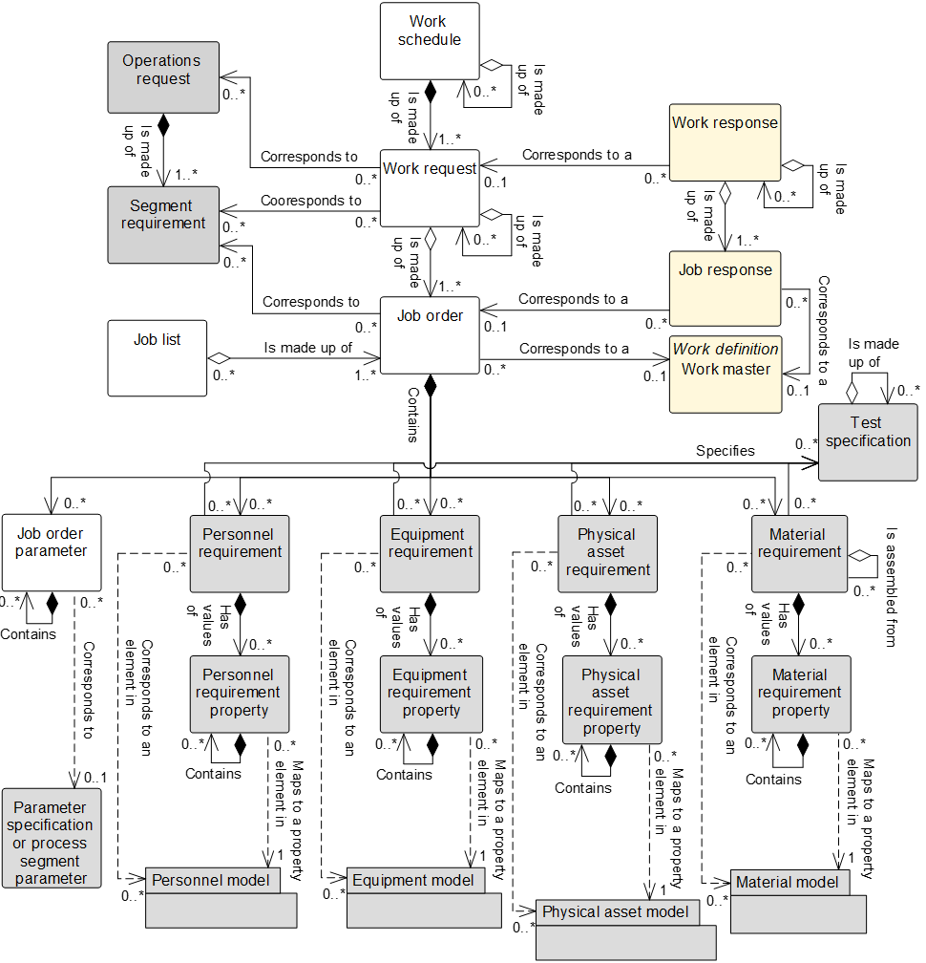

Figure 11 – Work schedule model

NOTE 1 The object color convention used in the Part 2 and Part 4 UML diagrams for information models is

* A UML object with a white background belongs to the information model defined in the clause containing the UML diagram.
* A UML object with a gray background belongs to a defined information model in Part 2 that is not defined in the clause containing the UML diagram.
* A UML object with a yellow background belongs to a defined information model in Part 4 that is not defined in the clause containing the UML diagram.

NOTE 2 When a Part 2 (gray) or Part 4 (yellow) object has relationship to an object (white) defined in the clause containing the UML diagram, only the basic relationships between the objects not defined in the clause are shown for better context of the object (white) defined in the clause.

Table 64 – Work schedule model relationships

| From | To | Type | Relationship Name |
| --- | --- | --- | --- |
| Work schedule | Work request | Composition whole | Is made up of |
| Work schedule | Work schedule | Aggregation hierarchy | Is made up of |
| Work request | Job order | Aggregation whole | Is made up of |
| Work request | Work request | Aggregation hierarchy | Is made up of |
| Work response | Work request | Association | Corresponds to |
| Work request | Operations request (Part 2) | Association | Corresponds to |
| Work request | Segment requirement  (Part 2) | Association | Corresponds to |
| Job order | Work master | Association | Corresponds to a |
| Job response | Job order | Association | Corresponds to a |
| Job list | Job order | Aggregation whole | Is made up of |
| Job order | Job order parameter | Composition whole | Contains |
| Job order parameter | Job order parameter | Composition hierarchy | Contains |
| Job order parameter | Parameter specification | Dependency | Corresponds to |
| Job order parameter | Process segment parameter | Dependency | Corresponds to |
| Job order | Personnel requirement | Composition whole | Contains |
| Job order | Equipment requirement | Composition whole | Contains |
| Job order | Physical asset requirement | Composition whole | Contains |
| Job order | Material requirement | Composition whole | Contains |
| Personnel requirement | Personnel requirement property | Composition whole | Has values of |
| Personnel requirement | Test specification | Association | Specifies |
| Personnel requirement property | Personnel requirement property | Composition hierarchy | Contains |
| Personnel requirement | Personnel class | Association (A) | Corresponds to |
| Personnel requirement | Person | Association (C) | Corresponds to |
| Personnel requirement property | Personnel class property | Dependency (B) | Maps to |
| Personnel requirement property | Person property | Dependency (D) | Maps to |
| Equipment requirement | Equipment requirement property | Composition whole | Has values of |
| Equipment requirement | Test specification | Association | Specifies |
| Equipment requirement property | Equipment requirement property | Composition hierarchy | Contains |
| Equipment requirement | Equipment class | Association (A) | Corresponds to |
| Equipment requirement | Equipment | Association (C) | Corresponds to |
| Equipment requirement property | Equipment class property | Dependency (B) | Maps to |
| Equipment requirement property | Equipment property | Dependency (D) | Maps to |
| Physical asset requirement | Physical asset requirement property | Composition whole | Has values of |
| Physical asset requirement | Test specification | Association | Specifies |
| Physical asset requirement property | Physical asset requirement property | Composition hierarchy | Contains |
| Physical asset requirement | Physical asset class | Association (A) | Corresponds to |
| Physical asset requirement | Physical asset | Association (C) | Corresponds to |
| Physical asset requirement property | Physical asset class property | Dependency (B) | Maps to |
| Physical asset requirement property | Physical asset property | Dependency (D) | Maps to |
| Material requirement | Material requirement property | Composition whole | Has values of |
| Material requirement | Test specification | Association | Specifies |
| Material requirement property | Material requirement property | Composition hierarchy | Contains |
| Material requirement | Material class | Association (A) | Corresponds to |
| Material requirement | Material definition | Association (A) | Corresponds to |
| Material requirement | Material lot | Association (C) | Corresponds to |
| Material requirement | Material sublot | Association (C) | Corresponds to |
| Material requirement property | Material class property | Dependency (B) | Maps to |
| Material requirement property | Material definition property | Dependency (B) | Maps to |
| Material requirement property | Material lot property | Dependency (D) | Maps to |
| Material requirement | Material requirement | Aggregation hierarchy | Is assembled from |

NOTE *Objects shaded gray are defined in Part 2 of this standard.

EXAMPLE 1 Figure 12 is an example of an *operations schedule* for a site.



Figure 12 – Operations schedule for a site

EXAMPLE 2 Figure 13 is an example of a *work schedule* for an area in which one *operation request* is implemented in multiple *work requests*. In this example, each *work request* is made up of multiple *job orders*.



Figure 13 – Work schedule for an area

EXAMPLE 3 Figure 14 is an example of a *work request* with nested *job orders* and the associated *work master* for a *job order*. Each *job order* is associated with a *work master*.



Figure 14 – Work request, job order, job list

EXAMPLE 4 Figure 15 illustrates the use of a *work request* in a continuous process, where there can be no unused time between activities and where the *job list* can be the *job orders* required to perform a product slate switchover.



Figure 15 – Work request example for continuous processing

## Work schedule

Table 65 defines the relationship roles for the *work schedule*. Table 66 defines the attributes for the *work schedule*.

A *work schedule* may be made up of zero or more nested *work schedule(s)*.

Table 65 – Work schedule relationship roles

| Related Object | Role | Multiplicity | Relationship Name | Description |
| --- | --- | --- | --- | --- |
| Work request | Work request | 1..* | Is made up of | *The work request(s)* that make up this *work schedule*. |
| Work schedule | Work schedule child | 0..* | Is made up of | The related object(s), *work schedule*, makes up part of this *work schedule* as the whole. |

Table 66 – Work schedule attributes

| Attribute name | Description | Production examples | Maintenance examples | Quality examples | Inventory examples |
| --- | --- | --- | --- | --- | --- |
| ID | A unique identification of the *work schedule* and could include version and revision identification.  The ID shall be used in other parts of the model when the *work schedule* needs to be identified. | PMMFUF | MWOIDND | QNFKVUV | IECBDU |
| Work type | Describes the category of work.  Required attribute.  Defined values are:  production, maintenance, quality, inventory, and mixed.  “Mixed” shall be used when the *work schedule* contains several types of *work requests* and/or *segment requirements.* | Production | Maintenance | Quality | Inventory |
| Description | Contains additional information and descriptions of the *work schedule.* | “Widget manufacturing schedule” | “Daily planned maintenance” | “Widget raw material testing schedule” | “Widget raw material staging schedule” |
| Start time | The starting time for the associated *work schedule*, if applicable. | 10-28-2006 | 10-28-2006 | 10-28-2006 | 10-28-2006 |
| End time | The ending time for the associated *work schedule*, if applicable. | 10-30-2006 | 10-30-2006 | 10-30-2006 | 10-30-2006 |
| Published date | The date and time on which the *work schedule* was published or generated. | 12-30-1951 18:30 UTC | 10-17-2005  18:30 UTC | 10-17-2005  18:30 UTC | 10-17-2005  18:30 UTC |
| Hierarchy scope | Identifies where the exchanged information fits within the role based equipment hierarchy. | East Wing manufacturing line #2 | CNC Machine  Asset ID 13465 | Test cell 4  Receiving | Warehouse B |
| Schedule state | Indicates the state of the *work schedule.*  Defined values are:  Forecast, released, cancelled, waiting, ready, running, completed, aborted, held, suspended, closed. | Completed | Closed | Running | Paused |

NOTE 1 A MIMOSA *segment request for work* and an *asset request for work* are the equivalent of a *work request* for either *equipment* or for a *physical asset*. The table of *request for work* is the equivalent of the *work schedule*.

NOTE 2 The defined values for state attributes for the following objects shall be clarified as the “principal name” per ANSI/ISA-95.00.07, Enterprise/control system integration – Alias service model: *Work schedule, work request, job order, work performance, work response*, and *job response*.

The defined values for the *schedule state* attribute of the *work schedule* object and *request state* attribute for the *work request* object have the following definitions:

1. Waiting – Necessary pre-conditions have not been met and the job orders or activities are not ready to run;
2. Forecast - The requirements have not been released for use.

EXAMPLE This may be a schedule, which is an estimate derived from a finite capacity algorithm for line balancing, backward scheduling, or forward scheduling to derive best possible alternatives for a *work schedule* and associated *work request*. The best alternative work schedule is released to the dispatching function as a “Released” *work schedule* when the schedule is approved and released to production.

1. Released - The requirements have been released for use.
2. Cancelled – A scheduling decision has been taken to cancel the requirements prior to commencement of execution.
3. Ready – Necessary pre-conditions have been met and the *job order* or activities are ready to run.
4. Running – *Job order* or activities are in execution.
5. Completed – *Job order* or activities have been completed and are no longer in execution.
6. Aborted – An execution decision has been taken to terminate the *job order* or activities that may, or may not, have been previously commenced.
7. Held – *Job order* or activities have been temporarily stopped due to a constraint of some form.
8. Suspended – *Job order* or activities have been temporarily stopped due to a deliberate decision within execution.
9. Closed – *Job order* or activities have been completed and fully reconciled. No further changes, or restatement of actuals is expected.

## Work request

A request for work defined by a set of *job orders* shall be defined as a *work request*. A *work request* contains the information required by manufacturing to fulfill scheduled work. This may be a subset of the business information, or it may contain additional information not normally used by the business system.

A *work request* shall contain at least one *job order*.

A *work request* may include

1. when to start work, typically used if a scheduling system controls the schedule;
2. when the work is to be finished, typically used if the manufacturing operations system controls its internal schedule to meet deadlines;
3. the priority of the request, typically used if exact ordering of production is not externally scheduled.

Additional information may be described in the associated *job order’s* *parameters, personnel requirements, equipment requirements,* and *material requirements.*

A *work request* may be made up of zero or more nested *work requests*.

A *work request* may be reported on by one or more *work responses*.

Table 67 defines the relationship roles for the *work request*. Table 68 defines the attributes for the *work request*.

Table 67 – Work request relationship roles

| Related Object | Role | Multiplicity | Relationship Name | Description |
| --- | --- | --- | --- | --- |
| Work request | Work request child | 0..* | Is made up of | The related object(s), *work request*, makes up part of this *work request* as the whole. |
| Work schedule | NA | 1 | Is made up of | The *work schedule* defined in part by this *work request.* |
| Job order | Job order | 1..* | Is made up of | The related object(s) *job order*, makes up part of this *work request* as the whole. Often shared with *job list*. |
| Operations request | Operations request | 0,,* | Corresponds to | The *operations request(s)* related to this *work request.* |
| Segment requirement | Segment requirement | 0,,* | Corresponds to | The *operations request(s)* related to this *work request.* |
| Work response | NA | 0,,* | Corresponds to | The *work response(s)* related to this *work request.* |

Table 68 – Work request attributes

| Attribute name | Description | Production examples | Maintenance examples | Quality examples | Inventory examples |
| --- | --- | --- | --- | --- | --- |
| ID | A unique identification of the *work request*.  The ID shall be used in other parts of the model when the *work request* needs to be identified. | 1001091 | CNC-PM-F1 | SAMP#1A | BLEND KIT 101 |
| Work type | Describes the category of work.  Required attribute.  Defined values are:  production, maintenance, quality, inventory, and mixed.  “Mixed” shall be used when the work request contains several types of job orders. | Production | Maintenance | Quality | Inventory |
| Description | Contains additional information and descriptions of the *work request.* | “Work request for export quality widgets for October 29, 1999” | Preventive maintenance of CNC machine for runtime exceeding 1 500 h | Take batch sample at end of batch | Prepare dispense kit for batch |
| Start time | When work is to be started, if applicable. | 1999-10-27 8:00 UTC | 2011-03-07 | N/A | 8:00 AM |
| End time | When work is to be completed, if applicable. | 1999-10-27 17:00 UTC | 2011-03-10 | N/A | 8:30 AM |
| Priority | The priority of the request, if applicable. | Highest | Low | High | N/A |
| Hierarchy scope | Identifies where the exchanged information fits within the role based equipment hierarchy. | East Wing manufacturing line #2 | CNC machine  Asset ID 13465 | Test cell 4  Receiving | Warehouse B |
| Segment requirement ID | A unique identification of the *segment requirement* within the scope of an *operations request* that specifically relates to the *work request* (i.e. the *segment requirement(s)* corresponding to the *work request*). | A6646 | KU492 | 48283 | 4883DV |
| Request state | Indicates the state of the *work request.*  Defined values are:  Waiting, Released, cancelled, ready, running, completed, aborted, held, suspended, closed. | Completed | Closed | Running | Paused |

## Job list definition

A *job list* shall be defined as a collection of *job orders* for a specific period of time and selected work centers or other resources. A *job list* may be considered as a slice of *work schedules*.

A *job list* may contain *job orders* from multiple *work requests* and *work schedules*. The model for *job lists* is shown in Figure 10; objects shown as gray boxes are defined in part 2 of this standard.

NOTE 1 The determination of how to specify a slice of work *schedules is* not defined in this standard.

EXAMPLE 1 Slices can be by time, for example, all *job orders* for the first shift for a specific day, or by *equipment* and time such as all *job orders* for production line 1 for the next week.

EXAMPLE 2 Slices can be by resource; for example, all *job orders* for a specific work cell for some period of time.

NOTE 2 The level of granularity of a *job list* is determined by the applications. It can be very granular and refer to level 2 *equipment,* or it can be less granular and refer to *equipment* at the planning level.

*Job lists* may contain a sequence of *job orders*. In this case, the sequence is embedded in the *job list* entry start rules.

## Job list

*Job list* has the same attributes as *work requests*, because it is a slice of a *work schedule*.

Table 69 lists the relationship roles of the *job list.* Table 70 lists the attributes of the *job list.*

Table 69 – Job list relationship roles

| Related Object | Role | Multiplicity | Relationship Name | Description |
| --- | --- | --- | --- | --- |
| Job order | Job order | 1..* | Is made up of | The j*ob orders* contained by this *job list*. |

Table 70 – Job list attributes

| Attribute name | Description | Production examples | Maintenance examples | Quality examples | Inventory examples |
| --- | --- | --- | --- | --- | --- |
| ID | A unique identification of the *job list* and could include version and revision identification.  The ID shall be used in other parts of the model when the *job list* needs to be identified. | PMMFUF | MWOIDND | QNFKVUV | IECBDU |
| Work type | Describes the category of work.  Required attribute.  Defined values are:  production, maintenance, quality, inventory, and mixed.  “Mixed” shall be used when the work schedule contains several types of job orders. | Production | Maintenance | Quality | Inventory |
| Description | Contains additional information and descriptions of the *job list.* | “Widget manufacturing schedule” | “Daily planned maintenance” | “Widget raw material testing schedule” | “Widget raw material staging schedule” |
| Start time | The starting time for the associated *job list*, if applicable. | 10-28-2006 | 10-28-2006 | 10-28-2006 | 10-28-2006 |
| End time | The ending time for the associated *job list*, if applicable. | 10-30-2006 | 10-30-2006 | 10-30-2006 | 10-30-2006 |
| Published date | The date and time on which the *job list* was published or generated. | 12-30-1951 18:30 UTC | 10-17-2005  18:30 UTC | 10-17-2005  18:30 UTC | 10-17-2005  18:30 UTC |
| Hierarchy scope | Identifies where the exchanged information fits within the role based equipment hierarchy. | East Wing manufacturing line #2 | CNC machine  Asset ID 13465 | Test cell 4  Receiving | Warehouse B |

## Job order

The unit of work requested for execution in a *job list* and a *work request* shall be defined as a *job order*. A *job order* references an associated *work master*.

A *job order* may be reported by one or more *job responses*. It has attributes to contain information added by the dispatching activities.

Table 71 lists the relationship roles of the *job order.* Table 72 lists the attributes of the *job order.*

Table 71 – Job order relationship roles

| Related Object | Role | Multiplicity | Relationship Name | Description |
| --- | --- | --- | --- | --- |
| Work request | NA | 0..1 | Is made up of | The *work request* containing this *job order*. |
| Job list | NA | 0..* | Is made up of | The *job list(s)* make up part of this *job order*. |
| Work master | Work master | 0..1 | Corresponds to | *The work master* applied to *this job order*, if applicable. |
| Job response | NA | 0..* | Corresponds to | This *job order* related to the *job response*, if applicable |
| Segment requirement | Segment requirement | 0..* | Corresponds to | The *segment requirement(s)* within the scope of an *operations request* that specifically relates to this *job order* (i.e. the s*egment requirement(s)*) corresponding to the *job order*). |
| Job order parameter | Job order parameter | 0..* | Contains | The *job order parameter.* related to this *job order*. |
| Personnel requirement | Personnel requirement | 0..* | Contains | The *personnel requirements* related to this *job order.* |
| Equipment requirement | Equipment requirement | 0..* | Contains | The *equipment requirements* related to this *job order.* |
| Physical asset requirement | Physical asset requirement | 0..* | Contains | The *physical asset requirements* related to this *job order.* |
| Material requirement | Material requirement | 0..* | Contains | The *material requirements* related to this *job order.* |

Table 72 – Job order attributes

| Attribute name | Description | Production examples | Maintenance examples | Quality examples | Inventory examples |
| --- | --- | --- | --- | --- | --- |
| ID | A unique identification of the *job order*.  The ID shall be used in other parts of the model when the *job order* needs to be identified. | 1001091 | DO4833-A | EE9O989 | 38483ED |
| Work type | Describes the category of work.  Required attribute.  Defined values are:  Production, maintenance, quality, inventory, and mixed.  “Mixed” shall be used when the work request contains several types of segment requirements. | Production | Maintenance | Quality | Inventory |
| Description | Contains additional information and descriptions of the *job order.* | “Work request for export quality widgets for October 29, 1999” | “Work order to repair shear” | “Ambient temperature sampling procedure” | “Stage material for production” |
| Work master ID | Identifies the associated *work master* to be used, if applicable. | Export quality widget | Repair shear | Raw material sampling procedure | Kit assembly |
| Work master version | Identifies the version of the associated *work master* to be used, if applicable. | V010 |  | 943 | A84 |
| Start time | When work is to be started, if applicable. | 1999-10-27 8:00 UTC | 2014-03-07 10:00 UTC | 2010-04-27 20:30 | 2011-01-20 14:45 UTC-10:00 |
| End time | When work is to be completed, if applicable. | 1999-10-27 17:00 UTC | 2014-03-08 08:00 UTC | 2010-06-27 17:00 | 2011-01-27 09:30 UTC-10:00 |
| Priority | The priority of the job order, if applicable. | Highest | 3 | A | Medium |
| Hierarchy scope | Identifies where the exchanged information fits within the role based equipment hierarchy. | East Wing manufacturing line #2 | Lid press  Asset ID 13465 | Test cell 4  Receiving | Warehouse B |
| Segment requirement ID | A unique identification of the *segment requirement* within the scope of an *operations request* that specifically relates to the *job order* (i.e. the s*egment requirement(s)*) corresponding to the *job order*). | A6646 | KU492 | 48283 | 4883DV |
| Command | Identifies the action the execution management activity is to perform on the *job order.* | Start  Hold  Cancel  Abort  Stop | Start  Hold  Cancel  Abort  Stop | Start  Hold  Cancel  Abort  Stop | Start  Hold  Cancel  Abort  Stop |
| Dispatch status | Identifies the status of the entry from the perspective of the dispatch activity.  Defined values are:  Waiting, pending, cancelled, dispatched, ready, running, completed, aborted, held, suspended, closed.  NOTE This status is similar to what planners would write on their whiteboard to track a job order. | Pending | Dispatched | Running | Closed |
| Command rule | Instruction to execution management activities specifying conditions to execute the command. | Equipment is clean.  After *job order* WED89 is complete | Parts available and equipment not in production. | Request from production.  Request from receiving. | Stock out condition |

The defined values for the *dispatch status* attribute of the *job order* object has the following definitions:

1. Waiting – *Job order* or activities are scheduled, but are not yet dispatched to work center for execution.
2. Cancelled – A scheduling decision has been taken to cancel the requirements prior to commencement of execution.
3. Dispatched – *Job order* or activities have been dispatched to work center for execution.
4. Ready – Necessary pre-conditions have been met and the *job order* or activities are ready to run.
5. Running – *Job order* or activities are in execution.
6. Completed – *Job order* or activities have been completed and are no longer in execution.
7. Aborted – An execution decision has been taken to terminate the *job order* or activities that may, or may not, have been previously commenced.
8. Held – *Job order* or activities have been temporarily stopped due to a constraint of some form.
9. Suspended – *Job order* or activities have been temporarily stopped due to a deliberate decision within execution.
10. Closed – *Job order* or activities have been completed and fully reconciled. No further changes, or restatement of actuals is expected.

## Job order parameter

Information to be exchanged which cannot be mapped as *personnel, equipment, physical asset* or *material properties* shall be defined as *job order parameters*.

The attributes for a *job order parameter* are the same as those for a *segment parameter* defined in part 2 of this standard.

A *job order parameter* may be made up of zero or more nested *job order parameters*.

A *job order parameter* should include a set of limits that apply to any change to the value, such as quality limits and safety limits.

Table 73 lists the relationship roles of the *job order parameter.*

Table 73 – Job order parameter relationship roles

| Related Object | Role | Multiplicity | Relationship Name | Description |
| --- | --- | --- | --- | --- |
| Job order | NA | 1 | Contains | The *job order* containing this *job order parameter*. |
| Job order parameter | Job order parameter child | 0..* | Contains | The child *job order parameter(s)* that are part of this *job order parameter.* |
| Parameter specification | Parameter specification | 0..1 | Corresponds to | This *segment parameter(s)* corresponds to the *parameter specification(s)* in the *operations definition*. |
| Process segment parameter | Process segment parameter | 0..1 | Corresponds to | This *segment parameter(s)* corresponds to the *process segment parameter(s)* in the *process segment*. |

## Personnel requirement

The definition of this object and the attributes for this object are defined in part 2 of this standard.

## Personnel requirement property

The definition of this object and the attributes for this object are defined in part 2 of this standard.

## Equipment requirement

The definition of this object and the attributes for this object are defined in part 2 of this standard.

## Equipment requirement property

The attributes for *equipment requirement property* are defined in part 2 of this standard.

## Physical asset requirement

The definition of this object and the attributes for this object are defined in part 2 of this standard.

## Physical asset requirement property

The attributes for *physical asset requirement property* are defined in part 2 of this standard.

## Material requirement

The definition of this object and the attributes for this object are defined in part 2 of this standard.

A *material requirement* may be an assembly of zero or more nested *material requirements*.

## Material requirement property

The definition of this object and the attributes for this object are defined in part 2 of this standard.

## Job order to work master relationship

Figure 16 illustrates an example of how a *job order* references a *work master*, and how steps in the *work master’s workflow specification* may request additional *job orders* that have their own references to other *work masters*.



Figure 16 – Example of job orders and work master relationships

# Work performance information

## Work performance model

*Work performance* shall be defined as a collection of *work responses* that is a report on requested manufacturing information. *Work responses* are responses from manufacturing that are associated with a *work request*. There may be one or more *work responses* for a single *work request* if the manufacturing facility needs to split the *work request* into smaller elements.

Figure 17 is the work performance model; objects shown as gray boxes are defined in part 2 of this standard. Table 74 lists the relationships of the objects in the work performance model.

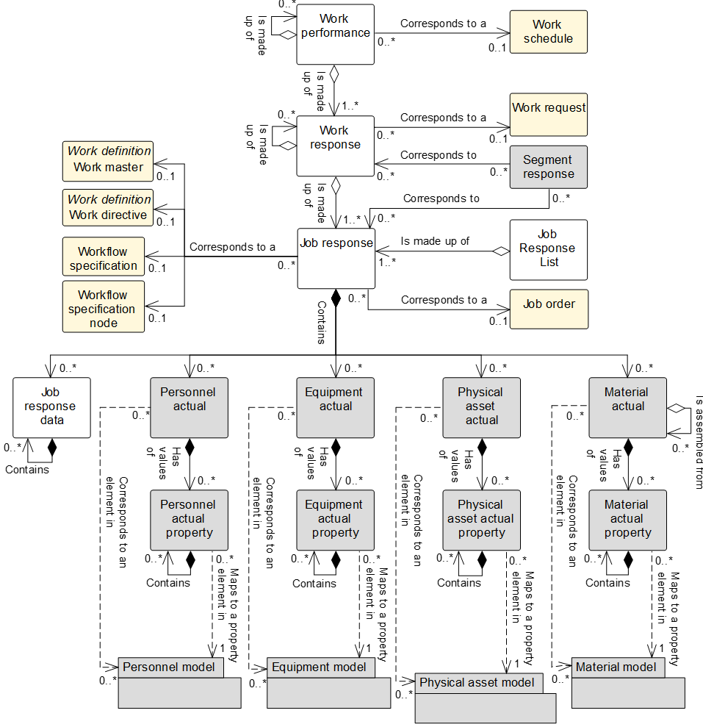

Figure 17 – Work performance model

NOTE 1 The object color convention used in the Part 2 and Part 4 UML diagrams for information models is

* A UML object with a white background belongs to the information model defined in the clause containing the UML diagram.
* A UML object with a gray background belongs to a defined information model in Part 2 that is not defined in the clause containing the UML diagram.
* A UML object with a yellow background belongs to a defined information model in Part 4 that is not defined in the clause containing the UML diagram.

NOTE 2 When a Part 2 (gray) or Part 4 (yellow) object has relationship to an object (white) defined in the clause containing the UML diagram, only the basic relationships between the objects not defined in the clause are shown for better context of the object (white) defined in the clause.

Table 74 – Work performance model relationships

| From | To | Type | Relationship Name |
| --- | --- | --- | --- |
| Work performance | Work schedule | Association | Corresponds to a |
| Work performance | Work response | Aggregation whole | Is made up of |
| Work performance | Work performance | Aggregation hierarchy | Is made up of |
| Work response | Work request | Association | Corresponds to |
| Work response | Work response | Aggregation hierarchy | Is made up of |
| Work response | Job response | Aggregation whole | Is made up of |
| Segment response (Part 2) | Work response | Association | Corresponds to a |
| Segment response (Part 2) | Job response | Association | Corresponds to a |
| Job response list | Job response | Aggregation whole | Is made up of |
| Job response | Workflow specification | Association | Corresponds to |
| Job response | Workflow specification node | Association | Corresponds to |
| Job response | Job order | Association | Corresponds to a |
| Job response | Work master | Association | Corresponds to a |
| Job response | Work directive | Association | Corresponds to a |
| Job response | Job response data | Composition whole | Contains |
| Job response data | Job response data | Composition hierarchy | Contains |
| Job order | Personnel actual | Composition whole | Contains |
| Job order | Equipment actual | Composition whole | Contains |
| Job order | Physical asset actual | Composition whole | Contains |
| Job order | Material actual | Composition whole | Contains |
| Personnel actual | Personnel actual property | Composition whole | Has values of |
| Personnel actual property | Personnel actual property | Composition hierarchy | Contains |
| Personnel actual | Personnel class | Association (A) | Corresponds to |
| Personnel actual | Person | Association (C) | Corresponds to |
| Personnel actual property | Personnel class property | Dependency (B) | Maps to |
| Personnel actual property | Person property | Dependency (D) | Maps to |
| Equipment actual | Equipment actual property | Composition whole | Has values of |
| Equipment actual property | Equipment actual property | Composition hierarchy | Contains |
| Equipment actual | Equipment class | Association (A) | Corresponds to |
| Equipment actual | Equipment | Association (C) | Corresponds to |
| Equipment actual property | Equipment class property | Dependency (B) | Maps to |
| Equipment actual property | Equipment property | Dependency (D) | Maps to |
| Physical asset actual | Physical asset actual property | Composition whole | Has values of |
| Physical asset actual property | Physical asset actual property | Composition hierarchy | Contains |
| Physical asset actual | Physical asset class | Association (A) | Corresponds to |
| Physical asset actual | Physical asset | Association (C) | Corresponds to |
| Physical asset actual property | Physical asset class property | Dependency (B) | Maps to |
| Physical asset actual property | Physical asset property | Dependency (D) | Maps to |
| Material actual | Material actual property | Composition whole | Has values of |
| Material actual property | Material actual property | Composition hierarchy | Contains |
| Material actual | Material class | Association (A) | Corresponds to |
| Material actual | Material definition | Association (A) | Corresponds to |
| Material actual | Material lot | Association (C) | Corresponds to |
| Material actual | Material sublot | Association (C) | Corresponds to |
| Material actual property | Material class property | Dependency (B) | Maps to |
| Material actual property | Material definition property | Dependency (B) | Maps to |
| Material actual property | Material lot property | Dependency (D) | Maps to |
| Material actual | Material actual | Aggregation hierarchy | Is assembled from |

NOTE *Segment response defined in the operations performance model in Part 2 of this standard.

## Work performance

Table 75 defines the relationship roles for the *work performance*. Table 76 defines the attributes for the *work performance*.

A *work performance* may be made up of zero or more nested *work performances*.

Table 75 – Work performance relationship roles

| Related Object | Role | Multiplicity | Relationship Name | Description |
| --- | --- | --- | --- | --- |
| Work response | Work response | 1..* |  | The *work response(s)* related to this *work performance*. |
| Work performance | Work performance child | 0..* | Is made up of | The related object(s) makes up part of this *work performance* as the whole. |
| Work schedule | Work schedule | 0..1 | Corresponds to | An identification of the associated *work schedule*, if applicable.  *Work performance* may not relate to a *work schedule*; it may be a report on work for a specific time or a report plant floor events. |

Table 76 – Work performance attributes

| Attribute name | Description | Production examples | Maintenance examples | Quality examples | Inventory examples |
| --- | --- | --- | --- | --- | --- |
| ID | A unique identification of the *work performance* and could include version and revision identification.  The ID shall be used in other parts of the model when the *work performance* needs to be identified. | 1999-10-27-A15 | CNC-PM-20110307-13465 | B12345-S01 | B12345-KIT101-A |
| Work type | Describes the category of work.  Required attribute.  Defined values are  production, maintenance, quality, inventory, or mixed.  “Mixed” shall be used when the work definition contains resources and routing information required to perform several types of work. | Production | Maintenance | Quality | Inventory |
| Description | Contains additional information and descriptions of the *work performance.* | “Work performance report on October 27, 1999 work schedule.” | Preventive maintenance performed on CNC machine | Production sample for batch 12345 | Dispense kit for batch 12345 |
| Start time | The starting time of the associated *work performance*, if applicable. | 10-28-1999 | 2011-03-07 09:31 | N/A | 2011-03-07 08:01 |
| End time | The ending time of the associated *work performance*, if applicable. | 10-30-1999 | 2011-03-10 11:15 | N/A | 2011-03-07 08:31 |
| Published date | The date and time in which the *work performance* was published or generated. | 10-27-1999 13:42 EST | 2011-03-10 13:21 | 2009-12-14 13:31 PT | 2011-03-07 08:33 |
| Hierarchy scope | Identifies where the exchanged information fits within the role based equipment hierarchy. | East Wing manufacturing line #2 | CNC machine  Asset ID 13465 | Test cell 4  Receiving | Warehouse B |
| Work state | Indicates the state of the *work performance*.  Defined values are:  Waiting, ready, running, completed, aborted, held, suspended, closed. | Completed | Closed | Running | Paused |

The defined values for the *work state* attribute of the *work performance* object, the *response state* attribute for the *work response* object, and the *job state* attribute of the *job response* object have the following definitions:

1. Waiting – Necessary pre-conditions have not been met and the job orders or activities are not ready to run;
2. Ready – Necessary pre-conditions have been met and the *job order* or activities are ready to run.
3. Running – *Job order* or activities are in execution.
4. Completed – *Job order* or activities have been completed and are no longer in execution.
5. Aborted – An execution decision has been taken to terminate the *job order* or activities that may, or may not, have been previously commenced.
6. Held – *Job order* or activities have been temporarily stopped due to a constraint of some form.
7. Paused – *Job order* or activities have been temporarily stopped due to a deliberate decision within execution.
8. Closed – *Job order* or activities have been completed and fully reconciled. No further changes, or restatement of actuals is expected.

## Work response

The responses from manufacturing that are associated with a *work request* shall be defined as *work responses*. There may be one or more *work responses* for a single *work request* if the manufacturing facility needs to split the *work request* into smaller elements of work.

A *work response* may include the status of the request, such as the percentage complete, a finished status, or an aborted status.

A *work response* may be made up of zero or more nested *work responses*.

Table 77 defines the relationship roles for the *work response*. Table 78 defines the attributes for the *work response*.

Table 77 – Work response relationship roles

| Related Object | Role | Multiplicity | Relationship Name | Description |
| --- | --- | --- | --- | --- |
| Work performance | NA | 1 | Is made up of | The *work performance* contains in part this *work response*. |
| Work response | Work response child | 0..* | Is made up of | The related object(s) makes up part of this *work response* as the whole. |
| Work request | Work request | 0..1 | Corresponds to a | An identification of the associated *work request*, if applicable.  *Work response* may not relate to a *work request*, it may be a report on all work for a specific time, or reported on by plant floor events. |
| Job response | Job response | 1..* | Is made up of | The *job responses* that make up this *work response*. |
| Segment response* (Part 2) | NA | 0..1 | Corresponds to | The *segment response* contains in part this *work response*. |

NOTE *Segment response defined in the operations performance model in Part 2 of this standard.

Table 78 – Work response attributes

| Attribute name | Description | Production examples | Maintenance examples | Quality examples | Inventory examples |
| --- | --- | --- | --- | --- | --- |
| ID | An identification within the associated *work performance*.  The ID shall be used in other parts of the model when the *work response* needs to be identified. | 1001091 | R-CNC-PM-20110307-13465 | B12345-S01-RESP | B12345-KIT101-R |
| Work type | Describes the category of work.  Required attribute.  Defined values are  production, maintenance, quality, inventory, or mixed.  “Mixed” shall be used when the work definition contains resources and routing information required to perform several types of work. | Production | Maintenance | Quality | Inventory |
| Start time | The starting time of this *work response*. | 1999-10-27 8:33 UTC | 2011-03-07 09:31 | 2011-03-10 15:12 | 2011-03-07 08:01 |
| End time | The ending time of this *work response*. | 1999-10-27 16:55 UTC | 2011-03-10 11:15 | 2011-03-10 18:00 | 2011-03-07 08:31 |
| Hierarchy scope | Identifies where the exchanged information fits within the role based equipment hierarchy. | East Wing manufacturing line #2 | CNC machine  Asset ID 13465 | Test cell 4  Receiving | Zone B |
| Response state | Indicates the state of the *work response.*  Defined values are:  Waiting, ready, running, completed, aborted, held, suspended, closed. | Completed | Closed | Running | Paused |

## Job response list

A *job response* list shall be defined as a collection of *job responses* for a specific period of time and selected work centers or other resources. A *job response list* may be considered as a slice of *work performances*.

A *job response list* may contain *job responses* from multiple *work responses* and *work performances*.

Table 79 defines the relationship roles for the *job response list*. Table 80 defines the attributes for the *job response list*.

Table 79 – Job response list relationship roles

| Related Object | Role | Multiplicity | Relationship Name | Description |
| --- | --- | --- | --- | --- |
| Job response | Job response | 1..* | Is made up of | The *job response(s)* that make up this *job response list*. |

Table 80 – Job response list attributes

| Attribute name | Description | Production examples | Maintenance examples | Quality examples | Inventory examples |
| --- | --- | --- | --- | --- | --- |
| ID | A unique identification of the job response list.  The ID shall be used when the job response list needs to be identified in other objects. | Area51/Line2 | R-CNC-PM-20110307-13465 | B12345-S01-RESP | B12345-KIT101-R |
| Version | An identification of the version of the *job response list*.  In cases where there are multiple versions of a *job response list*, then the version attribute shall contain the additional identification information to differentiate each version. | 1.0 | 1.4 | 1.1 | 1.1 |
| Work type | Describes the category of work.  Describes the category of work.  Required attribute.  Defined values are  production, maintenance, quality, inventory, or mixed.  “Mixed” shall be used when the work definition contains resources and routing information required to perform several types of work. | Production | Maintenance | Quality | Inventory |
| Start time | The starting time of this *job response list*. | 1999-10-27 8:33 UTC | 2011-03-07 09:31 | 2011-03-10 15:12 | 2011-03-07 08:01 |
| End time | The ending time of this *job response list*. | 1999-10-27 16:55 UTC | 2011-03-10 11:15 | 2011-03-10 18:00 | 2011-03-07 08:31 |
| Hierarchy scope | Identifies where the exchanged information fits within the role based equipment hierarchy. | East Wing manufacturing line #2 | CNC machine  Asset ID 13465 | Test cell 4  Receiving | Zone B |

## Job response

The responses from manufacturing that are associated with a *job order* shall be defined as a *job response*. There may be one or more *job responses* for a single *job order* if the manufacturing facility needs to split the *job order* into smaller elements of work. Where smaller elements of work are reported, the *job response* may be for a specific *workflow specification* or a *workflow specification node*.

A *job order* may include the status of the request, such as the percentage complete, a finished status, or an aborted status.

Table 81 defines the relationship roles for the *job response*. Table 82 defines the attributes for the *job response*.

Table 81 – Job response relationship roles

| Related Object | Role | Multiplicity | Relationship Name | Description |
| --- | --- | --- | --- | --- |
| Work response | NA | 1 | Is made up of | The *work response* aggregated in this *job response*. |
| Segment response (Part 2) | NA | 0..1 | Corresponds to | The *segment response* contains in part this *job response*. |
| Work master | Work master | 0..1 | Corresponds to a | The *work master (s)* related to this *job response*.  The *version* of the *work master* may be specified in the attribute of this *job response*. |
| Work directive | Work directive | 0..1 | Corresponds to a | The *work directive(s)* related to this *job response*.  The *version* of the *work directive* may be specified in the attribute of this *job response*. |
| Workflow specification | Workflow specification | 0..1 | Corresponds to a | The *workflow specifications* related to this *job response*. |
| Workflow specification node | Workflow specification node | 0..1 | Corresponds to a | The *workflow specification node* related this *job response*. |
| Job order | Job order | 0..1 | Corresponds to a | The *job order* related to this *job response*, |
| Job response list | NA | 0..1 | Is made up of | The *job response list(s)* referenced in this *job response*. |
| Personnel actual | Personnel actual | 0..* | Contains | The *personnel actual(s)* related to this *job response.* |
| Equipment actual | Equipment actual | 0..* | Contains | The *equipment actual(s)* related to this *job response.* |
| Physical asset actual | Physical asset actual | 0..* | Contains | The *physical asset actual(s)* related to this *job response.* |
| Material actual | Material actual | 0..* | Contains | The *material actual(s)* related to this *job response.* |
| Job response data | Job response data | 0..* | Contains | Data associated with this *job response.* |

NOTE Segment response defined in the operations performance model in Part 2 of this standard.

Table 82 – Job response attributes

| Attribute name | Description | Production examples | Maintenance examples | Quality examples | Inventory examples |
| --- | --- | --- | --- | --- | --- |
| ID | An identification within the associated *job response*.  The *ID* shall be used in other parts of the model when the *job response* needs to be identified. | 1001091 | R-CNC-PM-20110307-13465 | B12345-S01-RESP | B12345-KIT101-R |
| Work type | Describes the category of work.  Required attribute.  Defined values are  production, maintenance, quality, inventory, or mixed.  “Mixed” shall be used when the work definition contains resources and routing information required to perform several types of work. | Production | Maintenance | Quality | Inventory |
| Job order | An identification of the associated *job order*, if applicable.  *Job responses* may not relate to a *job order*, it may be a report on all work for a specific time, or reported on by plant floor events. | 1001091 | CNC-PM-20110307-13465 | B12345-S01 | B12345-KIT101-A |
| Start time | The actual starting time of information in the *job response*. | 1999-10-27 8:33 UTC | 2011-03-07 09:31 | 2011-03-10 15:12 | 2011-03-07 08:01 |
| End time | The actual ending time of information in the *job response*. | 1999-10-27 16:55 UTC | 2011-03-10 11:15 | 2011-03-10 18:00 | 2011-03-07 08:31 |
| Hierarchy scope | Identifies where the exchanged information fits within the role based equipment hierarchy. | East Wing manufacturing line #2 | CNC machine  Asset ID 13465 | Test cell 4  Receiving | Zone B |
| Job state | Indicates the state of the *work response.*  Defined values are:  Waiting, ready, running, completed, aborted, held, suspended, closed. | Completed | Closed | Running | Paused |

## Job response data

Other information related to the actual work made shall be presented as *job response data*.

The attributes for *job response* data are defined in part 2 of this standard as *segment data*.

A *job response data* object may be made up of zero or more nested *job response data* objects.

Table 83 defines the relationship roles for the *job response data*.

Table 83 – Job response data relationship roles

| Related Object | Role | Multiplicity | Relationship Name | Description |
| --- | --- | --- | --- | --- |
| Job response | Job response | 1 | Contains | The *job response* contains in part this *job response data(s)*. |

## Personnel actual

The definition of this object and the attributes for this object are defined in part 2 of this standard.

## Personnel actual property

The definition of this object and the attributes for this object are defined in part 2 of this standard.

## Equipment actual

The definition of this object and the attributes for this object are defined in part 2 of this standard.

## Equipment actual property

The definition of this object and the attributes for this object are defined in part 2 of this standard.

## Physical asset actual

The definition of this object and the attributes for this object are defined in part 2 of this standard.

## Physical asset actual property

The definition of this object and the attributes for this object are defined in part 2 of this standard.

## Material actual

The definition of this object and the attributes for this object are defined in part 2 of this standard.

A *material actual* may be an assembly of zero or more nested *material actuals*.

## Material actual property

The definition of this object and the attributes for this object are defined in part 2 of this standard.

# Work capability information

## Work capability model

The collection of information about the resources for work for selected future and past times shall be defined as *work capability*. This is made up of information about committed, available, and unattainable *equipment, material, personnel, physical assets*, and *work master capabilities*. *Work capability* describes the names, terms, statuses, and quantities of which the manufacturing operations and control system has knowledge.

NOTE *Work capability* is used when the capability and capacity do not vary based on the product being produced or any specific *work master* used.

Figure 18 is the *work capability* model that applies to the production, maintenance, quality test and inventory operations; objects shown as gray boxes are defined in part 2 of this standard. Table 84 lists the relationships of the objects in the work capability model.

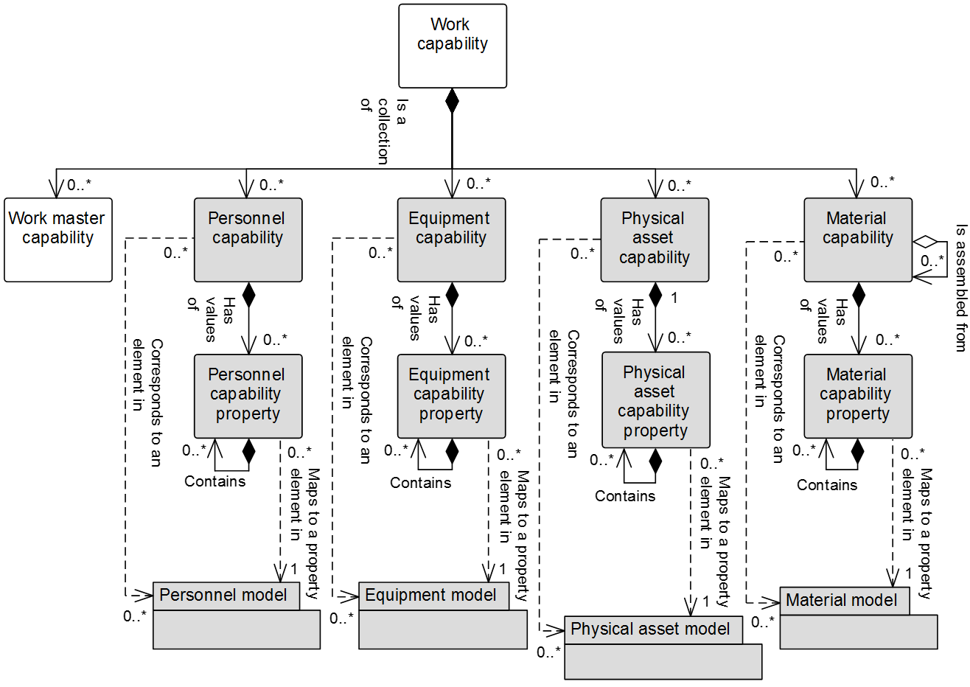

Figure 18 – Work capability model

NOTE 1 The object color convention used in the Part 2 and Part 4 UML diagrams for information models is

* A UML object with a white background belongs to the information model defined in the clause containing the UML diagram.
* A UML object with a gray background belongs to a defined information model in Part 2 that is not defined in the clause containing the UML diagram.
* A UML object with a yellow background belongs to a defined information model in Part 4 that is not defined in the clause containing the UML diagram.

NOTE 2 When a Part 2 (gray) or Part 4 (yellow) object has relationship to an object (white) defined in the clause containing the UML diagram, only the basic relationships between the objects not defined in the clause are shown for better context of the object (white) defined in the clause.

Table 84 – Work capability model relationships

| From | To | Type | Relationship Name |
| --- | --- | --- | --- |
| Work capability | Work master capability | Composition whole | Is collection of |
| Work capability | Personnel capability | Composition whole | Is collection of |
| Work capability | Equipment capability | Composition whole | Is collection of |
| Work capability | Physical asset capability | Composition whole | Is collection of |
| Work capability | Material capability | Composition whole | Is collection of |
| Material capability | Material capability | Aggregation hierarchy | Is assembled from |
| Personnel capability | Personnel capability property | Composition whole | Has values of |
| Personnel capability property | Personnel capability property | Composition hierarchy | Contains |
| Personnel capability | Personnel class | Association (A) | Corresponds to |
| Personnel capability | Person | Association (C) | Corresponds to |
| Personnel capability property | Personnel class property | Dependency (B) | Maps to |
| Personnel capability property | Person property | Dependency (D) | Maps to |
| Equipment capability | Equipment capability property | Composition whole | Has values of |
| Equipment capability property | Equipment capability property | Composition hierarchy | Contains |
| Equipment capability | Equipment class | Association (A) | Corresponds to |
| Equipment capability | Equipment | Association (C) | Corresponds to |
| Equipment capability property | Equipment class property | Dependency (B) | Maps to |
| Equipment capability property | Equipment property | Dependency (D) | Maps to |
| Physical asset capability | Physical asset capability property | Composition whole | Has values of |
| Physical asset capability property | Physical asset capability property | Composition hierarchy | Contains |
| Physical asset capability | Physical asset class | Association (A) | Corresponds to |
| Physical asset capability | Physical asset | Association (C) | Corresponds to |
| Physical asset capability property | Physical asset class property | Dependency (B) | Maps to |
| Physical asset capability property | Physical asset property | Dependency (D) | Maps to |
| Material capability | Material capability property | Composition whole | Has values of |
| Material capability property | Material capability property | Composition hierarchy | Contains |
| Material capability | Material class | Association (A) | Corresponds to |
| Material capability | Material definition | Association (A) | Corresponds to |
| Material capability | Material lot | Association (C) | Corresponds to |
| Material capability | Material sublot | Association (C) | Corresponds to |
| Material capability property | Material class property | Dependency (B) | Maps to |
| Material capability property | Material definition property | Dependency (B) | Maps to |
| Material capability property | Material lot property | Dependency (D) | Maps to |

## Work capability

Table 85 defines the relationship roles for the *work capability*. Table 86 defines the attributes for the *work capability*.

Table 85 – Work capability relationship roles

| Related Object | Role | Multiplicity | Relationship Name | Description |
| --- | --- | --- | --- | --- |
| Personnel capability | Personnel capability | 0..* | Is a collection of | The *personnel capability(s)* related to this *work capability.* |
| Equipment capability | Equipment capability | 0..* | Is a collection of | The *equipment capability(s)* related to this *work capability.* |
| Physical asset capability | Physical asset capability | 0..* | Is a collection of | The *physical asset capability(s)s* related to this *work capability.* |
| Material capability | Material capability | 0..* | Is a collection of | The *material capability(s)* related to this *work capability.* |
| Work master capability | Work master capability | 0..* | Is a collection of | *Work master capability(s)* associated with this *work capability.* |

Table 86 – Work capability attributes

| Attribute name | Description | Production examples | Maintenance examples | Quality examples | Inventory examples |
| --- | --- | --- | --- | --- | --- |
| ID | Defines a unique instance of a *work capability* for a specified element of the equipment hierarchy model [IEC 62264-1:2013, 5.2] (*enterprise, site, area, work center, or work unit*). | 1999/12/30-HPC52 | HHG6778 | LAB6678 | AGV556 |
| Description | Contains additional information and descriptions of the *work capability*. | “One day’s work capacity for the Boston Widget Company.” | Motor shop capacity, week 15 | Lab centrifuge capacity | Pallet movement capacity |
| Operations type | Describes the category of the activity. Required attribute. Defined values are:  Production, maintenance, quality, inventory, or mixed.  “Mixed” shall be used when the activity contains several categories of *process segments*. | Production | Maintenance | Quality | Inventory |
| Capability type | Defines the type of capability. Defined values are  Committed, unattainable, available, used, unused, total.  Committed – capacity that is committed for future productive use.  Unattainable – capacity that is not attainable for future productive use given the equipment condition, equipment utilization, personnel availability or material availability.  Available – capacity that is available for additional future productive use.  Used – a historical value that defines the portion of the capacity with acceptable quality.  Unused – a historical value that defines the portion of the capacity that was not used or had unacceptable quality.  Total – the sum of used and unused capability or the sum of available, unattainable and committed capability. | Available | Total | Committed | Available |
| Reason | Defines the reason for the capability type.  EXAMPLE 1 If unused, then the reason for why the capability was unused, such as a specific equipment failure or unacceptable product quality. | Available for work | Total hours of motor maintenance | Stability tests | Uncommitted AGVs |
| Confidence factor | A measure of the confidence of the capacity value.  EXAMPLE 3 A percentage value representing the confidence of the capacity. | 90 % | 100 % | 100 % | 75 % |
| Hierarchy scope | Identifies where the exchanged information fits within the role based equipment hierarchy.  Zero or more as required to identify the specific scope of the *work capability definition*. | Boston Widget Company | Boston Widget Company | Boston Widget Company | Boston Widget Company |
| Start time | The starting date and time of the *work capability*. | 2015-12-29 11:59 | 2011-04-03 12:00 | 2011-04-03 12:00 | 2011-04-03 12:00 |
| End time | The ending date and time of the *work capability*. | 2015-12-30 12:00 | 2011-04-09 11:59 | 2011-04-09 11:59 | 2011-04-09 11:59 |
| Published date | The date and time on which the *work capability* was published or generated. | 2015-11-03 13:55 | 2011-04-01 8:00 | 2011-04-01 8:00 | 2011-04-01 8:00 |

## Personnel capability

The definition of this object and the attributes for this object are defined in part 2 of this standard.

## Personnel capability property

The definition of this object and the attributes for this object are defined in part 2 of this standard.

## Equipment capability

The definition of this object and the attributes for this object are defined in part 2 of this standard.

## Equipment capability property

The definition of this object and the attributes for this object are defined in part 2 of this standard.

## Physical asset capability

The definition of this object and the attributes for this object are defined in part 2 of this standard.

## Physical asset capability property

The definition of this object and the attributes for this object are defined in part 2 of this standard.

## Material capability

The definition of this object and the attributes for this object are defined in part 2 of this standard.

A *material capability* may be an assembly of zero or more nested *material capabilities*.

## Material capability property

The definition of this object and the attributes for this object are defined in part 2 of this standard.

# Work master capability information

## Work master capability model

A representation of a logical grouping of personnel resources, equipment resources, physical asset resources, and material that is committed, available, or unavailable for a given *work master* for a specific time shall be defined as a *work master capability*, as shown in Figure 19; objects shown as gray boxes are defined in part 2 of this standard. Table 87 lists the relationships of the objects in the work master capability model.

NOTE *Work master capability* is used when the capability and capacity vary based on the product being produced or the specific *work master* used.

The *work master capability* shall identify:

1. the capability type (available, unattainable, committed, used, unused, total);
2. the time associated with the capability (for example, third shift on a specific date).

The *work master capabilities* shall be made up of

1. *personnel segment capabilities*, which list specific properties required in *personnel segment capability properties*;
2. *equipment segment capabilities*, which list specific properties required in *equipment capability properties*;
3. *physical asset segment capabilities*, which list specific properties required in *physical asset capability properties*;
4. *material segment capabilities*, which list specific properties required in *material segment capability properties.*

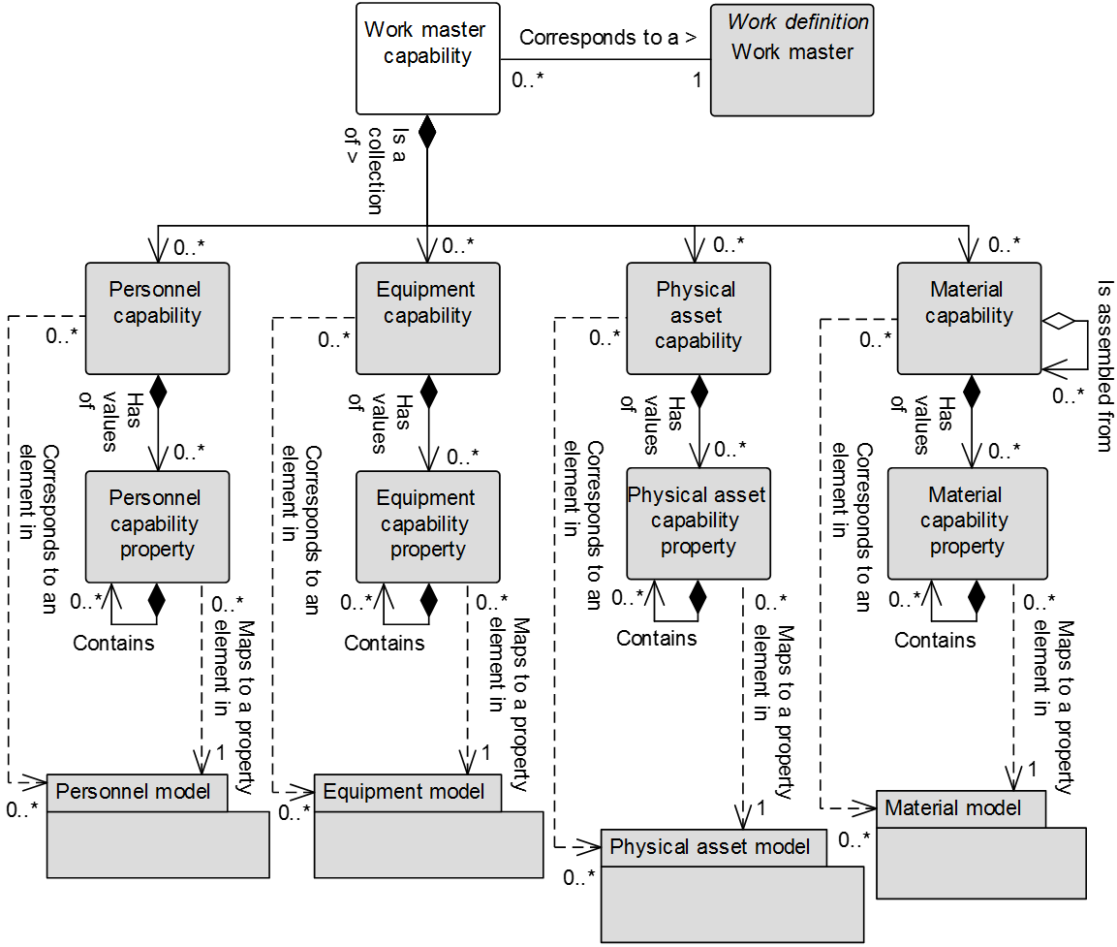

Figure 19 – Work master capability model

NOTE The object color convention used in the Part 2 and Part 4 UML diagrams for information models is

* A UML object with a white background belongs to the information model defined in the clause containing the UML diagram.
* A UML object with a gray background belongs to a defined information model in Part 2 that is not defined in the clause containing the UML diagram.
* A UML object with a yellow background belongs to a defined information model in Part 4 that is not defined in the clause containing the UML diagram.

NOTE When a Part 2 (gray) or Part 4 (yellow) object has relationship to an object (white) defined in the clause containing the UML diagram, only the basic relationships between the objects not defined in the clause are shown for better context of the object (white) defined in the clause.

Table 87 – Work master capability model relationships

| From | To | Type | Relationship Name |
| --- | --- | --- | --- |
| Work master capability | Work master | Association | Corresponds to |
| Work master capability | Personnel capability | Composition whole | Is a collection of |
| Work master capability | Equipment capability | Composition whole | Is a collection of |
| Work master capability | Physical asset capability | Composition whole | Is a collection of |
| Work master capability | Material capability | Composition whole | Is a collection of |
| Material capability | Material capability | Aggregation hierarchy | Is assembled from |
| Personnel capability | Personnel capability property | Composition whole | Has values of |
| Personnel capability property | Personnel capability property | Composition hierarchy | Contains |
| Personnel capability | Personnel class | Association (A) | Corresponds to |
| Personnel capability | Person | Association (C) | Corresponds to |
| Personnel capability property | Personnel class property | Dependency (B) | Maps to |
| Personnel capability property | Person property | Dependency (D) | Maps to |
| Equipment capability | Equipment capability property | Composition whole | Has values of |
| Equipment capability property | Equipment capability property | Composition hierarchy | Contains |
| Equipment capability | Equipment class | Association (A) | Corresponds to |
| Equipment capability | Equipment | Association (C) | Corresponds to |
| Equipment capability property | Equipment class property | Dependency (B) | Maps to |
| Equipment capability property | Equipment property | Dependency (D) | Maps to |
| Physical asset capability | Physical asset capability property | Composition whole | Has values of |
| Physical asset capability property | Physical asset capability property | Composition hierarchy | Contains |
| Physical asset capability | Physical asset class | Association (A) | Corresponds to |
| Physical asset capability | Physical asset | Association (C) | Corresponds to |
| Physical asset capability property | Physical asset class property | Dependency (B) | Maps to |
| Physical asset capability property | Physical asset property | Dependency (D) | Maps to |
| Material capability | Material capability property | Composition whole | Has values of |
| Material capability property | Material capability property | Composition hierarchy | Contains |
| Material capability | Material class | Association (A) | Corresponds to |
| Material capability | Material definition | Association (A) | Corresponds to |
| Material capability | Material lot | Association (C) | Corresponds to |
| Material capability | Material sublot | Association (C) | Corresponds to |
| Material capability property | Material class property | Dependency (B) | Maps to |
| Material capability property | Material definition property | Dependency (B) | Maps to |
| Material capability property | Material lot property | Dependency (D) | Maps to |

## Work master capability

*Work master capability* has an equivalent structure to the *personnel, equipment* and *material* structure of *work capability*, except the *work master capability* is defined for a specific *work master*.

Table 88 lists the relationship roles of *work master capability.* Table 89 lists the attributes of *work master capability.*

Table 88 – Work master capability relationship roles

| Related Object | Role | Multiplicity | Relationship Name | Description |
| --- | --- | --- | --- | --- |
| Personnel capability | Personnel capability | 0..* | Is a collection of | The *personnel capability(s)* related to this *work capability.* |
| Equipment capability | Equipment capability | 0..* | Is a collection of | The *equipment capability(s)* related to this *work capability.* |
| Physical asset capability | Physical asset capability | 0..* | Is a collection of | The *physical asset capability(s)s* related to this *work capability.* |
| Material capability | Material capability | 0..* | Is a collection of | The *material capability(s)* related to this *work capability.* |
| Work master | Work master | 0..* | Corresponds to | *Work master* associated with this *work master capability.* |

Table 89 – Work master capability attributes

| Attribute name | Description | Production examples | Maintenance examples | Quality examples | Inventory examples |
| --- | --- | --- | --- | --- | --- |
| ID | A unique identification of the *work master capability.* | A7756 | 20121111 | 20121111Q |  |
| Description | Contains additional information and descriptions of the *work master capability*. | “Defines the available capability for the widget assembly process segment” | Calibration of custody transfer gas flow meters | Hazardous material incoming inspection | Movement of hazardous material to warehouse |
| Work master | Identifies the *work master*. | Widget assembly | CTCF calibration | HMII | Fork truck movement |
| Operations type | Describes the category of the activity. Required attribute. Defined values are:  Production, maintenance, quality, inventory, or mixed.  “Mixed” shall be used when the activity contains several categories of *process segments*. | Production | Maintenance | Quality | Inventory |
| Capability type | Defines the type of capability. Defined values are  Committed, unattainable, available, used, unused, total.  Committed – capacity that is committed for future productive use.  Unattainable – capacity that is not attainable for future productive use given the equipment condition, equipment utilization, personnel availability or material availability.  Available – capacity that is available for additional future productive use.  Used – a historical value that defines the portion of the capacity with acceptable quality.  Unused – a historical value that defines the portion of the capacity that was not used or had unacceptable quality.  Total – the sum of used and unused capability or the sum of available, unattainable and committed capability. | Available | Committed | Available | Available |
| Reason | Defines the reason for the capability type.  EXAMPLE 1 If unused, then the reason for why the capability was unused, such as a specific equipment failure or unacceptable product quality. | Available for production | Required by regulation | Available from scheduling | Available for scheduling |
| Confidence factor | A measure of the confidence of the capacity value.  EXAMPLE A percentage value representing the confidence of the capacity | 90% | 100% | Medium | 2 |
| Hierarchy scope | Identifies where the exchanged information fits within the role based equipment hierarchy.  If omitted, then the capability is associated to the parent *work capability* hierarchy scope.  Zero or more as required to identify the specific scope of the *operations capability* definition. | Production Line #15 | West production site | Receiving warehouse 13 | Receiving warehouse 13 |
| Start time | The starting time of the time span defining the *capability type*.  If omitted, then the capability is associated to the parent *work capability* start time. | 2013-12-30 11:59 | 2012-11-11 11:59 | 2012-11-11 11:59 | 2012-11-11 11:59 |
| End time | The ending time of the time span defining the *capability type*.  If omitted, then the capability is associated to the parent *work capability* end time. | 2014-01-01 12:00 | 2012-11-12 11:59 | 2012-11-12 11:59 | 2012-11-12 11:59 |
| Published date | The date and time on which the *work master capability* was published or generated. | 1999-11-03 13:55 | 10-25-2006 00:00 UTC | 10-25-2006 00:00 UTC | 10-25-2006 00:00 UTC |

## Personnel capability

The definition of this object and the attributes for this object are defined in part 2 of this standard.

## Personnel capability property

The definition of this object and the attributes for this object are defined in part 2 of this standard.

## Equipment capability

The definition of this object and the attributes for this object are defined in part 2 of this standard.

## Equipment capability property

The definition of this object and the attributes for this object are defined in part 2 of this standard.

## Physical asset capability

The definition of this object and the attributes for this object are defined in part 2 of this standard.

## Physical asset capability property

The definition of this object and the attributes for this object are defined in part 2 of this standard.

## Material capability

The definition of this object and the attributes for this object are defined in part 2 of this standard.

## Material capability property

The definition of this object and the attributes for this object are defined in part 2 of this standard.

# Work KPI information

Values that have a business or operational value related to a measure of performance shall be defined as *Work KPIs* (key performance indicators). KPIs are registered and defined. Registered KPI values are exchanged on a regular or event basis. See ISO 22400 for a definition of the KPI object model, attributes, and standard KPIs.

# Work alert information

## Work alert model

A notification of a Level 3 event shall be defined as a *work alert*. Not all events warrant creating a *work alert*. A *work alert* does not require acknowledgement. If acknowledgement is needed, then an alarm model may be used (see IEC 62682, for information on alarms). *Work alerts* may be generated by any Level 3 activity.

*Work alert definitions* are descriptions of the available types of *work alerts*.

NOTE 1 The detailed configuration data for *work alerts*, such as trigger conditions, registration of recipients and actions to be taken upon receipt are out of the scope of this part of this standard.

NOTE 2 *Work alerts* differ from *work KPIs* in that the primary content of a *work alert* is the contextual information required to convey that an event has occurred.

EXAMPLE 1 This is similar to a “gate change alert” emailed to a traveler if an airplane gate change occurs. It indicates a potentially significant event but does not require any response or action.

EXAMPLE 2 A calculation or checking of a *work KPI* may trigger a *work alert*, but other events may also trigger a work alert.

EXAMPLE 3 A *work alert* that indicates the completion of a production run may be a trigger to start the execution of a workflow.

EXAMPLE 4 A workflow event, such as the expiration of a deadline timer, may trigger a *work alert*.

Figure 20 is the *work alert* model. Table 90 lists the relationships of the objects in the work alert model.

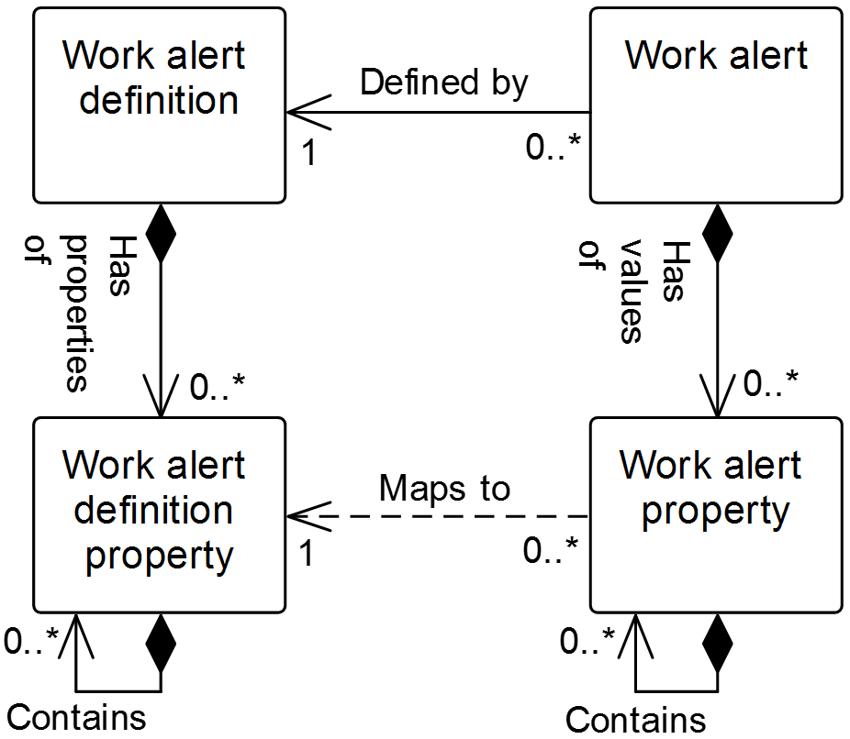

Figure 20 – Work alert model

Table 90 – Work alert model relationships

| From | To | Type | Relationship Name |
| --- | --- | --- | --- |
| Work alert definition | Work alert definition property | Composition whole | Has properties of |
| Work alert definition property | Work alert definition property | Composition hierarchy | Contains |
| Work alert | Work alert definition | Association (A) | Defined by |
| Work alert | Work alert property | Composition whole | Has values of |
| Work alert property | Work alert definition property | Dependency | Maps to |
| Work alert definition property | Work alert definition property | Composition hierarchy | Contains |
| Work alert property | Work alert property | Composition hierarchy | Contains |

## Work alert definition

Table 91 lists the relationship roles of the *work alert definition.*

Table 92 lists the attributes of the *work alert definition.*

Table 91 – Work alert definition relationship roles

| Related Object | Role | Multiplicity | Relationship Name | Description |
| --- | --- | --- | --- | --- |
| Work alert | NA | 0..* | Defined by | The *work alert(s)* defined by this *work alert definition.* |
| Work alert definition property | Work alert definition property | 0..* | Has properties of | The *work alert definition properties* that are part of this *work alert definition.* These properties are supported by *work alerts* defined by the *work alert definition.* |

Table 92 – Work alert definition attributes

| Attribute name | Description | Production examples | Maintenance examples | Quality examples | Inventory examples |
| --- | --- | --- | --- | --- | --- |
| ID | Unique identification of the *work alert definition*. | P_0004293 | M32D | 834 | Inven88 |
| Description | Contains additional information and descriptions of the *work alert definition*. | Notification of job order started | Reminder that PM is overdue | Test setup complete | Shipment arrived |
| Hierarchy scope | Identifies where the exchanged information fits within the role based equipment hierarchy. | East Wing manufacturing line #2 | CNC Machine  Asset ID 13465 | Test cell 4  Receiving | Warehouse B |
| Priority | List of the priorities that act as a guide to the relative level of importance of a *work alert.* | {1,2,3} | {Low, Medium, High} | {Information, Error} | {1..10} |
| Category | General grouping associated with a *work alert definition*. | Scheduling | PM | Lab | Receiving |

## Work alert definition property

The *work* *alert definition property* shall be defined as property on a *work alert definition property*.

A *work alert definition property* may contain nested *work alert definition property(s)*.

Table 93 lists the relationship roles of the *work alert definition property.* Table 94 lists the attributes of the *work alert definition property.*

Table 93 – Work alert definition property relationship roles

| Related Object | Role | Multiplicity | Relationship Name | Description |
| --- | --- | --- | --- | --- |
| Work alert definition | NA | 1 | Has properties of | The *work alert definition* defined in part by this *work alert definition property.* |
| Work alert property | NA | 0..* | Maps to | If the parent *work alert* supports a *work alert definition*, this *work alert definition property(s)* is applied in the *work alert property(s)*.  The *work alert property* maps to this corresponding *work alert definition property.* |
| Work alert definition property | Work alert definition property child | 0..* | Contains | The child *work alert definition properties* of this *work alert definition property*. |

Table 94 – Work alert definition property attributes

| Attribute name | Description | Production examples | Maintenance examples | Quality examples | Inventory examples |
| --- | --- | --- | --- | --- | --- |
| ID | An identification of the specific property, unique under the scope of the parent *work alert definition* object. | Job order ID | Physical asset ID | Test ID | Quantity |
| Description | Additional information and description about the *work alert definition property.* | Identification of the associated job order | Identification of the equipment to be maintained | Identification of the test type | Quantity of material received |
| Value | The value, set of values, or range of the property.  This presents a range of possible numeric values, a list of possible values, or it may be empty if any value is valid. | Not applicable | Not applicable | 0..99999 | 0..20000 |
| Value unit of measure | The unit of measure of the associated property values, if applicable. | Not applicable | Not applicable | Not applicable | Kg |

EXAMPLE Possible properties for *work alerts* are shown in Table 95:

Table 95 – Examples of work alert properties

|  |  |
| --- | --- |
| Property | Description |
| Asset key | A unique data source identifier of the asset associated with the alert |
| Help | Text to provide additional information about the alert and may include information about the cause of the problem and suggestions on how to fix the problem |

## Work alert

Table 96 lists the relationship roles of the *work alert.* Table 97 lists the attributes of the *work alert.*

Table 96 – Work alert relationship roles

| Related Object | Role | Multiplicity | Relationship Name | Description |
| --- | --- | --- | --- | --- |
| Work alert definition | Work alert definition | 1 | Defined by | The *work definition* definingthis *work alert.* |
| Work alert property | Work alert property | 0..* | Has values of | This *work alert property(s)* defined in part by the *work alert property(s).* |

Table 97 – Work alert attributes

| Attribute name | Description | Production examples | Maintenance examples | Quality examples | Inventory examples |
| --- | --- | --- | --- | --- | --- |
| ID | Unique identification of the *work alert.* | 49293847523 | M-53A | ER4232 | INV-FG |
| Message text | Textual content of the *work alert.* | Vacuum gas unit switched to feedstock ABC | Overdue PM on compressor 105, WO # 2843 | Test #88765 ready | Material arrived |
| Timestamp | Timestamp the *work alert* was generated. | Mon August 16 at 01:36 PM | 2014-03-07 10:00 UTC | 2010-04-27 10:30 | 2011-01-20 14:45 UTC-10:00 |
| Hierarchy scope | Identifies where the exchanged information fits within the role based equipment hierarchy. | East Wing manufacturing line #2 | CNC Machine  Asset ID 13465 | Test cell 4  Receiving | Warehouse B |
| Priority | Guide to the relative level of importance of the value for the *work alert.*  NOTE 1 No standard priority types are defined in this standard. | 1 | Medium | Informational | 8 |
| Category | General grouping associated with a *work alert.*  NOTE 2 No standard categories are defined in this standard. | Scheduling | PM | Lab | Receiving |

## Work alert property

The *work alert property* shall be defined as property on a *work alert property.*

A *work alert property* may contain nested *work alert property(s)*.

Table 98 lists the relationship roles of the *work alert property.* Table 99 lists the attributes of the *work alert.*

Table 98 – Work alert property relationship roles

| Related Object | Role | Multiplicity | Relationship Name | Description |
| --- | --- | --- | --- | --- |
| Work alert definition property | Work alert definition property | 1 | Maps to | If the parent *work alert* supports *a work alert definition*, the *work alert definition property(s)* is applied in this *work alert property(s)*.  This *work alert property* maps to the corresponding *work alert definition property*. |
| Work alert | NA | 1 | Has values of | The *work alert(s) defined in part by* this *work alert property*. |
| Work alert property | Work alert property child | 0..* | Contains | The child *work alert properties* of this *work alert property*. |

Table 99 – Work alert property attributes

| Attribute name | Description | Production examples | Maintenance examples | Quality examples | Inventory examples |
| --- | --- | --- | --- | --- | --- |
| ID | An identification of the specific *work alert property*. | Job order ID | Physical asset ID | Test ID | Quantity of material received |
| Description | Additional information about the *work alert property*. | On time switch over | Scheduled maintenance | Test ready | Not applicable |
| Value | The value, set of values, or range of the property. | 99387A | 105 | 88765 | 1856 |
| Value unit of measure | The unit of measure of the associated property value, if applicable. | Not applicable | Not applicable | Not applicable | Kg |

# Work calendar information

## Work calendar model

*Work calendar definitions* define a set of rules that specify specific calendar entries, along with repeat rules, duration, starting and ending dates and times for the entries. The entries can be used to generate a *work calendar*, which is a calendar of specific entries for specific dates (and times).

The work calendar model defines an exchange format for exchanging the rules (*work calendar definition*) or a calendar with specific dates (*work calendar*).

EXAMPLE The information of the *work calendar* can be used for different purposes:

* Assigning *personnel* to different shifts and track their work time compared to the assigned shifts;
* Use work calendar information in order to correctly calculate and track *operations performance*;
* Use work calendar information for detailed operations scheduling;
* Determine planned production and non-production times for *equipment* that is used for *operations* *performance* calculations;
* Account work hours for *personnel*;
* Compare actual production time with planned production times.

NOTE *Work calendar definitions* and *work calendars* could represent time periods of different dimensions:

* Work / non-work time definition: hours or minutes;
* Shift definition - day or shifts;
* Work day Definition - days or day;
* Pattern - months or weeks;
* Work shift calendar - years or months.

Figure 21 is the model for *work calendar definitions* and *work calendars*. Table 100 lists the relationships of the objects in the work calendar model.

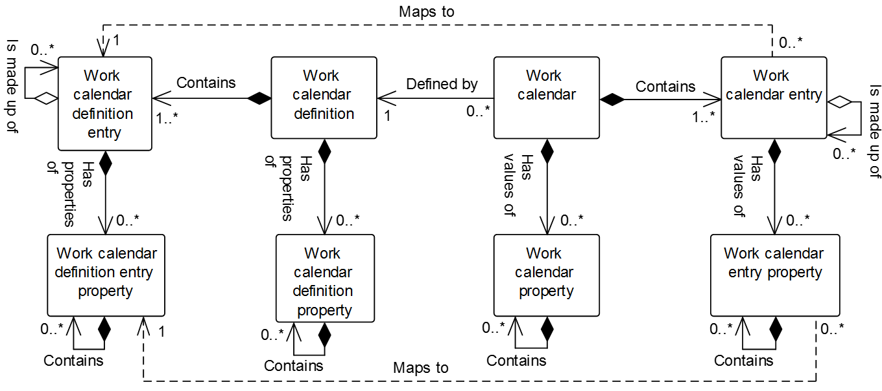

Figure 21 – Work calendar model

Table 100 – Work calendar model relationships

| From | To | Type | Relationship Name |
| --- | --- | --- | --- |
| Work calendar definition | Work calendar definition entry | Composition whole | Contains |
| Work calendar definition | Work calendar definition property | Composition whole | Has properties of |
| Work calendar definition property | Work calendar definition property | Composition hierarchy | Contains |
| Work calendar definition entry | Work calendar definition entry property | Composition whole | Has properties of |
| Work calendar definition entry | Work calendar definition entry | Aggregation hierarchy | Is made up of |
| Work calendar definition entry property | Work calendar definition entry property | Composition hierarchy | Contains |
| Work calendar entry | Work calendar definition entry | Dependency | Maps to |
| Work calendar | Work calendar entry | Composition whole | Contains |
| Work calendar | Work calendar property | Composition whole | Has values of |
| Work calendar property | Work calendar property | Composition hierarchy | Contains |
| Work calendar entry | Work calendar entry property | Composition whole | Has values of |
| Work calendar entry | Work calendar entry | Aggregation hierarchy | Is made up of |
| Work calendar entry property | Work calendar entry property | Composition hierarchy | Contains |
| Work calendar entry property | Work calendar definition entry property | Dependency | Maps to |

## Work calendar definition

The *work calendar definition* shall be defined as a collection of *work calendar definition entries*.

Table 101 lists the relationship roles of the *work calendar definition.* Table 102 lists the attributes of the *work calendar definition.*

Table 101 – Work calendar definition relationship roles

| Related Object | Role | Multiplicity | Relationship Name | Description |
| --- | --- | --- | --- | --- |
| Work calendar definition entry | Work calendar definition entry | 1..* | Contains | The *work calendar definition entry(s)* that are part of this *work calendar definition.* |
| Work calendar | NA | 0..* | Defined by | The *work calendar(s)* defined by this *work calendar definition.* |
| Work calendar definition property | Work calendar definition property | 0..* | Has properties of | This *work calendar definition* defined in part bythe *work calendar definition property(s)*. |

Table 102 – Work calendar definition attributes

| Attribute name | Description | Production examples | Maintenance examples | Quality examples | Inventory examples |
| --- | --- | --- | --- | --- | --- |
| ID | An identification of the specific *work calendar definition*. | 7 days | Maintenance | Quality env check | 3 shifts |
| Description | Additional information about the *work calendar definition*. | 7-day fortnight shift pattern | Weekly maintenance | Periodic environmental quality checks | 3-shift pattern |
| Hierarchy scope | Identifies where the exchanged information fits within the role based equipment hierarchy. | East Wing manufacturing line #2 | CNC Machine  Asset ID 13465 | Test cell 4  Receiving | Warehouse B |

## Work calendar definition property

The *work calendar definition property* shall be defined as property on a *work calendar definition property*.

A *work calendar definition property* may contain nested *work calendar definition property(s)*.

Table 103 defines the relationship roles for *work calendar definition property* objects. Table 104 defines the attributes for *work calendar definition property* objects.

Table 103 – Work calendar definition property relationship roles

| Related Object | Role | Multiplicity | Relationship Name | Description |
| --- | --- | --- | --- | --- |
| Work calendar definition | N/A | 1 | Has properties of | The *work calendar definition* defined in part bythis *work calendar definition property(s)*. |
| Work calendar definition property | Work calendar definition property child | 0..* | Contains | The *work calendar definition properties* of this *work calendar definition property*. |

Table 104 – Work calendar definition property attributes

| Attribute name | Description | Examples |
| --- | --- | --- |
| ID | A unique identification of the property. | Approver |
| Description | Additional information about the property. | The approver of the work calendar definition. |
| Value | The default value, set of values, or range of the property. | Stephen Smith |
| Value unit of measure | The unit of measure of the associated property value, if applicable. | n/a |

## Work calendar definition entry

The *work calendar* shall be defined as a set of start, duration, and recurrence rules that can be used to create *work calendar entries* of a specific type.

A *work calendar definition entry* may be made up of zero or more nested *work calendar definition entries*.

Table 105 lists the relationship roles of the *work* *calendar definition entry.* Table 106 lists the attributes of the *work* *calendar definition entry.*

Table 105– Work calendar definition entry relationship roles

| Related Object | Role | Multiplicity | Relationship Name | Description |
| --- | --- | --- | --- | --- |
| Work calendar definition | NA | 1 | Contains | The w*ork calendar definition* defined in part by this w*ork calendar definition entry*. |
| Work calendar definition entry | Work calendar definition entry child | 0..* | Is made up of | The related object(s) makes up part of this *work calendar definition entry* as the whole. |
| Work calendar entry | Work calendar entry | 0..* | Maps to | This *work calendar definition entry defines in part* the *work calendar entry(s).* |
| Work calendar definition entry property | Work calendar definition entry property | 0..* | Has properties of | The *work calendar definition entry property(s)* defines in part this *work calendar definition entry.* |

Table 106 – Work calendar definition entry attributes

| Attribute name | Description | Examples |
| --- | --- | --- |
| ID | An identification of the specific *work calendar definition entry*. | 123 |
| Description | Additional information about the *work calendar definition entry*. | Drop New Year’s ball |
| Start rule | Defines the starting date and time for the *work calendar definition entry* in ISO 8601 format for a date and time.  The Start Rule may include an ending time, following ISO 8601 format for a time interval. | 2014-01-01T00:00/2114-12-31T00:00:00 |
| Recurrence time interval rule | Defines the rule for recurrence of the entry in ISO 8601 format for recurrences. | R/P1Y |
| Duration rule | Defines the duration of the *work calendar definition entry* in ISO 8601 format for durations. | PT24H |
| Entry type | Defines the type of *work calendar definition entry.* There are no standard entry types defined. | Work shift  Bank holiday  Plant shutdown |

The *start rule* in a *work calendar definition entry* shall be defined in ISO 8601 format for a date and time.

EXAMPLE 1 2014-05-01.

The *start rule* may include an ending time, following ISO 8601 format for a time interval.

EXAMPLE 2 2014-05-01/2015-06-01.

The *recurrence time interval rule* in a *work calendar definition entry* shall be defined in ISO 8601 format for recurrences.

EXAMPLE 3 R2M15D – Recurrence every 2 months and 15 days.

The *duration rule* in a *work calendar definition entry* shall be defined in ISO 8601 format for durations.

EXAMPLE 4 PT15H – 15 hours.

## Work calendar definition entry property

The *work calendar definition entry property* shall be defined as property on a *work calendar definition entry*.

A *work calendar definition entry property* may contain nested *work calendar definition entry property(s)*.

Table 107 lists the relationship roles of the *work* *calendar definition entry property.* Table 108 lists the attributes of the *work* *calendar definition entry property.*

Table 107 – Work calendar definition entry property relationship roles

| Related Object | Role | Multiplicity | Description |
| --- | --- | --- | --- |
| Work calendar definition entry | NA | 1 | The *work calendar definition entry* defined in part by this *work calendar definition entry property*. |
| Work calendar entry property | N/A | 0..* | The *work calendar entry properties* mapping to this *work calendar definition entry property*. |
| Work calendar definition entry property | Work calendar definition entry property child | 0..* | The *work calendar definition entry properties* of this *work calendar definition entry property*. |

Table 108 – Work calendar definition entry property attributes

| Attribute name | Description |
| --- | --- |
| ID | A unique identification of the property. |
| Description | Additional information about the property. |
| Value | The default value, set of values, or range of the property. |
| Value unit of measure | The unit of measure of the associated property value, if applicable. |

## Work calendar

The *work calendar* shall be defined as a collection of *work calendar entries*.

Table 109 lists the relationship roles of the *work calendar.* Table 110 lists the attributes of the *work calendar.*

Table 109 – Work calendar relationship roles

| Related Object | Role | Multiplicity | Description |
| --- | --- | --- | --- |
| Work calendar entry | Work calendar entry | 1..* | The *work calendar entry(s)* that are part of this *work calendar.* |
| Work calendar definition | Work calendar definition | 1 | The *work calendar definition* defines this *work calendar.* |
| Work calendar property | Work calendar property | 0..* | This *work calendar* is defined in part  bythe *work calendar definition property(s)*. |

Table 110 – Work calendar attributes

| Attribute name | Description | Production examples | Maintenance examples | Quality examples | Inventory examples |
| --- | --- | --- | --- | --- | --- |
| ID | An identification of the specific *work calendar*. | First shift | Planned shutdowns | Reagent order | Tank transfers |
| Description | Additional information about the *work calendar*. | Definition of the first shift with holidays | Planned shutdowns for next year | Schedule to order reagents | Tank transfer calendar |
| Hierarchy scope | Identifies where the exchanged information fits within the role based equipment hierarchy. | East Wing manufacturing line #2 | CNC Machine  Asset ID 13465 | Test cell 4  Receiving | Warehouse B |

## Work calendar property

The *work calendar property* shall be defined as property on a *work definition property*.

A *work calendar property* may contain nested *work calendar property(s)*.

Table 111 defines the relationship roles for *work calendar property* objects. Table 112 defines the attributes for *work calendar property* objects.

Table 111 – Work calendar property relationship roles

| Related Object | Role | Multiplicity | Description |
| --- | --- | --- | --- |
| Work calendar | NA | 1 | The *work calendar* defined in part bythis *work calendar definition property(s)*. |
| Work calendar property | Work calendar property child | 0..* | The *work calendar property(s)* contained in this *work calendar property*. |

Table 112 – Work calendar property attributes

| Attribute name | Description | Examples |
| --- | --- | --- |
| ID | A unique identification of the property. | Approver |
| Description | Additional information about the property. | The approver of the work calendar. |
| Value | The default value, set of values, or range of the property. | Stephen Smith |
| Value unit of measure | The unit of measure of the associated property value, if applicable. | n/a |

## Work calendar entry

The *work calendar entry* shall be defined as a calendar entry with a start date and time, a finish date and time, and an entry type.

A *work calendar entry* may be made up of zero or more nested *work calendar entries*.

Table 113 lists the relationship roles of the *work calendar entry.* Table 114 lists the attributes of the *work calendar entry.*

Table 113 – Work calendar entry relationship roles

| Related Object | Role | Multiplicity | Description |
| --- | --- | --- | --- |
| Work calendar | NA | 1 | The *work calendar* defined in part by this work calendar entry*,* |
| Work calendar entry | Work calendar entry child | 0..* | The *work calendar entry(s)* makes up part of this *work calendar entry* as the whole. . |
| Work calendar definition entry | Work calendar definition entry | 1 | The *work calendar definition entry* that defines this *work calendar entry.* |
| Work calendar entry property | Work calendar entry property | 0..* | The *work calendar entry property(s)* in part defines this *work calendar entry.* |

Table 114 – Work calendar entry attributes

| Attribute name | Description | Examples |
| --- | --- | --- |
| ID | An identification of the specific *calendar entry*. | 001 |
| Description | Additional information about the *calendar entry*. | May ;;Day Holiday |
| Start date time | Defines the starting date and time of the *work calendar entry.* | 2014-05-01T00H00M00S |
| Finish date time | Defines the ending date and time of the *work calendar entry.* | 2014-05-01T23H59M59S |
| Entry type | Defines the type of *work calendar entry.* There are no standard entry types defined. | Work shift  Bank holiday  Plant shutdown |

## Work calendar entry property

The *work calendar entry property* shall be defined as a property on a *work calendar entry*.

A *work calendar entry property* may contain nested *work calendar entry property(s)*.

Table 115 lists the relationship roles of the *work calendar entry property.* Table 116 lists the attributes of the *work calendar entry property.*

Table 115 – Work calendar entry property relationship roles

| Related Object | Role | Multiplicity | Description |
| --- | --- | --- | --- |
| Work calendar entry | NA | 1 | The *work calendar entry* defined in part by this *work calendar entry property*. |
| Work calendar definition entry property | Work calendar definition entry property | 1 | The *work calendar entry definition property* to which this *work calendar entry property* maps. |
| Work calendar entry property | Work calendar entry property child | 0..* | The *work calendar entry properties* of this *work calendar entry property*. |

Table 116 – Work calendar entry property attributes

| Attribute name | Description |
| --- | --- |
| ID | A unique identification of the property. |
| Description | Additional information about the property. |
| Value | The default value, set of values, or range of the property. |
| Value unit of measure | The unit of measure of the associated property value, if applicable. |

# Work documents

Work documents should be represented as *materials*, role based *equipment,* or a *physical asset* when documents are considered a resource necessary to perform a unit of work.

NOTE 1 Documents are mentioned as a resource in ANSI/ISA-95.00.01:2013, 5.2.4.2:

“The MOM domain shall include the functionality of managing resources directly associated with control and manufacturing. The resources in the MOM domain include *personnel, equipment,* and *material*, as well as other entities, such as documents, that are required for work to start and to be completed. The management of these resources may include local resource reservation to meet production-scheduling objectives.”

NOTE 2 Documentation is mentioned as a resource in ANSI/ISA 95.00.03:2013, 7.5:

“Maintenance resource management shall be defined as the collection of activities that manage the information about the state of the resources and relationships between resources used within the domain of control of maintenance. The managed resources may include maintenance equipment, maintenance tools, personnel (with skill sets), documentation and material and energy used in maintenance.”

In manufacturing operations management, it is often necessary to manage work documents as resources necessary to perform specific units of work, like other resources already addressed in this standard.

NOTE 1 Work documents can represent any kind of media, e.g., paper, electronic file, etc.

NOTE 2 The work documents discussed here are limited to the documents required for operations.

NOTE 3 *Work masters* and *work performance* may contain references to the work documents.

EXAMPLE Work documents that may need to be managed include:

* equipment or system drawings
* SOPs
* engineering documentation
* manuals
* instructions

# Work Record information

## Operations record model (abstract)

The operations record model is shown in Figure 21 is specified in part 2 of this standard. The *operations record template* and *operations record specification template* are abstract types that are not standalone exchange objects. These abstract objects are realized in specialized implementations as occurrences of the *operations event record* in part 2 and the *work record* in part 4 of this standard. The operations record model represents a common structure for representing bundled information reported in data exchanges. The *operations record template* bundles *operations record entry template* objects by the type of action in the action attribute with defined values of created, changed, deleted and observed. The *operations record entry template* embeds objects defined in ISA-95 and manufacturing operations profiles or references to external objects. The *operations record specification template* specifies the content and form of objects in an *operations record* within the associated *operations record entry template(s).*

NOTE In an implementation, the *operations record entry template* is validated against the *operations record specification template*.

Table 117 lists the relationships of the objects in the operations record model.

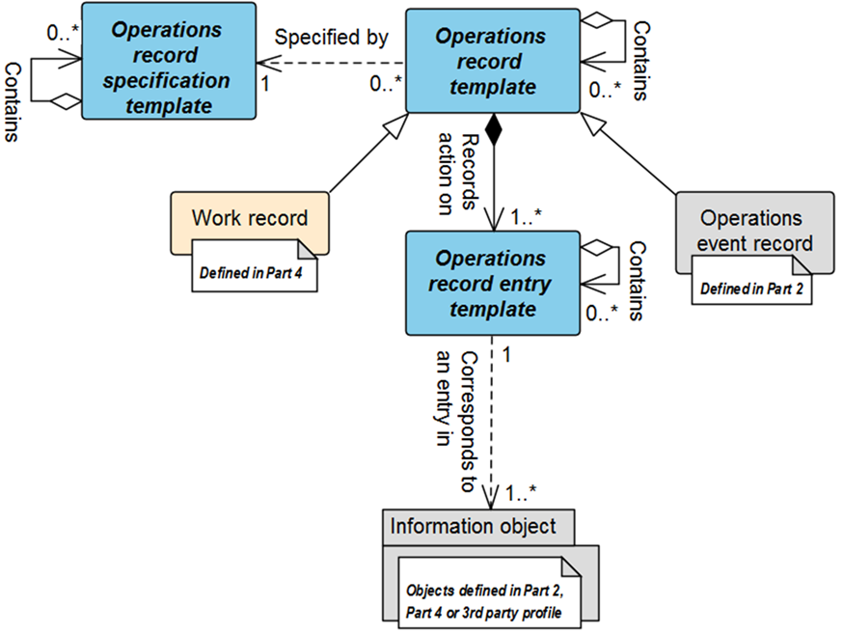

Figure 22 – Operations record model (abstract)

NOTE 1 The object color convention used in the Part 2 and Part 4 UML diagrams for information models is

* A UML object with a white background belongs to the information model defined in the clause containing the UML diagram.
* A UML object with a gray background belongs to a defined information model in Part 2 that is not defined in the clause containing the UML diagram.
* A UML object with a yellow background belongs to a defined information model in Part 4 that is not defined in the clause containing the UML diagram.
* A UML object with a blue background belongs to an abstract object defined in the clause.

NOTE 2 When a Part 2 (gray) or Part 4 (yellow) object has relationship to an object (white) defined in the clause containing the UML diagram, only the basic relationships between the objects not defined in the clause are shown for better context of the object (white) defined in the clause.

Table 117 – Operations record model relationships

| From | To | Type | Relationship Name |
| --- | --- | --- | --- |
| Operations record template | Operations record specification template | Dependency | Specified by |
| Operations record template | Operations record entry template | Composition | Records action on |
| Operations record entry template | Information object | Dependency | Corresponds to an entry in |
| Operations record template | Operations record template | Aggregation hierarchy | Contains |
| Operations record specification template | Operations record specification template | Aggregation hierarchy | Contains |
| Operations record entry template | Operations record entry template | Aggregation hierarchy | Contains |

## Work record information, an operations record specialization

A work record model is a specialization of the operations record model as defined in part 2 of this standard. The *work record* shall be defined as a subset of the execution and business information that is retained based upon business requirements identified by a *work record specification*. A *record* consists of data about the manufacture of the product plus all supporting data required to meet the business requirements of the record.

NOTE 1 This information could include the workflow execution information, both specific equipment information, operator comments, alarms, elements related to the definition of a job (such as *work masters*, *work directives*, *work schedule* information), and information important to the operation (such as training logs, maintenance records, and environmental conditions).

NOTE 2 *Work performance* contains information to a specific set of *job orders*. *Work records* can contain information about multiple *job orders* and information not directly related to any specific *job order*. A *work record* can contain a *work performance* (or *work response*). Generally, a *work performance* is the response to performing the work specified in a *work schedule*. A *work record* contains additional details of all activities involved in operations

*Work records* are intended to provide a vendor-neutral representation of information in a form suitable for archiving and storage. Figure 23 illustrates the activities and information associated with creating, maintaining, and using *work records*. Only the *work record* and *work record specification* (the white boxes) is defined in this standard; the activities and other information sets (the gray boxes and activities) are shown to illustrate the environment of *work records*. There is an activity of creating *work records*, which uses operations information, usually from multiple sources and in multiple forms and formats, and which uses a specification of the information to be used to create the *work record*. There is an activity which uses *work records* and work record report specifications to generate work record reports that are suitable for print or display. The work record report specification uses the *work record specification* to identify the data contained in the work record report.

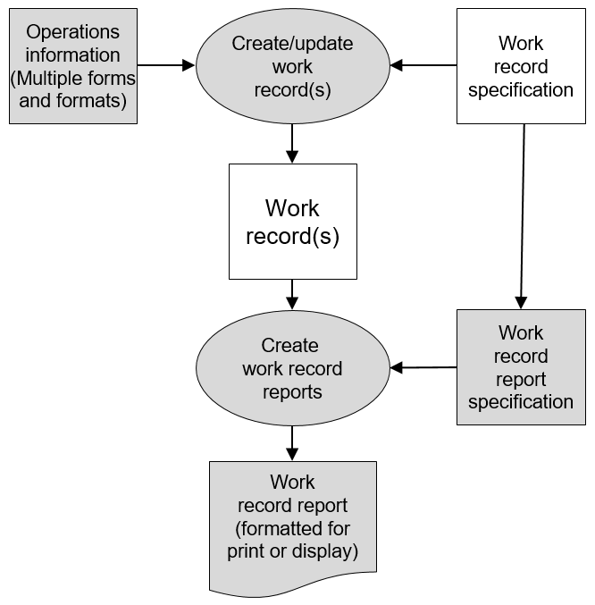

Figure 23 – Work record environment

NOTE 1 *A work record specification* is the information that is intended to be used to define a *work record*. The content and format for *work record specifications*.

NOTE 2 A *work record report specification* is the information that is intended to be used to define a *work record report.* The *work record report specification* uses the *work record specification* to identify the objects to be reported*.* The content and format for *work record report specifications* are not defined in this part of the standard.

## Work record model

The work record model is shown in Figure 24. The work record model specializes the operations record model to represent to information required to represent a *work record*.

The attributes and relationships for the *work record* include the attributes of the abstract *operations record template*. Similarly, the *work record specification* attributes include the attributes of the abstract *operations record specification template*. Table 118 lists the relationships of the objects in the work record model.

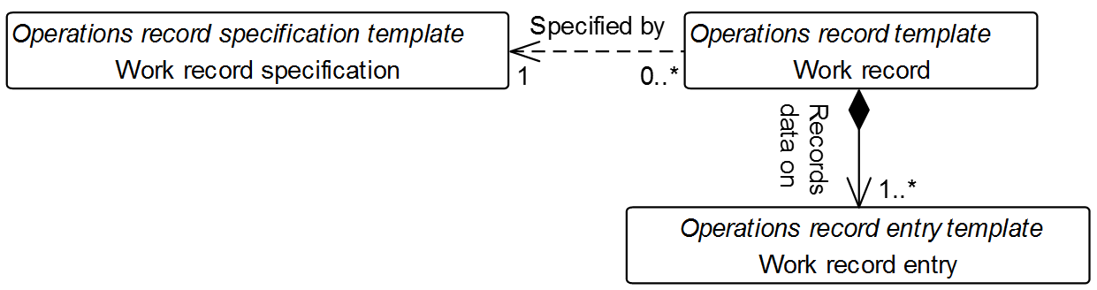

Figure 24 – Work record model

NOTE The *operations record specification template, operations record template and operations record entry template* in *italics* in Figure 24 are the abstract objects that each object is derived.

Table 118 – Work record model

| From | To | Type | Relationship Name |
| --- | --- | --- | --- |
| Work record | Work record entry | Composition | Records action on |
| Work record | Work record specification | Association | Specified by |
| Work record entry * | Information object (Part 2)* | Dependency | Corresponds to an entry in |
| Work record * | Work record * | Aggregation hierarchy | Contains |
| Work record specification* | Work record specification* | Aggregation hierarchy | Contains |
| Work record entry * | Work record entry * | Aggregation hierarchy | Contains |

NOTE *The dependency relationship to *information object* aggregation hierarchy relationships are not shown in Figure 23 and defined in part 2 of this standard as part of the operations record model. They are inherited by the specialized instances and not shown in the work record model.

## Work record specification

Specification of the allowed content of *work record* objects shall be defined as *work record specifications*.

*Information object* contents in the *work record* vary depending on the process context of the *work*. The *work record specification* describes and specifies the *information objects* and associated *actions* that are allowed in the *work record* occurrence. The publisher/sender shall follow this specification to construct the message. Subscribers/receivers shall use the *work record specification* to validate the content of the message.

Table 119 defines the relationship roles for the *work record specification*. Table 120 defines the attributes for the *work record specification*.

Table 119 – Work record specification relationship roles

| Related Object | Role | Multiplicity | Relationship Name | Description |
| --- | --- | --- | --- | --- |
| Work record | NA | 0..* | Specified by | The *work record* maps to this corresponding *work record specification.*  Allowed content in the *work record* is defined by this *work record specification.* |
| Work record specification | Work record specification child | 0..* | Is made up of | This parent *work record specification* is whole of the child *work record specification(s)* as the part. |

Table 120 - Work record specification attributes

| Attribute name | Description | Production examples | Maintenance examples | Quality examples | Inventory examples |
| --- | --- | --- | --- | --- | --- |
| ID | Identification within the associated *work record* *specification*.  *Work record* instances include this value with their *work record* object to enable recognition / validation of the message contents. | CR-87 | Uuid - 1FCF9DA1-DCC5-4012-BDEF-D76C754F4826 | 2016-03 | AB45 |
| Description | Contains additional information and description of the *work record specification*. |  |  |  |  |
| Information object type | Permitted set of information objectsallowed in the *work* *record* occurrence.  NOTE 1 A *work record entry* contains the attributes to the information object for *work record.*  NOTE 2 An unconstrained set of values can be represented with the * entry. | [Equipment, Personnel], | [JobList] | [TestSpecfication, Test Results] | [Material Lot, Material Sublot], |
| Information object type multiplicity | The range of the information object(s) in *work record entry* allowed in the *work record* occurrence.  NOTE 1 If no limit is explicitly specified, the unbounded keyword is specified.  NOTE 2 If no *multiplicity* entry is specified, this is equivalent to no constraint, i.e.: {Min: 0, Max: Unbounded} | {Min: 1, Max: 1} | {Min:0, Max: 1} | {Min:0, Max: 10} | {Min:1, Max: Unbounded} |
| Action | The permitted set of *actions* applied to the *work record entry* *object* in the *work s record* by the publisher.  Defined values for *action* are  *Added, changed, deleted, observed*  NOTE If no *action* is specified, this is equivalent to all *actions* being allowed. | Added, Deleted, Changed, Observed | Changed | Added, Deleted, Changed | Added |
| Action multiplicity | The range of *actions* allowed to be represented in the *work record* occurrence.  NOTE 1 If no limit is explicitly specified, the unbounded keyword is specified.  NOTE 2 If no *multiplicity* entry is specified, this is equivalent to no constraint, i.e.: {Min: 0, Max: Unbounded}. | {Min: 1, Max: 1} | {Min:0, Max: 1} | {Min:0, Max: 10} | {Min:1, Max: Unbounded} |

The number of *Information object* occurrences allowed in the *work record entry* occurrences is specified using the *information object multiplicity* attribute. The number of *actions* allowed for each *information object* is represented using the *action* *multiplicity* attribute. Each *work record* represents a single *action*. An *work record specification* may manage the contents of multiple *work records* in an occurrence.

NOTE 1 The *ID* entries can use the fully qualified name (FQN) syntax to avoid ID collisions.

NOTE 2 Annex F describes the specification of ISA-88 batch production record information in a *work record*.

## Work record

A *work record* is defined with its corresponding *work record specification* to represent the combination of objects that are considered relevant to the work being documented.

Table 121 defines the relationship roles for the *work record*. Table 122 defines the attributes for the *work record*.

The bundle of *work record entr*y *template* objects that are pertinent to the work record information shall be defined as *work records*.

Table 121 - Work record relationship roles

| Related Object | Role | Multiplicity | Relationship Name | Description |
| --- | --- | --- | --- | --- |
| Work record entry | Work record entry | 1..* | Records action on | This *work record* acts as a container for *work record entry (s)* applying a common action attribute for each *work record*. |
| Work record specification | Work record specification | 1 | Specified by | The *work record specification* defines the information object(s) allowed to be contained within a *work record entry* in this *work record*. The specified action must match the value in the attribute, action, in this *work record*. |
| Work record | Work record child | 0..* | Is made up of | This parent *work record* is whole of the child *work record(s)* as the part. |

Table 122 - Work record attributes

| Name | Description | Examples |
| --- | --- | --- |
| ID | A unique identification of the *work record*. This attribute is mandatory.  The *ID* is required to provide a *batch production record* per ISA-88.00.04 with a unique identity. The *ID* attribute may be modified over the lifecycle of a *work record*, although it shall not be completely removed. | 492-2931  T59482A4  456 |
| Description | Additional information about the *work record*. | Lot Release  Campaign costing  Compliance  Material tracking data |
| Hierarchy scope | Identifies where the exchanged information fits within the role based equipment hierarchy.  Optionally defines the scope of the *person* definition. | South Shore (Site) / Work Line (Area) |
| Creation date | The date of the *work record* was created. | 2003-07-14 1454+0100  01 March 2004 14:25 UTC  April 23, 2002 8:30 AM ET |
| Last changed date | The date of the *work record* was last changed. | 2003-07-14 1454+0100  01 March 2004 14:25 UTC  April 23, 2002 8:30 AM ET |
| Change indication | An indication enabling detection that the *work record* has not been altered.  The change indication enables detection that a *work record* has been altered, although may not identify the specific alterations.  EXAMPLE 1 A string generated by an MD5 algorithm used as a hashing algorithm.  EXAMPLE 2 A string representing a digital key of the entire batch production record.  EXAMPLE 3 A string representing a checksum of the entire batch production record. | E;4J9QJG;RGJAOF0  FKG9GRKGH44FF  KRJG49TJHVSNS |
| Record status | Current status of the *work record*. This reflects the current position in a *work record*’s lifecycle.  NOTE This standard does not define standard status values. | In Process  Review  Approved |
| Expiration date | Date and time at which the *work record* is no longer relevant. | 2003-07-14 1454+0100  01 March 2004 14:25 UTC  April 23, 2002 8:30 AM ET |
| Version | The current version of the *work record*.  NOTE Change objects provide historical information concerning how this version was created. | 1.0  11  T |
| Campaign ID | The list of IDs of the campaigns associated with the *work record*. | C4293  923-AKW5.7  832 |
| Lot ID | The list of IDs of the lots associated with the *work record*.  NOTE This is a roll up of detailed information about produced and consumed *material lots* that are included in other *work record* entries. | L492840  EOVMW2  84293 |
| Batch ID | The list of IDs of the batches associated with the *work record*.  NOTE This is a roll up of detailed information about produced and consumed *material lots* that are included in other *work record* entries. | 59429-35  B-000349  200309041435 |
| Material definition ID | The list of IDs of the products associated with the *work record*.  NOTE This is a roll up of detailed information about produced and consumed *material lots* that are included in other *work record* entries. | 459293A1  A4Q59492-5942.1  Polymer56 |
| Equipment ID | The list of *equipment* associated with *work record*.  NOTE This is a roll up of detailed information that may be included in other *work record* entries. | Reactor1  Tank 402 |
| Delimiter | Defines the character set to be used in delimiting elements in *equipment IDs* and procedural element reference. | “|”  “/t” |
| Language | The language used in the *work record* should be identified. If multiple languages are used, the primary language should be identified here, and each instance where other languages are used throughout the batch production record a local reference to the language should be made. | English  Spanish  French  Korean |

## Work record entry

The *work record entry* objectshall be a single *information object* as an object defined in Part 2 and Part 4, and any third-party manufacturing operations message profile within an *operations record* *template*. There shall be one or more *work record entry* objectsin a *work* *record*.

EXAMPLE *Work schedule* and *material lot* as *information objects* require two *work record entry* objects in a *work record*.

Table 123 defines the relationship roles for *work record entry*. Table 124 defines the attributes for *work record entry*.

Table 123 – Work record entry relationships

| Related Object | Role | Multiplicity | Relationship Name | Description |
| --- | --- | --- | --- | --- |
| Operations record template | NA | 1 | Records action on | The *operations record template* applying a single common action (e.g. Changed) acts as a container for this work record *entry(s)*. |
| work record entry | work record entry child | 0..* | Contains | This parent *work record entry* is whole of the child  *work record entry(s)* as the part. |
| Information object | Information object | 0..1 | Corresponds to an entry in | An embedded *information object.*  NOTE 1 If data is referenced in this *work record entry*, the attribute is not used.  NOTE 2 The format of the *information object* is specified in the *work record specification.* |
| Information object | External reference | 0..1 | Corresponds to an entry in | The reference to external data *(information object)* which is stored external to this *work record entry*.  NOTE 1 If data is embedded in this  *work record entry*, the attribute is not used.  NOTE 2 The format of the reference is specified in the *work record specification*. |

NOTE The relationships and their roles in a *work record entry* are defined in the *work record specification.*

Table 124 – Work record entry attributes

| Attribute name | Description | Production examples | Maintenance examples | Quality examples | Inventory examples |
| --- | --- | --- | --- | --- | --- |
| ID | ID which is unique within the scope of *work record entry.* | 1 | 4A34B | 239432 | A11 |
| Description | Additional information about the *work record entry*. | The control recipe is embedded in this *operations record* *template.* |  |  | Data set time series data is stored in the historian database |
| Information object | An embedded information object.  NOTE 1 If data is referenced in this *work record entry*, the attribute is not used.  NOTE 2 The format of the *information object* is specified in this *work record specification*. | Material Lot 11A | Mixer 4 | Work Master QC5001 | Material Lot 59B |
| Information object ID | The reference to external data *(information object)* which is stored external to this *work record entry*.  NOTE 1 If data is embedded in this  *work record entry,* the attribute is not used.  NOTE 2 The format of the reference is specified in this *work record specification*. | Material Lot 11A | Mixer 4 | Work Master QC5001 | Material Lot 59B |
| Effective timestamp | The date and time that the *work record entry* was/is effective.  NOTE If no effective timestamp is provided with *work record entry*, the effective timestamp is represented by the effective timestamp attribute in the *work record*, | Mon August 15 at 01:36 PM | 2014-03-06 11:00 UTC | 2010-04-26 10:30 | 2011-01-20 12:45 UTC-10 |
| Record timestamp | The date and time the publisher recorded / transacted the action.  NOTE If no entry is provided, the record timestamp is the record timestamp attribute in the *work record*. | Mon August 16 at 01:36 PM | 2014-03-07 10:00 UTC | 2010-04-27 12:30 |  |
| Information object type | Identifies the type of information object type that an work record entry is based upon.  NOTE The allowed information object types are defined in the *work record specification.* | Work Master  Control Recipe | Physical Asset | Test Specification | Equipment |

NOTE When multiple *work record entry* are exchanged, the effective timestamps of these *actions* of when each occurred may be relevant to the interpretation of the *work recor*d.

EXAMPLE Awork schedule update (event) creates requirements for new *material lot* and *person* objects in the source system. The publisher/sender advises that the *work schedule* was created after the new *material lot* and *person* objects were created.

# Object lists and relationships

Figure 25 provides an illustration of how some of the object models inter-relate.

NOTE 1 The *work alert,* *work calendar, and work record* models are not directly related to the other models.

NOTE 2 The *resource relationship network* model is not shown because it relates to the resources (defined in part 2 of this standard).

The slanted rectangles in Figure 25 represent any of the resources (*personnel, equipment, physical asset*, or *material*) or properties of the resources.

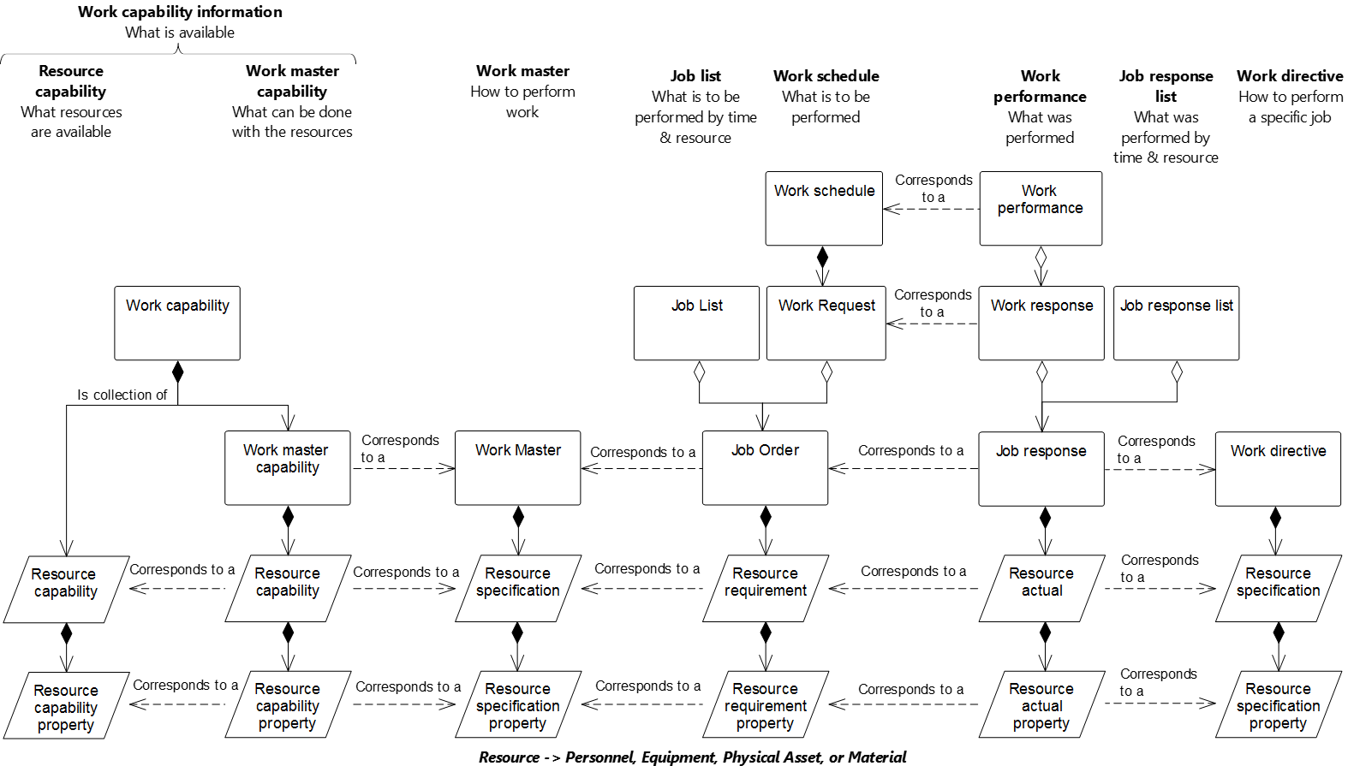

Figure 25 – Relationship between models

Table 125 presents the objects defined in this standard and the associated model.

Table 125 – Objects and models

| Object | Model |
| --- | --- |
| From resource reference | Resource relationship network model |
| From resource reference property | Resource relationship network model |
| Job list | Work schedule model |
| Job order | Work schedule model |
| Job order parameter | Work schedule model |
| Job response | Work performance model |
| Job response data | Work performance model |
| Job response list | Work performance model |
| Resource network connection property | Resource relationship network model |
| Resource network connection type | Resource relationship network model |
| Resource network connection type property | Resource relationship network model |
| Resource relationship network | Resource relationship network model |
| To resource reference | Resource relationship network model |
| To resource reference property | Resource relationship network model |
| Work alert | Work alert model |
| Work alert definition | Work alert model |
| Work alert definition property | Work alert model |
| Work alert property | Work alert model |
| Work calendar | Work calendar model |
| Work calendar definition | Work calendar model |
| Work calendar definition entry | Work calendar model |
| Work calendar definition entry property | Work calendar model |
| Work calendar entry | Work calendar model |
| Work calendar entry property | Work calendar model |
| Work capability | Work capability model |
| Work definition | Work definition model |
| Work directive | Work definition model |
| Work master | Work definition model |
| Work master capability | Work master capability model |
| Work performance | Work performance model |
| Work record | Work record model |
| Work request | Work schedule model |
| Work response | Work performance model |
| Work schedule | Work schedule model |
| Workflow specification | Work definition model |
| Workflow specification | Workflow specification model |
| Workflow specification connection | Workflow specification model |
| Workflow specification connection property | Workflow specification model |
| Workflow specification connection type | Workflow specification model |
| Workflow specification connection type property | Workflow specification model |
| Workflow specification node | Workflow specification model |
| Workflow specification node property | Workflow specification model |
| Workflow specification node type | Workflow specification model |
| Workflow specification node type property | Workflow specification model |

# Compliance

Any assessment of compliance of a specification shall be qualified by the following:

1. the use of the terminology defined in this part of the standard;
2. support of the object models defined in this part,
3. support the use of objects listed in Table 125 that are supported;
4. support the use of the attributes for each supported object;
5. support the defined relationships between the supported objects;
6. a statement of the total compliance concerning definitions, objects, attributes, and relationships or, in case of partial compliance, a statement identifying explicitly the areas of noncompliance.

This is a list of minimum criteria for a compliance assessment.

1. (informative)  
     
   Questions and answers about object use
   1. How are dependencies in the *work schedule* and *work response* handled?

**Question:**

How are dependencies in the *work schedule* and *work response* handled?

**Answer:**

There are different types of dependencies (resource availability, customer priority, process dependency, and other).

Real applications need to model different types of dependencies between *work requests*.

For example, an MRP/ERP at Level 4 can produce separate requests for subassemblies or a single request for the final assembly of a given finished product and for the manufacturing of the intermediate materials that are the subassemblies to be assembled. Of course, there is a work process dependency relationship and final assembly shall start after all subassemblies have been manufactured. This is handled in an implementation where an *operations* or *work request* states the start time and/or end time and then the associated *segment requests* specify the earliest start time, latest end time and duration for each segment. The algorithm for the actual dispatching of work can be done at Level 4 or Level 3, but be represented in the *operations schedule* or *work schedule* request.

* 1. Use of hierarchy scope in workflow specification model

**Question:**

What is the purpose of including the *hierarchy scope* attribute in the workflow specification model?

**Answer:**

The use of the *hierarchy scope* attribute in the workflow specification model provides for the ability to restrict (or scope) the applicability of individual *workflow specification* and *workflow specification node* instances to specific *hierarchy scopes*. The *hierarchy scope* defined in the *workflow specification* or *workflow specification node* instances may be applicable to a broader or narrower equipment model scope than the *work definition* for which they are associated.

EXAMPLE The *work master* for load and haul operations in an open pit mining process assumes the *work directive* being used to control one *job order* for the load and haul operations has the *hierarchy scope* for the area known as “Norte Pit”. The Norte Pit area consists of a number of work centers with a work center defined for each bench being mined. The scope of the *work directive* and its associated *job order* covers all the active benches being mined within the Norte Pit. One of the benches (Bench 10) is restricted to being mined using a front end loader due to geotechnical constraints and another (Bench 8) is not subject to this condition and is being mined using a shovel. The *workflow specification* and/or *workflow specification nodes* relevant for the loading from bench 10 will be different to those relevant for Bench 8. In this case, a single *work directive*/*job order* pair can be used to manage and control the work in the Norte Pit, with the appropriate *workflow specification* being applied when loading from each of Bench 8 and Bench 10.

* 1. What are examples of resource relationships?

**Question:**

What are some examples of *resource relationship networks* and how are they important?

**Answer:**

*Resource relationships networks* model resources that have some form of dependency among the resources.

In the examples below, the *resource relationship network* may be annotated with properties that are relevant to the environment. Properties such as optimum paths, rework paths, and selection criteria for scheduling and planning applications could be included.

The resource relationships may be an input to an application indicating configuration properties of the system or an output representing the result of a calculation such as an optimization process that has generated a resource relationship model to indicate its output.

The following example describes three different *resource relationship networks* using the equipment resources shown in Figure A.1.



Figure A.1 – Equipment resources

The first relationship is a material flow routing network as shown in Figure A.2.



Figure A.2 – Routing relationship network

The routing relationship network would be modelled as a set of *resource network connections*:

<Resource Network Connection AC> <From Resource Reference to A> <To Resource Reference to C>

<Resource Network Connection CE> <From Resource Reference to C> <To Resource Reference to E>

<Resource Network Connection EG> <From Resource Reference to E> <To Resource Reference to G>

<Resource Network Connection BD> <From Resource Reference to B> <To Resource Reference to D>

<Resource Network Connection DE> <From Resource Reference to D> <To Resource Reference to E>

<Resource Network Connection DF> <From Resource Reference to D> <To Resource Reference to F>

<Resource Network Connection FG> <From Resource Reference to F> <To Resource Reference to G>

A detailed scheduling package would use the routing network to determine which paths through the *equipment* should be used for each production run.

The next relationship, shown in Figure A.3 with the same *equipment*, illustrates a gas line relationship, showing which *equipment* is connected to a gas main. This relationship could be used by a maintenance scheduling activity to determine which *equipment* is to be shut down when maintenance is performed on the gas main network.



Figure A.3 – Gas main relationship network

The gas main relationship network would be modelled as a set of *resource network connections*:

<Resource Network Connection GM1> <From Resource Reference to GAS_MAIN> <To Resource Reference to C>

<Resource Network Connection GM2> <From Resource Reference to GAS_MAIN> <To Resource Reference to D>

A *resource relationship network* across resource types is shown in Figure A.4. This relationship defines which *equipment* can be used for *material definition* X.



Figure A.4 – “Usable in” relationship network

The “usable in” *relationship network* would be modelled as a set of *resource network connections*, with each relationship containing selection criteria relevant to the selection algorithm:

<Resource Network Connection X1> <From Resource Reference to Material X> <To Resource Reference to B>

<Resource Network Connection X2> <From Resource Reference to Material X> <To Resource Reference to C>

<Resource Network Connection X3> <From Resource Reference to Material X> <To Resource Reference to E>

<Resource Network Connection X4> <From Resource Reference to Material X> <To Resource Reference to G>

This relationship would be used by a detailed scheduler to determine which resources may be used for production of *material* X.

1. (informative)  
     
   Related standards

Level 3 to Level 2 interfaces are defined in IEC 62541.

Standards for recipes are defined in ANSI/ISA-88.00.03.

As shown in Figure B.1, there is a relationship between the information models in ISA-95.00.02, the models in this part of ANSI/ISA-95, and the models in IEC 61512. ISA-95.00.02 models are used to exchange information based on the Level 4 business view of operations, using *process segments* as the method to define segments of operation as viewed by the business processes. Models such as *operations definition* and *operations schedule* support the business view by defining the allocation of resources and scheduling activities to the site.

Models in this part of ANSI/ISA-95 are used to exchange information for Level 3 execution. Models such as *work definition* may reference the *operations definition* exchanged with Level 4, but they contain the details needed for actual execution of Level 3 activities. Additionally, *work master* and *work directive* are types of *work definitions* that provide the details needed for work execution.

A single *operations definition* may relate to one or more *work masters*. The *work masters* describe how to perform the work, using the resources identified in the *operations definition*. A *work directive* is created from a *work master* for a specific *job order*. If the step in a *work directive* defines a batch process (or work accomplished through a recipe), then the step in a *work master* may reference a *master recipe* (IEC 61512-1) and a step in the *work directive* may reference a *control recipe* (IEC 61512-1).

An *operations schedule* (ISA-95.00.02) (defining the resource allocation) is used to create a *work schedule* (defining the physical routing and sequencing) in scheduling activity (ANSI/ISA 95.00.03). An operations dispatching activity (ANSI/ISA 95.00.03) uses the *job list* view of the *work schedule*. If there are batch processes in the *job list*, then the created batches are maintained in a *batch list* (IEV 61512-1).

Information on the execution of a batch can be maintained in a *batch production record*. This information could then be combined with other information in a *work operations record*. This information can then be used to create *work performance* information (defining the resource usage for the physical routing), which in turn can be used to create *operations performance* information (ISA-95.00.02) (defining the resource usage as viewed by business activities).

IEC 61512-3 defines an object model for general and site recipes, which define a research and development view of a product, independent of any specific equipment. There is no direct equivalent for these in the IEC 62264 models. However, the IEC 61512 models may be used to help define Level 4 operations definitions and/or Level 3 *work masters* by relating process stages (IEC 61512) and process operations (IEC 61512) to *process segments* and to the routing defined in *operations definitions* and *work masters.*



Figure B.1 – Relationship to ISA-95.00.02 and IEC 61512 standards

1. (informative)  
     
   Representing a workflow specification in BPMN

Annex C defines a possible mapping of BPMN 2.0 – business process model and notation to a *workflow specification*.

BPMN defines multiple different elements in a collaboration diagram; these include activities, gateways, events, data, choreographies, and conversations.

In general, the following elements would be represented as *workflow specification connection types*:

|  |  |  |
| --- | --- | --- |
| ****Name**** | ****Symbol**** | ****Description**** |
| Sequence flow |  | Defines the execution order of activities |
| Default flow |  | Defines the default branch chosen if all other conditions evaluate to false. |
| Conditional flow |  | Defines a branch with a condition assigned that defines whether or not the flow is used. |
| Message flow |  | Symbolizes information flow across organizational boundaries. |
| Conversation link |  | Connects communications and participants. |
| Forked conversation link |  | Connects communications and multiple participants. |

The following *workflow specification node types* could be defined to match elements in BPMN. The following is a partial list of all activities, gateways, events, data, choreographies, and conversations types.

|  |  |  |
| --- | --- | --- |
| Name | Symbol | Description |
| Task |  | Represents a unit of work, the job to be performed. May be annotated with different:  – activity markers: sub-process marker, loop marker, parallel MI marker, sequential MI marker, ad hoc marker, compensation marker;  – task types: send task, receive task, user task, manual task, business rule task, service task, script task. |
| Transaction |  | A set of activities that logically belong together. |
| Event sub-process |  | A task that is activated when the start event is triggered. |
| Call activity |  | A wrapper for a globally defined sub-process or task, |
| Exclusive gateway |  | When splitting, it routes the sequence flow to exactly one of the outgoing branches. When merging, it waits for one incoming branch to complete before triggering the outgoing flow. |
| Event-based gateway |  | Is always followed by catching events or receive tasks. |
| Parallel gateway |  | When used to split the sequence flow, all outgoing branches are activated simultaneously. When merging parallel branches it waits for all incoming branches to complete. |
| Inclusive gateway |  | When splitting one or more branches are activated, |
| Complex gateway |  | Complex merging and branching behavior that is not captured in other gateways. |
| Event |  | There are multiple types of events and each event may be defined for a different position in the execution sequence. Special indications:  – message, timer, escalation, conditional, link, error, cancel, compensation, signal, multiple, parallel multiple, terminate.  Sequence indications:  – top-level, start – event sub-process interrupting, start – event sub-process non-interrupting, intermediate catching, intermediate boundary interrupting, intermediate boundary non-interrupting, intermediate throwing, end.  Each event subtype would be represented as a different symbol on a BPMN diagram, as shown with figures to the left. |
| Input |  | An external input for the entire process. |
| Output |  | A variable available as the result of the entire process. |
| Data store |  | A place where the process can read and/or write data. |
| Pool (swimlane) |  | Represents responsibilities for activities in a process. |
| Lane (swimlane) |  | Represents responsibilities for activities in a process. |

The following example is used to illustrate the mapping to a *workflow specification*. The following abbreviations are used: *workflow specification* (WFS), *workflow specification node* (WSN), *workflow specification node property* (WSNP), *workflow specification connection* (WSC), and *workflow specification connection property* (WSCP).



Figure C.1 – Example of a workflow specification in BPMN notation

Figure C.2 illustrates the aggregation hierarchy of the *workflow specification model*.

WS: ID=EXAMPLE

+--- WSN: ID=MES, Type=LANE

+---- WSN: ID=Start, Type=EVENT START

+---- WSN: ID=Scan Material, Type=TASK

+---- WSNP: Task Type=MANUAL

+---- WSN: ID=Planned, Type=EXCLUSIVE GATEWAY

+---- WSN: ID= Assign Local Lot ID, Type=TASK

+---- WSNP: Task Type=SERVICE

+---- WSN: ID= Store Material, Type=TASK

+---- WSNP: Task Type=USER TASK

+---- WSN: ID= End, Type=EVENT END

+---- WSC: From=Start, To=Scan Material

+---- WSC: From= Scan Material, To=Planned

+---- WSC: From=Planned, To=Get ERP Lot ID

+---- WSCP: Condition=YES

+---- WSC: From=Planned, To=Assign Local Lot ID

+---- WSCP: Condition=NO

+---- WSC: From= Assign Local Lot ID, To=End

+--- WSN: ID=ERP, Type=LANE

+---- WSN ID=Get ERP Lot ID, Type=TASK

+---- WSNP: Task Type=SERVICE

+---- WSC: From= Get ERP Lot ID, To=Assign Local Lot ID

Figure C.2 – Example workflow process in the workflow specification model

1. (informative)  
     
   Representing a workflow specification in flowchart notation

Annex D defines a possible mapping of flowcharts to a *workflow specification*.

The following *workflow specification node types* could be defined to match elements in a flow chart:

process, decision, data, document, predefined process, stored data, internal storage, sequential data, direct data, manual input, card, paper tape, display, manual operation, preparation, parallel mode, loop limit, terminator

The following *workflow specification connection type* could be defined to match the links between flowchart elements:

control transfer

The following example is used to illustrate the mapping to a workflow specification. The following abbreviations are used: *workflow specification* (WPN), *workflow specification node* (WSN), *workflow specification node property* (WSNP), *workflow specification connection* (WSC), and *workflow specification connection property* (WSCP).



Figure D.1 – Example of a workflow specification in flowchart notation

Figure D.2 illustrates the aggregation hierarchy of the *workflow specification model*.

WPN: ID=EXAMPLE

+--- WSN: ID=MES, Type=LANE

+---- WSN: ID=Start, Type=START

+---- WSN: ID=Scan Material, Type=PROCESS

+---- WSN: ID=Planned, Type=DECISION

+---- WSN: ID= Assign Local Lot ID, Type= PROCESS

+---- WSN: ID= Store Material, Type= PROCESS

+---- WSN: ID= Stop, Type=TERMINATOR

+---- WSC: From=Start, To=Scan Material

+---- WSC: From= Scan Material, To=Planned

+---- WSC: From=Planned, To=Get ERP Lot ID

+---- WSCP: Condition=YES

+---- WSC: From=Planned, To=Assign Local Lot ID

+---- WSCP: Condition=NO

+---- WSC: From= Assign Local Lot ID, To=End

+--- WSN: ID=ERP, Type=LANE

+---- WSN ID=Get ERP Lot ID, Type= PROCESS

+---- WSC: From= Get ERP Lot ID, To=Assign Local Lot ID

Figure D.2 – Example workflow process in the workflow specification model

1. (informative)  
     
   Example of work calendars
   1. Four-day 24-hour shift pattern

Table E.1 illustrates a *work calendar* that defines a 4-day, 24-hour work shift pattern, with 24 hours on shift and 48 hours off shift. A is the first shift team, B is the second shift team, C is the third shift team, and D is the fourth shift team. The *work calendar* defines the times that each shift team is working.

Table E.1 – Four-day 24-hour shift pattern example

|  |  |  |  |  |  |  |  |  |  |  |  |  |  |  |  |  |  |  |  |  |  |  |  |  |  |  |  |  |  |
| --- | --- | --- | --- | --- | --- | --- | --- | --- | --- | --- | --- | --- | --- | --- | --- | --- | --- | --- | --- | --- | --- | --- | --- | --- | --- | --- | --- | --- | --- |
| 12/24/12/48 shift example | | | | | | | | | | | | | | | | | | | | | | | | | | | | | |
| Time | | Week 1 | | | | | | | Week 2 | | | | | | | Week 3 | | | | | | | Week 4 | | | | | | |
| Mon | Tue | Wed | Thu | Fri | Sat | Sun | Mon | Tue | Wed | Thu | Fri | Sat | Sun | Mon | Tue | Wed | Thu | Fri | Sat | Sun | Mon | Tue | Wed | Thu | Fri | Sat | Sun |
| Daily | 06:00–18:00 | A | C | D | B | A | C | D | B | A | C | D | B | A | C | D | B | A | C | D | B | A | C | D | B | A | C | D | B |
| Nightly | 18:00–06:00 | B | A | C | D | B | A | C | D | B | A | C | D | B | A | C | D | B | A | C | D | B | A | C | D | B | A | C | D |
| Pattern | | Run 1 | | | | Run 2 | | | | Run 3 | | | | Run 4 | | | | Run 5 | | | | Run 6 | | | | Run 7 | | | |

The *work calendar definition* used to define the shift pattern is illustrated in Table E.2.

Table E.2 – Work calendar definition for 4-day 24–hour shift entry examples

|  |  |
| --- | --- |
| ****Attribute**** | ****Value**** |
| ID | 001 |
| Description | Four-day 24-hour shift pattern |

The *work calendar definition entries* used to define the shift pattern are illustrated in Table E.3.

Table E.3 – Work calendar definition entry for 4-day 24–hour shift example

|  |  |
| --- | --- |
| First entry | |
| ****Attribute**** | ****Value**** |
| ID | Shift team A |
| Description | 24 hours on, 48 hours off shift pattern team A |
| Start rule | 0001-01-01T00:00:00 |
| Recurrence time interval rule | R/P4D |
| Duration rule | PT12H |
| Entry type | Work shift |
| **Second entry** | |
| **Attribute** | **Value** |
| ID | Shift team B |
| Description | 24 hours on, 48 hours off shift pattern team B |
| Start rule | 0001-01-01T00:00:00 |
| Recurrence time interval rule | R/P4D |
| Duration rule | PT24H |
| Entry type | Work shift |
| **Third entry** | |
| Attribute | Value |
| ID | Shift team C |
| Description | 24 hours on, 48 hours off shift pattern team C |
| Start rule | 0001-01-01T00:00:00 |
| Recurrence time interval rule | R/P4D |
| Duration rule | PT24H |
| Entry type | Work shift |
| **Fourth entry** | |
| Attribute | Value |
| ID | Shift team D |
| Description | 24 hours on, 48 hours off shift pattern team D |
| Start rule | 0001-01-01T00:00:00 |
| Recurrence time interval rule | R/P4D |
| Duration rule | P242H |
| Entry type | Work shift |

Some of the *work calendar entries* that define the 2014 shift pattern for the 24 hours on and 48 hours off shift pattern are illustrated in Table E.4.

Table E.4 – Work calendar entries for 2014 shift calendar

|  |  |  |  |  |
| --- | --- | --- | --- | --- |
| ID | Description | Start date time | Finish date time | Entry type |
| 1 | Team A | 2014-01-01T00:00:00 | 2014-01-01T23:59:59 | Work shift |
| 2 | Team B | 2014-01-02T00:00:00 | 2014-01-02T23:59:59 | Work shift |
| 3 | Team C | 2014-01-03T00:00:00 | 2014-01-03T23:59:59 | Work shift |
| 4 | Team D | 2014-01-04T00:00:00 | 2014-01-04T23:59:59 | Work shift |
| 5 | Team A | 2014-01-05T00:00:00 | 2014-01-05T23:59:59 | Work shift |
| 6 | Team B | 2014-01-06T00:00:00 | 2014-01-06T23:59:59 | Work shift |

* 1. Example of ISO 8601 format strings

ISO 8601 format is used to define the start rule, the recurrence time interval rule, and the duration rule. In ISO 8601 format some of these could be represented as a single string. In order to provide the necessary flexibility these are represented as separate ISO 8601 strings in this standard.

An ISO 8601 format string that represents a rule that defines the 15th of every month would be represented as: “R/2000-01-15/P1M”.

This is represented as two separate ISO 8601 strings. The start rule is “2000-01-15”and the recurrence time interval rule is “R/P1M”.

* 1. Bank holiday work calendar

Table E.5 defines a *work calendar definition* for 2014 England bank holidays. This *work calendar definition* could be combined with other *work calendar definitions*, such as company holidays and plant shutdown calendars, to determine working days during the year.

Table E.5 – Work calendar definition for 2014 England bank holidays

|  |  |
| --- | --- |
| Attribute | Value |
| ID | 001 |
| Description | 2014 England bank holidays |

Table E.6 defines the work calendar definition entries for 2014 England bank holidays.

Table E.6 – Work calendar definition entries for 2014 England bank holidays

|  |  |  |  |  |  |
| --- | --- | --- | --- | --- | --- |
| ID | Description | Start rule | Recurrence time interval rule | Duration rule | Entry type |
| 001 | New year’s day | 2014-01-01T00:00 | <na> | P1D | Bank holiday |
| 002 | Good Friday | 2014-18-04T00:00 | <na> | P1D | Bank holiday |
| 003 | Easter Monday | 2014-21-04T00:00 | <na> | P1D | Bank holiday |
| 004 | May Day | 2014-05-05T00:00 | <na> | P1D | Bank holiday |
| 005 | Spring bank holiday | 2014-05-26T00:00 | <na> | P1D | Bank holiday |
| 006 | Summer bank holiday | 2014-08-25T00:00 | <na> | P1D | Bank holiday |
| 007 | Christmas and Boxing day | 2014-12-25T00:00 | <na> | P1D | Bank holiday |

1. (informative)  
     
   Examples of work record implementation

The *work record model* is a logical model which is generic in structure that allows *work record* content to be specified that meet the requirements of a specific implementation (as part of an implementation model).

This annex presents two possible implementations of the *work record* being the ISA-88.00.04 and the initial representation of *work record* developed by IEC WG5 (included in this annex).

ISA-88.00.04 present a batch production record that consists of data about the manufacture of the product plus all supporting data required to meet the business requirements of the record. IEC WG5 extended this representation to generate an initial representation of data in ISA-95 related to the *work* record.

* 1. Representation of ISA-88 production record

The core objects in an ISA-88.00.04 *production record* are the *production record* and *batch production record entry* objects. These objects map to the ISA-95 *work record* and *operations record entry* objects.

The representation of record entry contents is defined in the *work record specification* object as data representing the allowed objects and their multiplicity.

NOTE The ISA-95 logical model does not represent container objects as presented in ISA-88, these container objects are represented in the implementation model as required. The specification of the container object representation is to be captured in an ISA-88 profile if required which will then allow the generation of a message structure that is equivalent to that presented in ISA-88.

The representation of the ISA-88 objects as presented in the *work record specification* is presented in Table F.1.

NOTE If an exact replica of the ISA-88 *production record* is required, the *production record* is associated directly.

NOTE ISA-95 does not prescribe the allowed contents in a *batch production record*. Refer to ISA-88.00.04 for current updates on the content of a production record.

Table F.1 – ISA-88 objects as presented in the work record specification

|  |  |  |  |
| --- | --- | --- | --- |
| **Information object** | **Information object multiplicity** | **Action(s)** | **Action(s) multiplicity** |
| Comment | 0.. * | Observed | 0.. * |
| Event | 0.. * | Observed | 0.. * |
| Resource qualifications | 0.. * | Observed | 0.. * |
| Samples | 0.. * | Observed | 0.. * |
| Operations responses | 0.. * | Observed | 0.. * |
| Operations definitions | 0.. * | Observed | 0.. * |
| Operations requests | 0.. * | Observed | 0.. * |
| Change history | 0.. * | Observed | 0.. * |
| Personnel identification | 0.. * | Observed | 0.. * |
| Master recipe | 0.. * | Observed | 0.. * |
| Control recipe | 0.. * | Observed | 0.. * |
| Recipe element | 0.. * | Observed | 0.. * |
| Batch production record | 0.. * | Observed | 0.. * |
| Resource qualification | 0.. * | Observed | 0.. * |

NOTE *Operations response*, *Operations definition* and *Operations request* are deprecated ISA-95 objects existing in ISA-88.00.04; they are replaced by *operations response*, *operations definition* and *operations request* in the current version of ISA-95, respectively.

* 1. Extension of ISA-88 production record to included ISA-95 objects

The following objects represent the objects identified by IEC WG5 as extensions to the *batch production record* to generate a *work record.* As shown Table F.2, the ISA-88 model representation of the allowed content of the *work record* is unconstrained. Specific applications may require more constrained *multiplicity* and allowed *information objects* to represent a complete *work record*.

Table F.2 – ISA-88 model representation of the allowed content of the *work record*

|  |  |  |  |
| --- | --- | --- | --- |
| Information object | Information object multiplicity | Action(s) | Action(s) multiplicity |
| Operations schedule | 0.. * | Observed | 0.. * |
| Operations definition | 0.. * | Observed | 0.. * |
| Operations performance | 0.. * | Observed | 0.. * |
| Work master | 0.. * | Observed | 0.. * |
| Work directive | 0.. * | Observed | 0.. * |
| Work schedule | 0.. * | Observed | 0.. * |
| Work performance | 0.. * | Observed | 0.. * |
| Work alert definition | 0.. * | Observed | 0.. * |
| Work alert | 0.. * | Observed | 0.. * |
| Work calendar | 0.. * | Observed | 0.. * |

* 1. Representation of IEC WG5 work record

On discussion of this information with Dennis Brandl this work is likely to be replaced by the current work record representation. If this occurs this section will be removed. Alternatively, if the IEC WG5 work record is retained this section will need to be filled out.

* 1. Work record model as presented in IEC WG5
     1. Work record definition

A *work record* shall be defined as a subset of the execution and business information that is retained based upon business requirements identified by a work record specification. A *work record* consists of data about the manufacture of the product plus all supporting data required to meet the business requirements of the record.

NOTE 1 This information could include the workflow execution information, both specific equipment information, operator comments, alarms, elements related to the definition of a job (such as *work masters*, *work directives*, *work schedule* information), and information important to the operation (such as training logs, maintenance records, and environmental conditions).

NOTE 2 *Work performance* contains information to a specific set of job orders. *Work records* can contain information about multiple *job orders* and information not directly related to any specific *job order*. A *work record* can contain a *work performance* (or *work response*). Generally, a *work performance* is the response to performing the work specified in a *work schedule*. A *work record* contains additional details of all activities involved in operations

*Work records* are intended to provide a vendor-neutral representation of information in a form suitable for archiving and storage. Figure F.1 illustrates the activities and information associated with creating, maintaining, and using *work records*. Only the *work record* (the white box) is defined in this standard; the activities and other information sets (the gray boxes and activities) are shown to illustrate the environment of *work records*. There is an activity of creating *work records*, which uses operations information, usually from multiple sources and in multiple forms and formats, and which uses a specification of the information to be used to create the *work record*. There is an activity which uses *work records* and work record report specifications to generate work record reports that are suitable for print or display.

**

Figure F.1 – Work record environment

NOTE 3 *A work record specification* is the information that is intended to be used to define a *work record*. The content and format for *work record specifications* are not defined in this part of ANSI/ISA-95.

NOTE 4 A *work record report specification* is the information that is intended to be used to define a *work record report.* The content and format for *work record report specifications* are not defined in this part of ANSI/ISA-95.

* + 1. Work record

A *work record* shall use IEC 61512-4 *batch production* record definitions with the following exceptions:

1. The *work record* shall be used in place of *batch production record;*
2. The *work record specification* shall be used in place of *batch production record specification*;
3. The *work record entry* shall be used in place of *batch production record entry*;
4. The *work recor*d *specification ID* shall be used in place of *batch production record* *specification ID*. This is a unique identification of a *work record specification* used to create a *work record*;
5. The *work record* *data reference* shall be used in place of *BPR* (*batch production record*) *data reference*;

NOTE This is a reference to a data element in a *work record*.

1. A *work record* may contain an ISA-88.00.04 *batch production record*;
2. Event information associated with a *work alert* may be represented in an alarm event.
   * 1. Work record extensions

The work record shall be an extension to the definition of ANSI/ISA-88.00.04 *batch production record* with the additional following extensions:

1. *Operations schedules* are included as a collection of *operations schedule* elements (as defined in part 2 of this standard);
2. *Operations definitions* are included as a collection of *operations definition* elements (as defined in part 2 of this standard);
3. *Operations performances* are included as a collection of *operations performance* elements (as defined in part 2 of this standard);
4. *Work masters* are included as a collection of *work master* elements;
5. *Work directives* are included as a collection of *work directive* elements;
6. *Work schedules* are included as a collection of *work schedule* elements;
7. *Work performance* are included as a collection of *work performance* elements;
8. *Work alert definitions* are included as a collection of *work alert definition* elements;
9. *Work alerts* are included as a collection of *work alert* elements;
10. *Work calendar definitions* are included as a collection of *work calendar definition* elements;
11. *Work calendars* are included as a collection of *work calendar* elements;
12. Batch specific elements were removed;
13. *Batch production records* are included as a collection of *batch production record* elements (as defined in IEC 61512-4).

A *work record* is a container for containers and each sub-container has zero or more elements for a specific type of object. Figure F.2 illustrates a sample *work record* (the outer white box) that contains one of each type of sub-container (the inner white boxes) and multiple elements within each sub-container (the gray boxes).

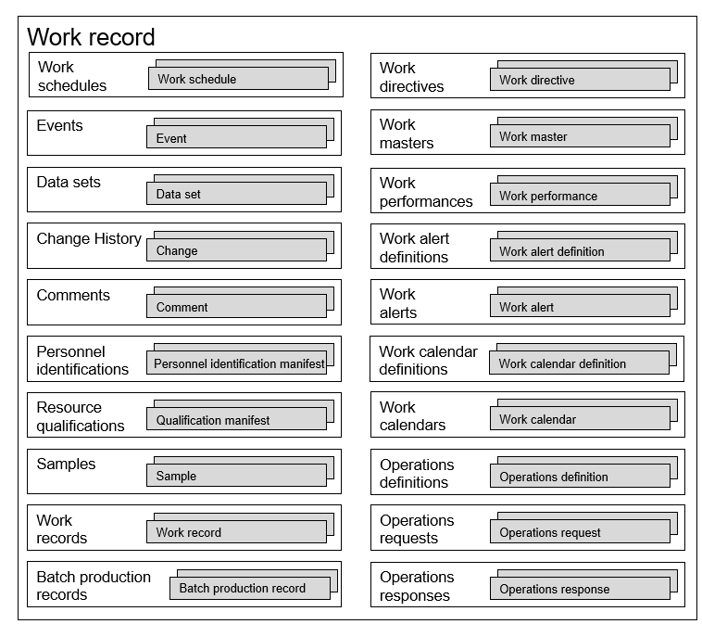

Figure F.2 – Work record container example

Elements of a *work record* can reference other elements within the *work record*, as illustrated in Figure F.3. It shows an example with one *change history* that references a changed *work directive workflow specification*, two *personnel identification manifests*, and one *comment* that references a *change history element*. One *personnel identification manifest* identifies the person and “Done by” action on the *change history*. The second identifies the *person* and *“Checked by” action* on the *change history*. The *comment* contains a comment associated with the change.



Figure F.3 – Work record element reference example

* + 1. Work record model example

The work record model is shown in Figure F.4. The objects with gray shading are defined in ANSI/ISA-88.00.04.

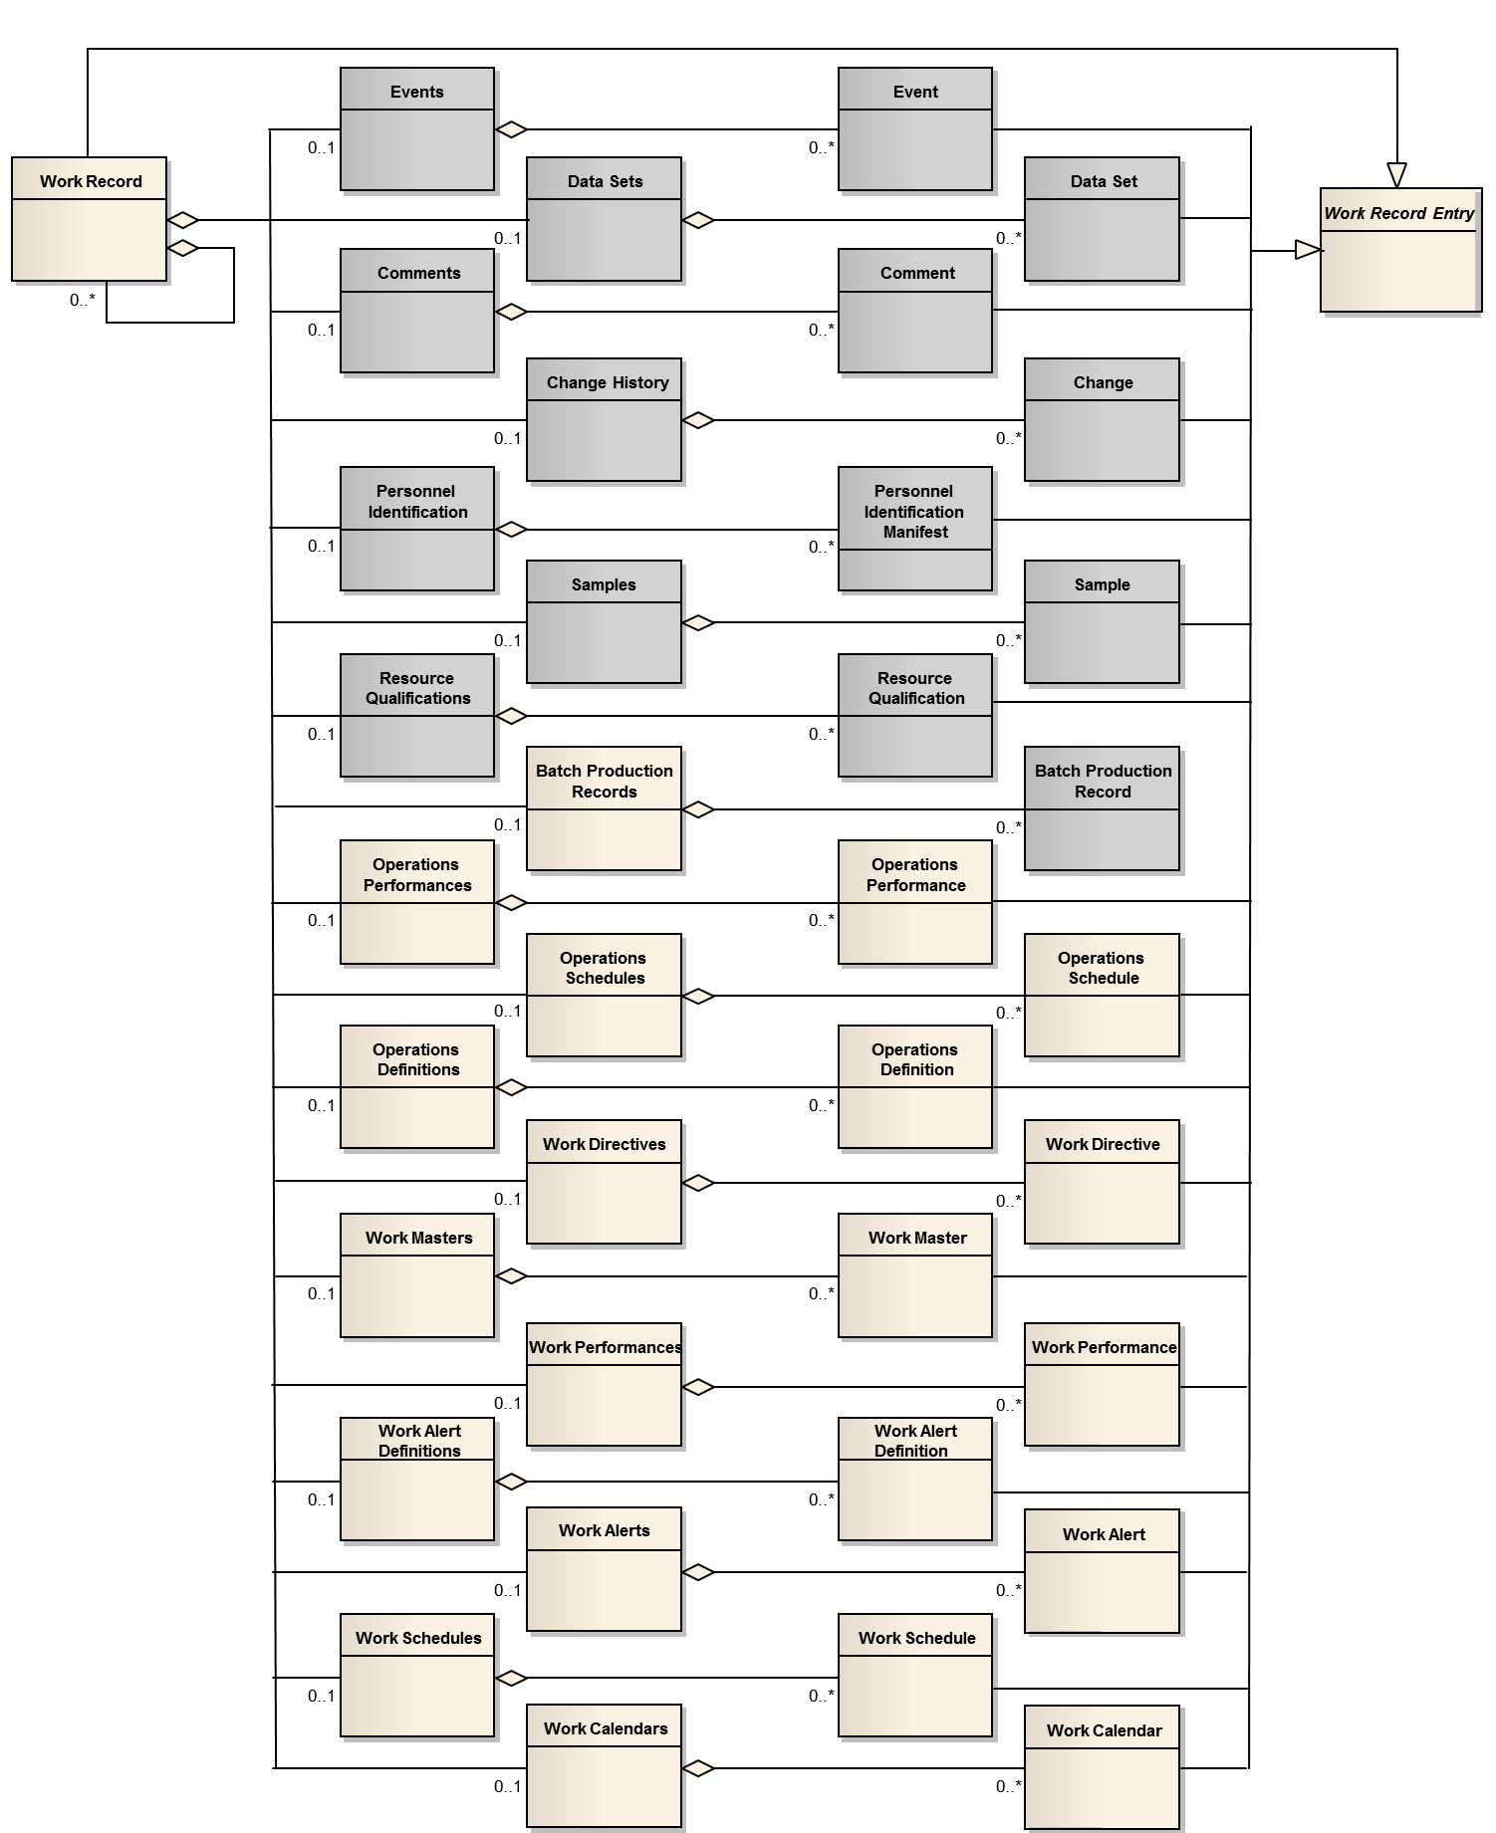

Figure F.4 – Work record model

* + 1. Work record entry

A *work record entry* is an abstract type used to define common attributes for many of the objects that make up a *work record*. All specialized types of *work record entry* objects (shown in Figure F.4) shall have the relationships defined in Table F.3 and the attributes defined Table F.4.

Table F.3 – Work record entry relationship

| Related object | Relationship | | | | Description |
| --- | --- | --- | --- | --- | --- |
| Role | Multiplicity | Name | Type |
| Work record | External reference | 0..* | Is superclass of | Generalization | The specialised object represents the related object, the *work record entry* specialization references.  *Work record* *entries* are abstract objects which cannot be instantiated, only the specialized objects can be instantiated.  Contains a reference to data which is stored externally to the *work record*.  NOTE 1 If data is embedded in the *work record*, this attribute is not used.  NOTE 2 The format of the reference is determined by a conforming specification.  The objects type is identified by the *object type* attribute in the *work record entry*. |
| Event |
| Data set |
| Comment |
| Change |
| Personnel identification manifest |
| Sample |
| Resource qualification |
| Operations performance |
| Operations schedule |
| Operations definition |
| Work directive |
| Work master |
| Work performance |
| Work alert definition |
| Work schedule |
| Work calendar |

Table F.4 – Work record entry attributes

| Attribute name | Description | Examples |
| --- | --- | --- |
| Entry ID | ID which is unique within the scope of a *work record*. This attribute is mandatory. | 1  239432  4A34B |
| Description | Additional information about the entry. | The *work directive* is embedded in this *work record entry*.  Data set time series data is stored in the historian database. |
| External reference | Contains a reference to data which is stored externally to the *work record*.  NOTE 1 If data is embedded in the work record this attribute is not used.  NOTE 2 The format of the reference is determined by a conforming specification. | Control system for work cell A  \\dept_share\archive2004\ product ABC |
| Object type | Identifies the type of object an entry is based upon. | *Work master*  *Data set*  *Change history* |
| Time stamp | The time stamp associated with the entry. | 2013-07-14 1454+0100  01 March 2014 14:25 UTC  April 23, 2012 8:30 AM ET |

* + 1. Work record container objects

The following objects are container objects, which have no defined attributes.

1. *Operations schedules* shall be defined as a container of *operations schedule* elements (as defined in part 2 of this standard).
2. *Operations definitions* shall be defined as a container of *operations definition* elements (as defined in part 2 of this standard).
3. *Operations performances* shall be defined as a container of *operations performance* elements (as defined in part 2 of this standard).
4. *Work masters* shall be defined as a container of *work master* elements.
5. *Work directives* shall be defined as a container of *work directive* elements.
6. *Work schedules* shall be defined as a container of *work schedule* elements.
7. *Work performances* shall be defined as a container of *work performance* elements.
8. *Work calendars* *definitions* shall be defined as a container of *work calendar* elements.
9. *Work calendar* shall be defined as container of *work calendar definition* elements
10. *Work alert definitions* shall be defined as container of *work alert definition* elements
11. *Work alerts* shall be defined as a container of *work alert* elements.
12. *Batch production records* shall be defined as a container of *batch production record* elements (as defined in ANSI/ISA-88.00.04).
    1. Event types and subtypes

The *procedural execution event* (defined in ANSI/ISA-88.00.04 shall be used to refer to events associated with a *job order’s workflow specification*.

As shown in Table F.5, the standard *event types* and *event subtypes* defined in shall be added to the ANSI/ISA-88.00.04 standard *event types.*

Table F.5 – Additional event types and subtypes

| Event type | Event subtype | Description |
| --- | --- | --- |
| Work directive | Modification | Change in value for a *parameter* in a *work directive*.  Value attribute contains the new data value. The previous value contains the old data value.  EXAMPLE  Temperature set point changed to 500, *scaling factor* applied to *work directive.* |
| Work directive | Equipment | Change in *equipment* assigned to or bound to a *work directive*.  *Value* attribute contains the new *equipment* name. The previous *value* contains the old data’s *equipment* name.  EXAMPLE  Packing Line 22 bound to Workflow Step 184. |
| Equipment | Allocation | Allocation of *equipment* to a *job order.*  *Value* attribute contains the *equipment ID*.  EXAMPLE  *Work unit acquired.* |
| Equipment | Deallocation | Deallocation of *equipment* from a *job order*.  *Value* attribute contains the *equipment ID.*  EXAMPLE  *Work unit* *released.* |
| Procedural execution | Prompt | A request from a workflow to the operator to provide information for the completion of the workflow logic.  *Value* attribute contains text sent to the operator.  EXAMPLE  Execute SOP 324, perform line clearance per SOP 394. |
| Physical asset | Allocation | Allocation of a *physical asset* to a *job order.*  *Value* attribute contains the *equipment ID.*  EXAMPLE  *Work unit acquired.* |
| Physical asset | Deallocation | Deallocation of a *physical asset* from a *job order.*  *Value* attribute contains the *equipment ID.*  EXAMPLE  *Work unit released.* |
| Personnel | Assignment | Assignment of a *person* to a *job order.*  *Value* contains the *person ID.* |
| Personnel | Unassigned | Removal of an assignment of a *person* to a *job order.*  V*alue* contains the *person ID.* |
| Work alert | Generated | A *work alert* was generated.  *Value* contains the *work alert* information. Additional information may be recorded in an *alarm event* (defined in IEC 61512-4). |

Bibliography

IEC 61512 (all parts), Batch control

IEC 62541 (all parts), OPC unified architecture

ISO 22400 (all parts), Automation systems and integration – Key performance indicators (KPIs) for manufacturing operations management

ANSI/ISA-95.00.01-2010 (IEC 62264-1 Mod) – Enterprise-Control System Integration – Part 1: Models and Terminology

ANSI/ISA-95.00.02-2010 (ISA-95.00.02 Mod) – Enterprise-Control System Integration – Part 2: Object Model Attributes

ANSI/ISA-95.00.03-2005, Enterprise-Control System Integration Part 3: Activity Models of Manufacturing Operations Management

ANSI/ISA-88.00.01-2010, Batch Control – Part 1: Models and Terminology

MIMOSA OSA-EAI CCOM V3.2 – [www.mimosa.org](http://www.mimosa.org)

BPMN specifications are maintained by Object Management Group (OMG) at <http://www.omg.org/spec/BPMN>. The current version is 2.0.

_____________

1. BPMN is an example of a suitable specification available commercially. This information is given for the convenience of users of this standard and does not constitute an endorsement by IEC of BPMN products.